

**MVJ COLLEGE OF ENGINEERING**

Near ITPB, Channasandra, Bengaluru – 560067

Affiliated to VTU, Belagavi Approved by AICTE, New Delhi

Recognized by UGC under 2(f) & 12(B)

Accredited by NBA & NAAC

**DEPARTMENT OF COMPUTER SCIENCE AND ENGINEERING**

**V SEMESTER**

**MVJ22CSL54 - DATA VISUALIZATION USING TABLEAU AND POWER BI**

**Academic Year: 2025-2026(ODD)**

**LABORATORY MANUAL**

**NAME OF THE STUDENT : __________________________________**

**BRANCH : __________________________________**

**UNIVERSITY SEAT N :**

**SEMESTER & SECTION : ____________________________________**

**BATCH** **:** ___________________________________

**DEPARTMENT OF COMPUTER SCIENCE AND ENGINEERING**

**VISION:**

To create an ambiance in excellence and provide innovative emerging programs in Computer Science and Engineering and to bring out future ready engineers equipped with technical expertise and strong ethical values.

**MISSION:**

1. **Concepts of Computing Discipline:** To educate students at under graduate, postgraduate and doctoral levels in the fundamental and advanced concepts of computing discipline.
2. **Quality Research:** To provide strong theoretical and practical background across the Computer Science and Engineering discipline with the emphasis on computing technologies, quality research, consultancy and training's.
3. **Continuous Teaching Learning:** To promote a teaching learning process that brings advancements in Computer Science and Engineering discipline leading to new technologies and products.
4. **Social Responsibility and Ethical Values:** To inculcate professional behavior, innovative research Capabilities , leadership abilities and strong ethical values in the young minds so as to work with the commitment for the betterment of the society

**PROGRAM OUTCOMES (POs):**

**PO1:** Engineering Knowledge: Apply knowledge of mathematics, natural science, computing, engineering fundamentals and an engineering specialization as specified in WK1 to WK4 respectively to develop to the solution of complex engineering problems.

**PO2:** Problem Analysis: Identify, formulate, review research literature and analyze complex engineering problems reaching substantiated conclusions with consideration for sustainable development. (WK1 to WK4)

**PO3:** Design/Development of Solutions: Design creative solutions for complex engineering problems and design/develop systems/components/processes to meet identified needs with consideration for the public health and safety, whole-life cost, net zero carbon, culture, society and environment as required. (WK5)

**PO4:** Conduct Investigations of Complex Problems: Conduct investigations of complex engineering problems using research-based knowledge including design of experiments, modelling, analysis & interpretation of data to provide valid conclusions. (WK8).

**PO5:** Engineering Tool Usage: Create, select and apply appropriate techniques, resources and modern engineering & IT tools, including prediction and modelling recognizing their limitations to solve complex engineering problems. (WK2 and WK6)

**PO6:** The Engineer and The World: Analyze and evaluate societal and environmental aspects while solving complex engineering problems for its impact on sustainability with reference to economy, health, safety, legal framework, culture and environment. (WK1, WK5, and WK7).

**PO7:** Ethics: Apply ethical principles and commit to professional ethics, human values, diversity and inclusion; adhere to national & international laws. (WK9)

**PO8:** Individual and Collaborative Team work: Function effectively as an individual, and as a member or leader in diverse/multi-disciplinary teams.

**PO9:** Communication: Communicate effectively and inclusively within the engineering community and society at large, such as being able to comprehend and write effective reports and design documentation, make effective presentations considering cultural, language, and learning differences.

**PO10:** Project Management and Finance: Apply knowledge and understanding of engineering management principles and economic decision-making and apply these to one’s own.

work, as a member and leader in a team, and to manage projects and in multidisciplinary environments. 1 **PO11:** Life-Long Learning: Recognize the need for and have the preparation and ability for i) independent and life-long learning ii) adaptability to new and emerging technologies and iii) critical thinking in the broadest context of technological change.

**PROGRAM EDUCATIONAL OBJECTIVES**

**PEO 1:** Our Graduates will have the capability to apply their knowledge and the skills that they have acquired, to solve issues in real world Data Science sectors, and to develop feasible and viable systems. **PEO 2:** Our Graduates will have the potential to participate in life-long learning through the successful completion of advanced degrees, continuing education, certifications and/or other professional developments.

**PEO 3:** Our Graduates will actively pursue post graduate studies in advanced areas of Data Science and related fields, by succeeding in competitive exams.

**PROGRAM SPECIFIC OUTCOMES (PSOs):**

**PSO 1:** Our Graduates will be endowed with the ability to become leaders in Industry and Academia, by possessing advanced knowledge and skills, which can empower them to analyze, design, develop and implement their learning to develop the society.

**PSO 2**: Our Graduates will have the ability to develop the skills to address and solve social and environmental problems in an ethical way, and perform multidisciplinary projects using advanced technologies and tools

**COURSE OBJECTIVES:**

This course will enable students to

● Understand the Importance of data Visualization for business intelligence and decision making.

● Learn different approaches to understand the importance of visual perception.

● Learn different data visualization techniques and tools.

● Gain knowledge of effective data visuals to solve workplace problem.

**List of experiments**

|  |  |
| --- | --- |
| **Sl. NO** | **Experiments** |
| 1 | **Getting Started -** Tableau Workspace, Tableau terminologies, basic functionalities. |
| 2 | **Connecting to Data Source –** Connecting to Database, Different types of Tableau Joins. |
| 3 | **Creating a View -** formatting charts, adding filters, creating calculated fields and defining parameters. |
| 4 | **Dashboard Design and Storytelling –** Components of Dashboard, Understanding how to place worksheets in Containers, Action filters and its types. |
| 5 | **Introducing Power BI –**Components and the flow of work. Power BI Desktop Interface-The Report has five main areas. |
| 6 | **Querying Data from CSV -** Query Editor, Connecting the data from the Excel Source, Clean, Transform the data. |
| 7 | **Creating Reports & Visualizations -** Different types of charts, Formatting charts with Title, Colors. |
| 8 | **Dashboards -** Filters in Power BI, Formatting dashboards. |
| 9 | **Analysis of revenue in sales dataset:**  i)Create a choropleth map (fill the map) to spot the special trends to show the state which has the highest revenue. ii)Create a line chart to show the revenue based on the month of the year. iii)Create a bin of size 10 for the age measure to create a new dimension to show the revenue.   1. Create a donut chart view to show the percentage of revenue per region by creating zero access in the calculated field. 2. Create a butterfly chart by reversing the bar chart to compare female & male revenue based on product category. 3. Create a calculated field to show the average revenue per state & display profitable & non-profitable state. vii)Build a dashboard. |
| 10 | **Analysis of GDP dataset:**  i)Visualize the countries data given in the dataset with respect to latitude and longitude along with country name using symbol maps. ii)Create a bar graph to compare GDP of Belgium between 2006 – 2026.  iii)Using pie chart, visualize the GDP of India, Nepal, Romania, South Asia, Singapore by the year 2010. iv)Visualize the countries Bhutan & Costa Rica competing in terms of GDP.   1. Create a scatter plot or circle views of GDP of Mexico, Algeria, Fiji, Estonia from 2004 to 2006.   Build an interactive dashboard |
| 11 | **Analysis of HR Dataset:**  i)Create KPI to show employee count, attrition count, attrition rate, attrition count, active employees, and average age. ii)Create a Lollipop Chart to show the attrition rate based on gender category.   1. Create a pie chart to show the attrition percentage based on Department Category- Drag department into colours and change automatic to pie. Entire view, Drag attrition count to angle. Label attrition count, change to percent, add total also, edit label. 2. Create a bar chart to display the number of employees by Age group, 3. Create a highlight table to show the Job Satisfaction Rating for each job role based on employee count. 4. Create a horizontal bar chart to show the attrition count for each Education field Education field wise attrition – drag education field to rows, sum attrition count to col, vii)Create multiple donut chart to show the Attrition Rate by Gender for different Age group. | |
| 12 | **Analysis of Amazon Prime Dataset:**  i)Create a Donut chart to show the percentage of movie and tv shows ii)Create a area chart to shows by release year and type iii)Create a horizontal bar chart to show Top 10 genre iv)Create a map to display total shows by country   1. Create a text sheet to show the description of any movie/movies.   Build an interactive Dashboard. | |
| **Course outcomes (Course Skill Set):**  At the end of the course the student will be able to:   1. Design the experiment to create basic charts and graphs using Tableau and Power BI. 2. Develop the solution for the given real world problem. 3. Analyze the results and produce substantial written documentation. | | |

Change of experiment is allowed only once and 15% of Marks allotted to the procedure part are to be made zero.

The minimum duration of SEE is 02 hours

**Suggested Learning Resources:**

* + 1. Microsoft Power BI Dashboards Step by Step by Errin O’Connor, 2019 byPearson Education, Inc
    2. Information Dashboard Design: Displaying Data for At-a-glance Monitoring” by Stephen Few
    3. https://help.tableau.com/current/guides/get-started-tutorial/en-us/get-started-tutorial-home.htm
    4. <https://www.tutorialspoint.com/tableau/index.htm>
    5. https://[www.simplilearn.com/tutorials/power-bi-tutorial/power-bi-vs-tableau](http://www.simplilearn.com/tutorials/power-bi-tutorial/power-bi-vs-tableau)

# Introduction to Various Data Visualization tools

**Data visualization** is the practice of translating information into a visual context, such as a map or graph, to make data easier for the human brain to understand and pull insights from. It is the representation of information and data through use of common graphics, such as charts, plots, infographics, and animations. Data visualization is a powerful way for people, especially data professionals, to display data so that it can be interpreted easily.

Data Visualization enables decision-makers of any enterprise or industry to look into analytical reports and understand concepts that might otherwise be difficult to grasp.

**Benefits of Data Visualization:**

1. It is easy to understand the information with graphics
2. It made data to be represented in attractive way
3. Shows complex relationships
4. Helps to process large datasets
5. Useful for identifying trends
6. Minimizes ambiguity

**Data visualization tools** provide the ability to see and understand data trends, outliers, and patterns in an easy, intuitive way. There are various data visualization tools available. One must choose the tool based on various factors such as its ease of use, types of graphical representations the tool can produce, size of the dataset the tool can handle etc. some of Data Visualization tools are Tableau, Power BI, Google Charts, Jupyter, Grafana etc.

The following are some common types of data visualizations:

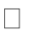**Table:** A table is data displayed in rows and columns, which can be easily created in a Word document or Excel spreadsheet.

**Chart or graph:** Information is presented in tabular form with data displayed along an x and y axis, usually with bars, points, or lines, to represent data in comparison.

**Geospatial visualization:** Data is depicted in map form with shapes and colours that illustrate the relationship between specific locations, such as a choropleth or heat map.

**Dashboard:** Data and visualizations are displayed, usually for business purposes, to help analysts understand and present data.

**Introduction to Tableau and Installation**

**Tableau** is a data visualization tool that provides pictorial and graphical representations of data. It is used for data analytics and business intelligence. Tableau provides limitless data exploration without interrupting flow of analysis. With an intuitive drag and drop interface, user can uncover hidden insights in data and make smarter decisions faster.

Tableau is a Business Intelligence tool for visually analyzing the data. Users can create and distribute an interactive and shareable dashboard, which depict the trends, variations, and density of the data in the form of graphs and charts. Tableau can connect to files, relational and Big Data sources to acquire and process data. The software allows data blending and real-time collaboration, which makes it very unique. It is used by businesses, academic researchers, and many government organizations for visual data analysis. It is also positioned as a leader Business Intelligence and Analytics Platform in Gartner Magic Quadrant.

As a leading data visualization tool, Tableau has many desirable and unique features. Its powerful data discovery and exploration application allows you to answer important questions in seconds. You can use Tableau's drag and drop interface to visualize any data, explore different views, and even combine multiple databases easily. It does not require any complex scripting. Anyone who understands the business problems can address it with a visualization of the relevant data. After analysis, sharing with others is as easy as publishing to Tableau Server.

**Tableau Features**

* **Speed of Analysis** − As it does not require high level of programming expertise, any user with access to data can start using it to derive value from the data.
* **Self-Reliant** − Tableau does not need a complex software setup. The desktop version which is used by most users is easily installed and contains all the features needed to start and complete data analysis.
* **Visual Discovery** − The user explores and analyzes the data by using visual tools like colors, trend lines, charts, and graphs. There is very little script to be written as nearly everything is done by drag and drop.
* **Blend Diverse Data Sets** − Tableau allows you to blend different relational, semi structured and raw data sources in real time, without expensive up-front integration costs. The users don’t need to know the details of how data is stored.
* **Architecture Agnostic** − Tableau works in all kinds of devices where data flows. Hence, the user need not worry about specific hardware or software requirements to use Tableau.
* **Real-Time Collaboration** − Tableau can filter, sort, and discuss data on the fly and embed a live dashboard in portals like SharePoint site or Salesforce. You can save your view of data and allow colleagues to subscribe to your interactive dashboards so they see the very latest data just by refreshing their web browser.
* **Centralized Data** − Tableau server provides a centralized location to manage all of the organization’s published data sources. You can delete, change permissions, add tags, and manage schedules in one convenient location. It’s easy to schedule extract refreshes and manage them in the data server. Administrators can centrally define a schedule for extracts on the server for both incremental and full refreshes.

**Working on Tableau -Some important screen shots and steps of sheets(Not**

**Related to Programs )**

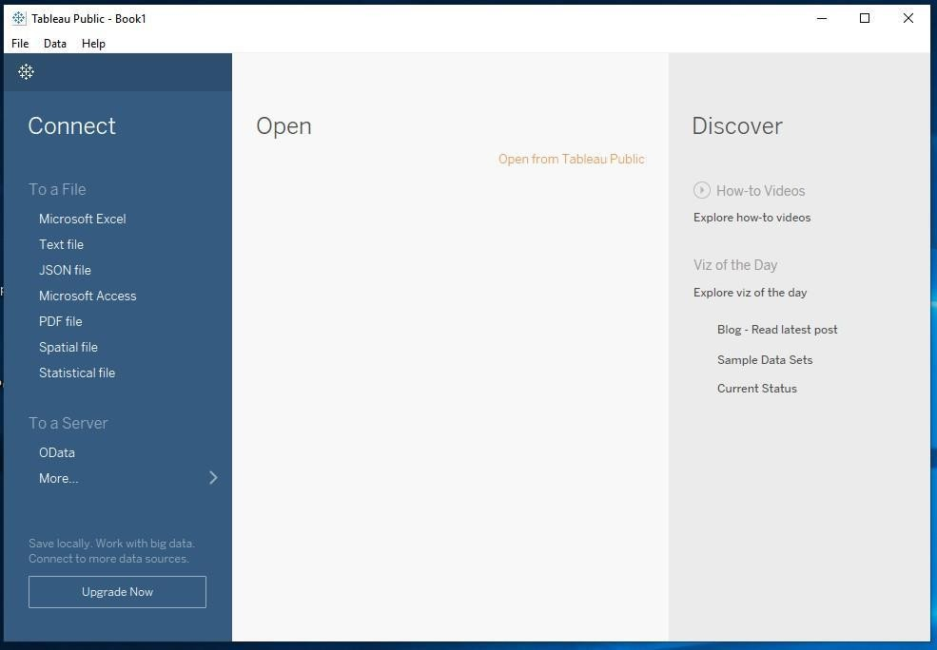

**Connecting to Data and preparing data for visualization in Tableau**

Tableau supports connecting to a wide variety of data, stored in a variety of places. For example, data might be stored on computer in a spread sheet or a text file, or in a big data, relational, or cube (multidimensional) database on a server in enterprise or the data can be from a public domain available on the web.

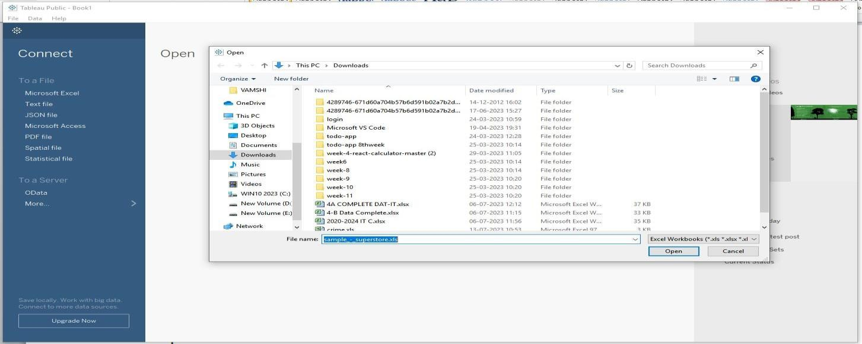

Data can be imported in Tableau Public from Connect panel on left side. For example, an Excel sample data set was loaded into Tableau as follows:

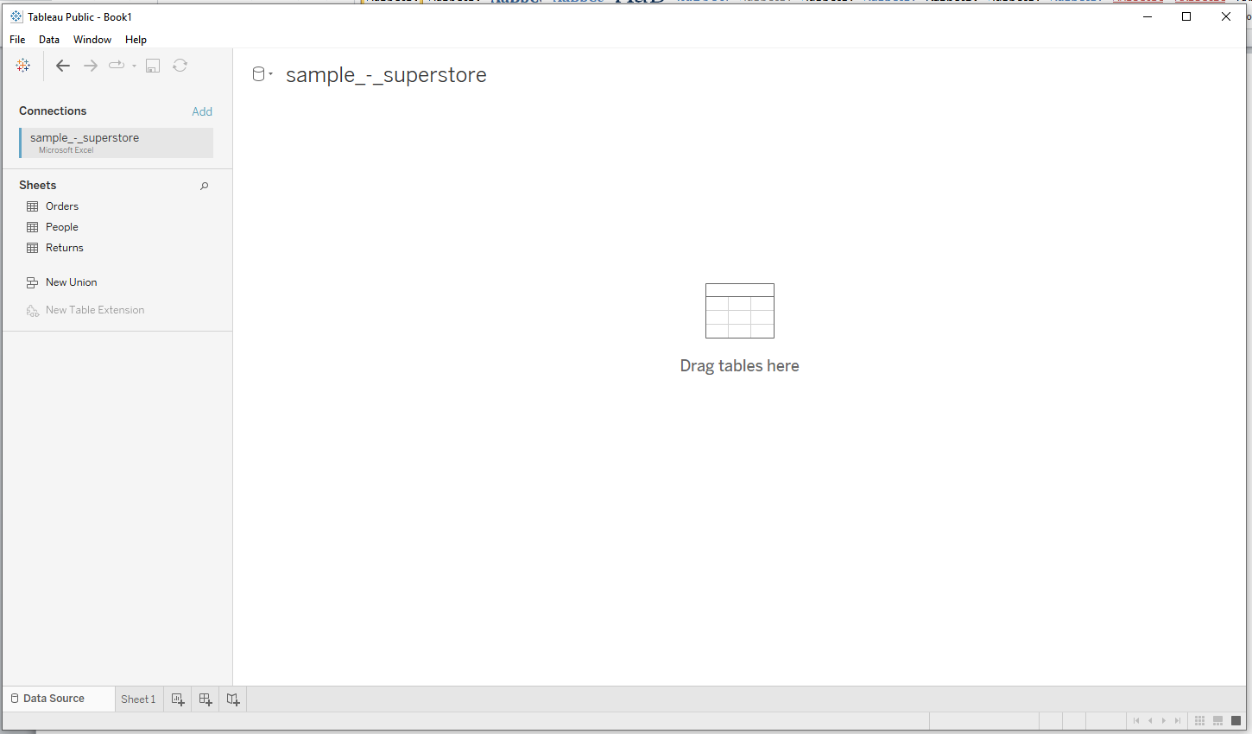After clicking on open, screen is as follows:

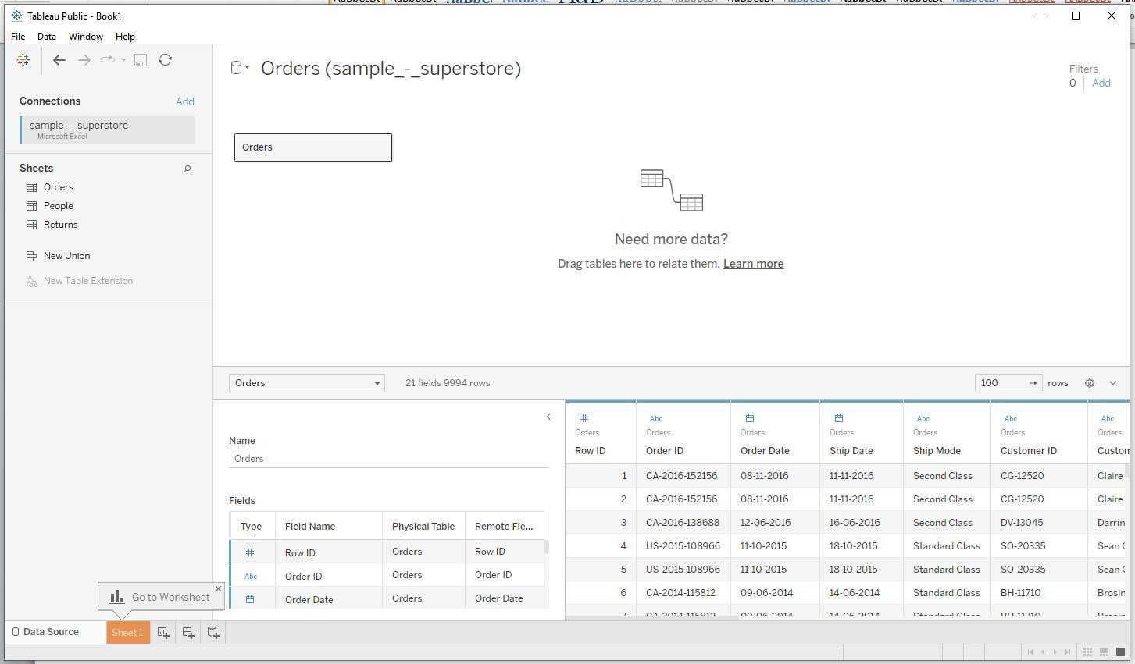The data store page appears as above. The left pan shows that above dataset consists of 3 worksheets. If we drag orders table, screen appears as follows: Tableau automatically identifies the data type of each column.

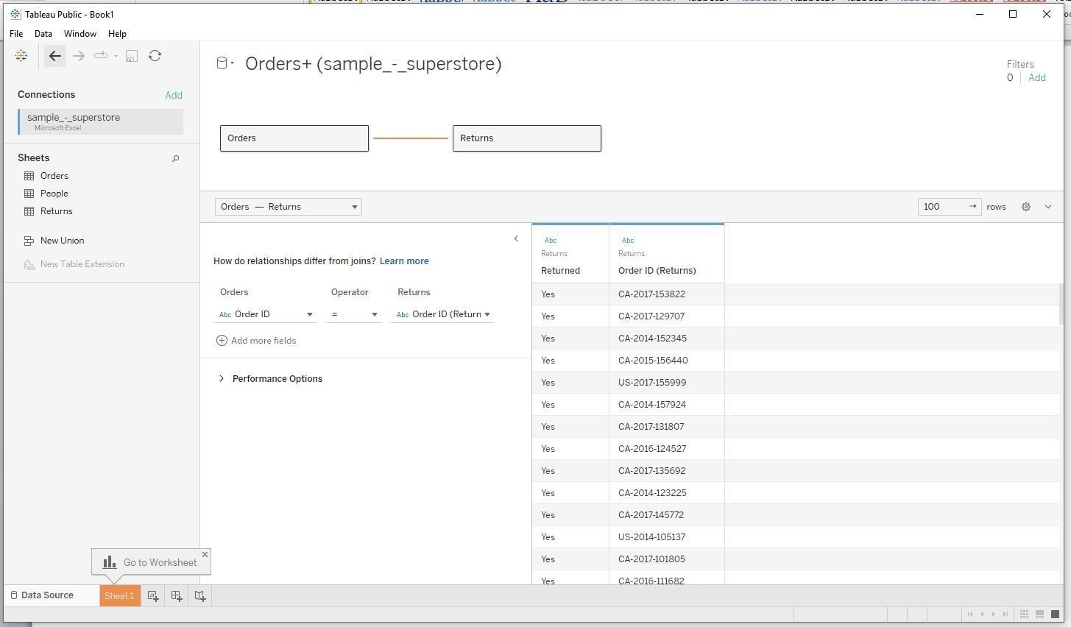Now drag Returns table onto the Canvas to the right of Orders table. This shows the relation between the two tables Orders and Returns.

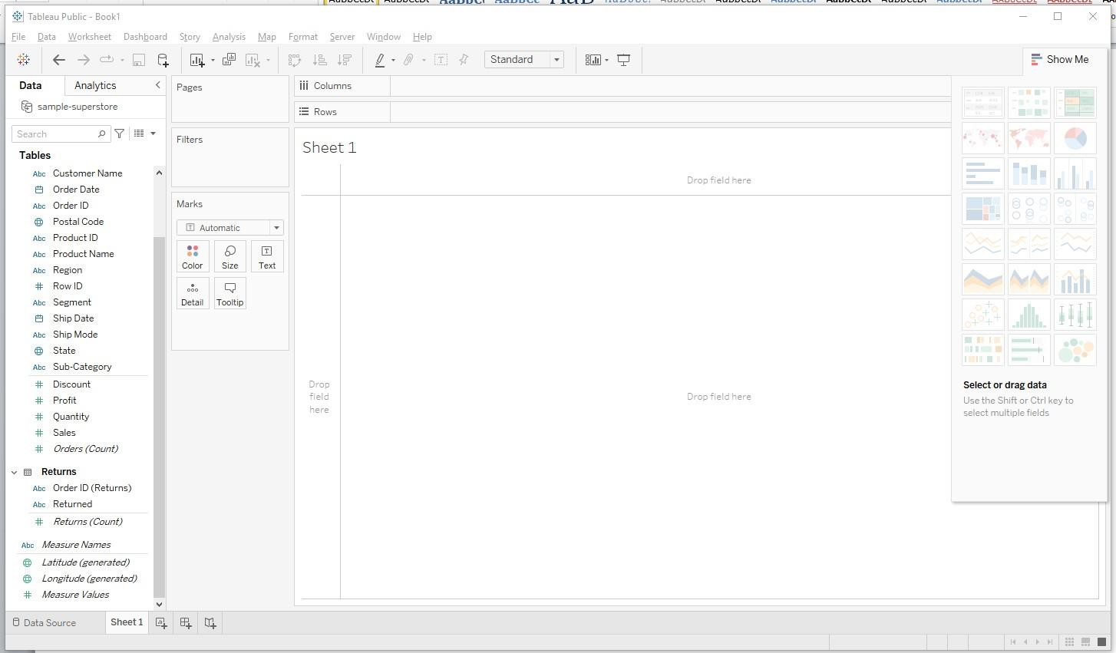If we click on the link between Orders and Returns table names at the top gives the summary of the relationship between the tables. Now rename the data store and click on Sheet1 at the bottom left to proceed. This step creates a data extract which improves query performance.

**Data aggregation and statistical functions**

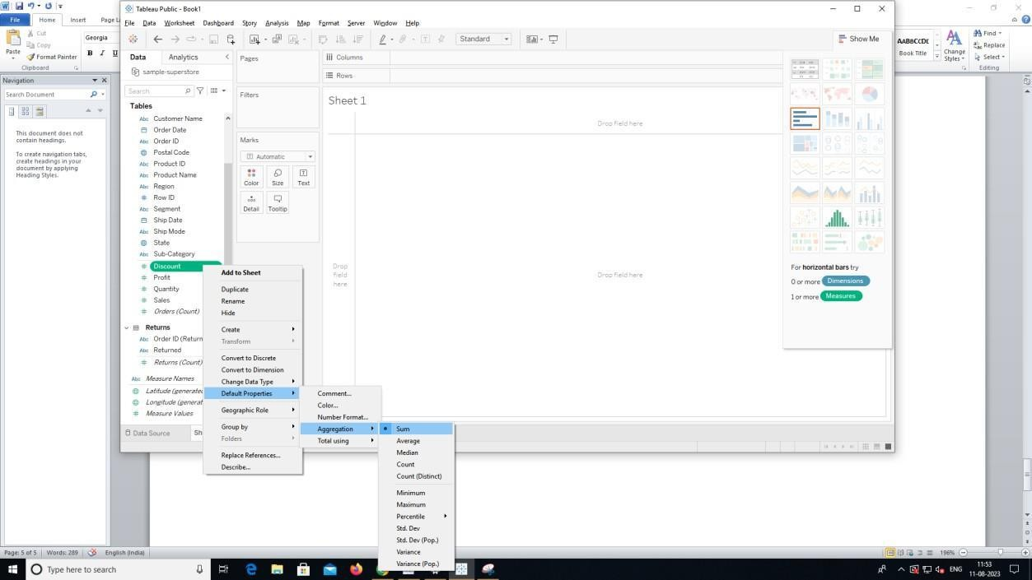We can apply various aggregation and statistical functions on data such as count, minimum, maximum, standard deviation, variance etc. This is shown below. This can be done by right clicking on the required field of dataset, click on Default properties and click on aggregation

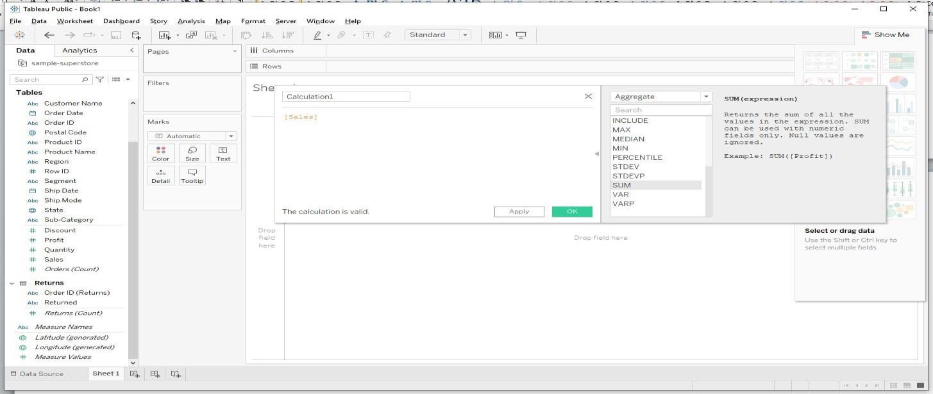Or the above operation can be done by creating a calculated field as shown below. To create a calculated field, click on the down arrow button beside search tab above Tables panel, drag a field to that calculated field window.

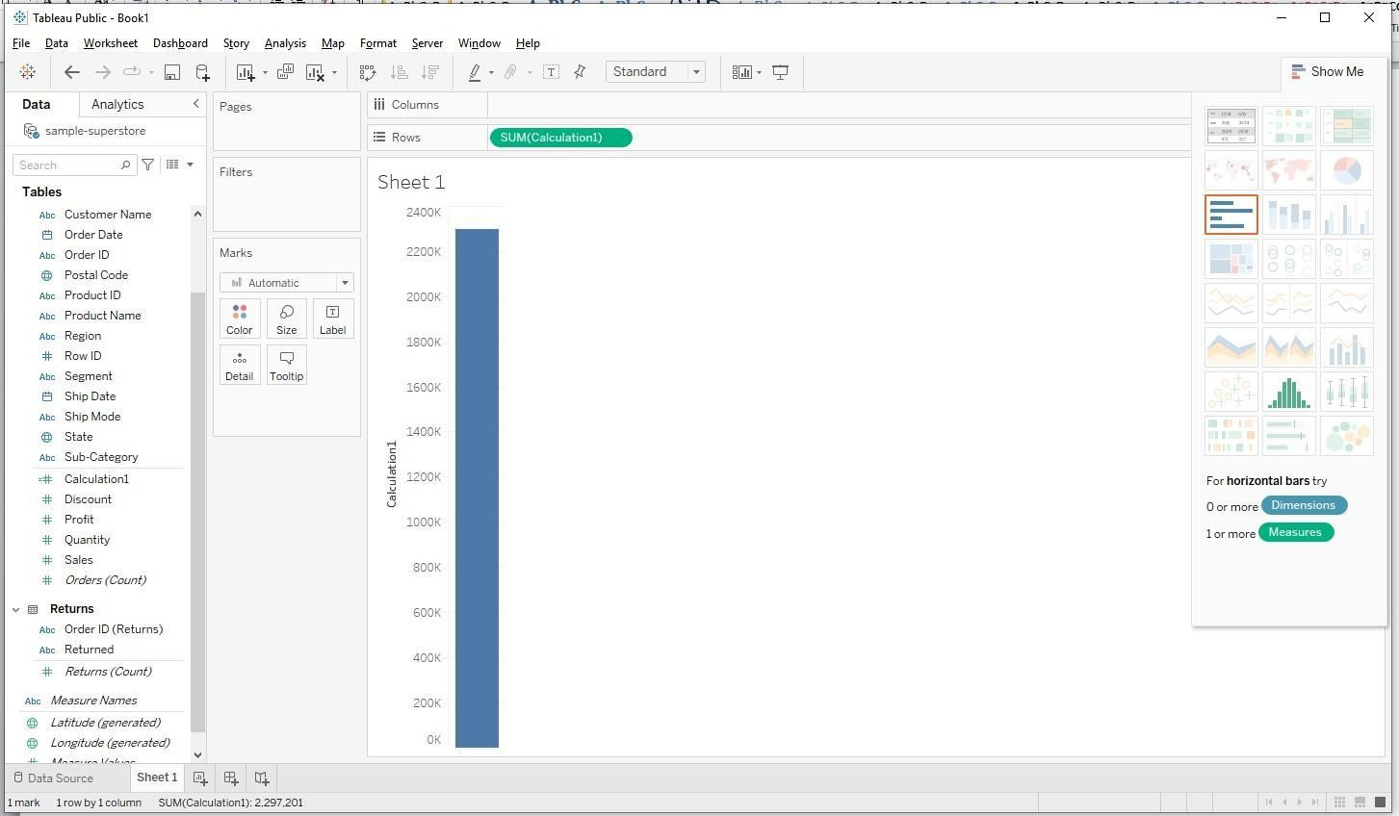Then click on apply and results are shown below.

In the same way we can apply any aggregate or statistical function on data with the help of calculated fields.

**Data Visualization**

We can perform various visualization operations on data in Tableau. Some of them are bar cart, histogram, bubble chart, gantt chart, scatter plot, heat map etc.

**Bar chart:**

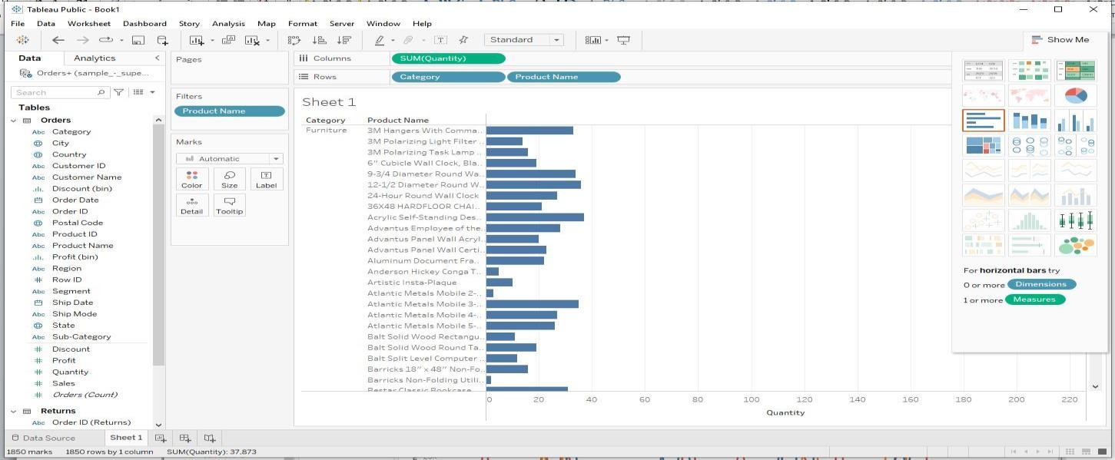Bar charts can be created in 3 variations in Tableau: Horizontal bars, stacked bars, side-by-side bars. Horizontal bars can be created by selecting that type of chart from Show Me menu on right hand side of Canvas. The type of chart in box on right hand side represents horizontal bar graph.

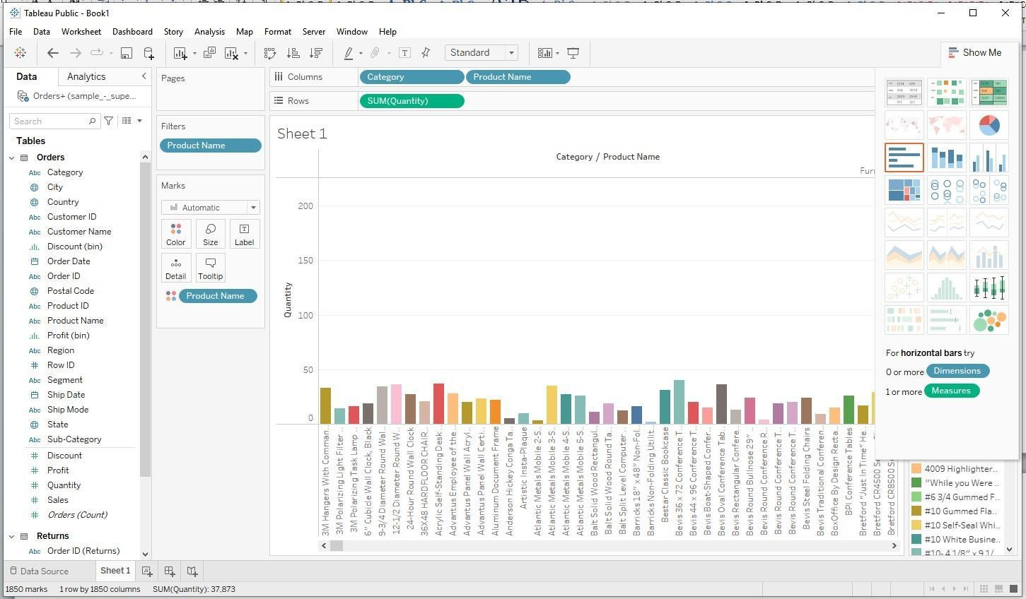Side-by-side bar chart can be created in following way.

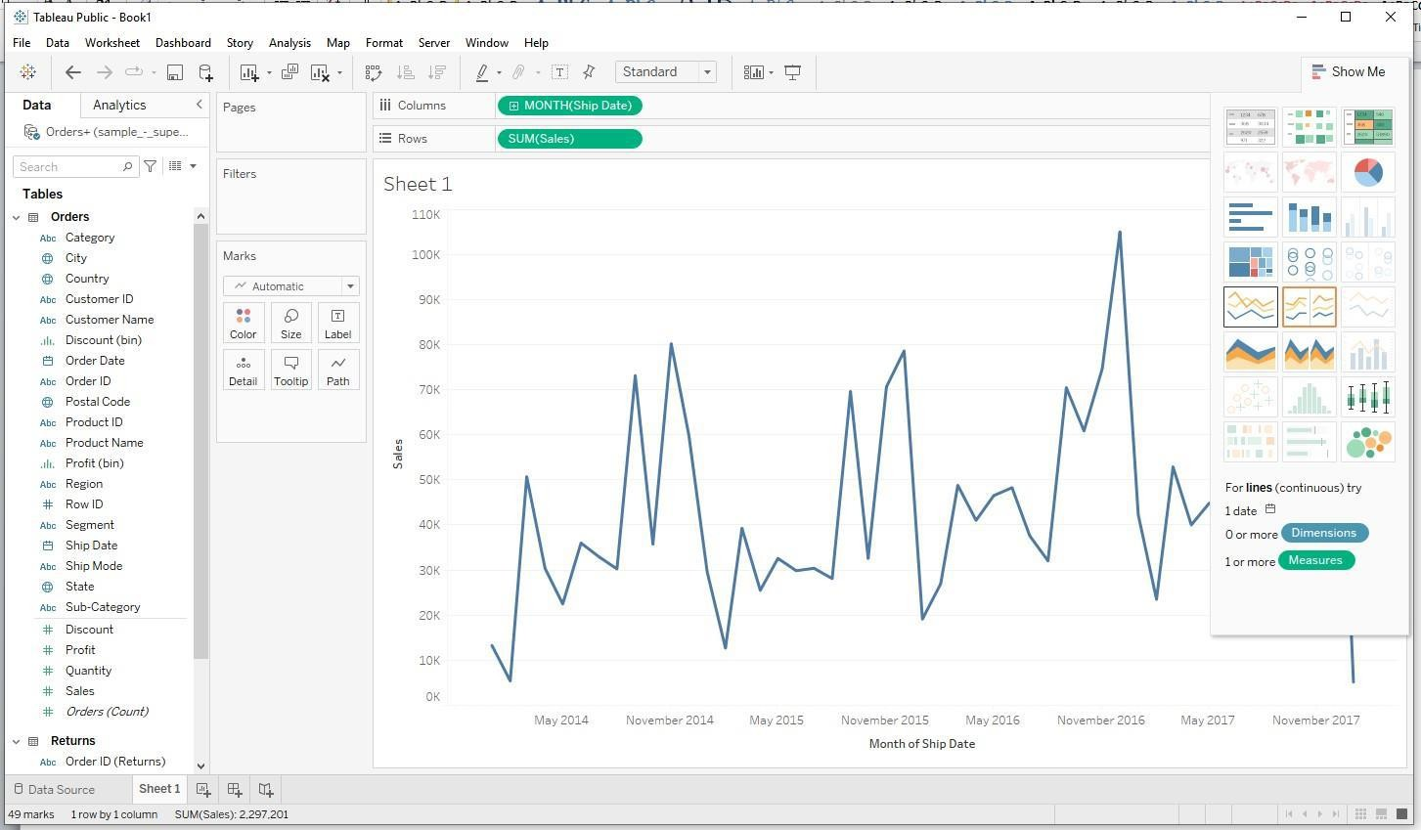**Line graph:** Line graph can be continuous or discrete.

Discrete line graph is shown below:

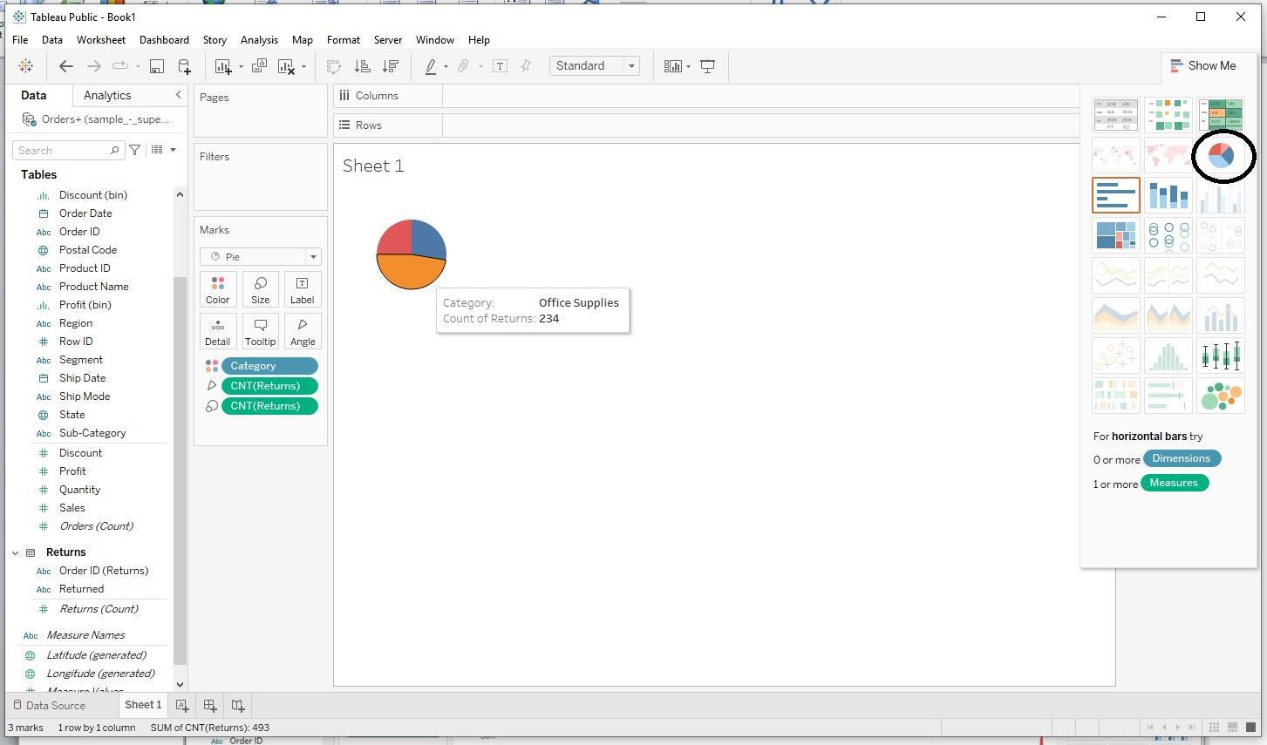

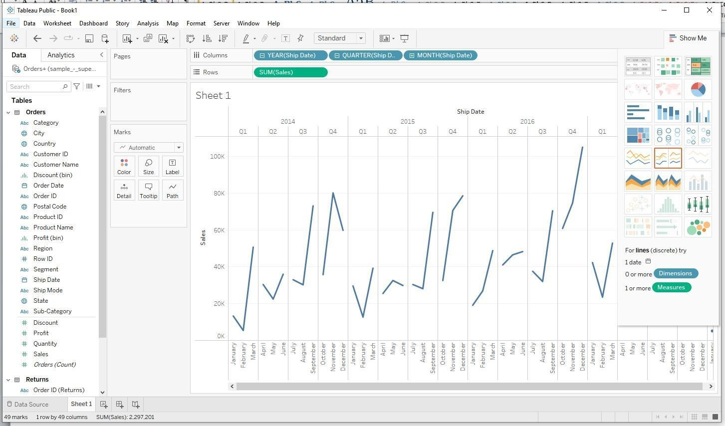**Pie chart:**

**Bubble chart:**

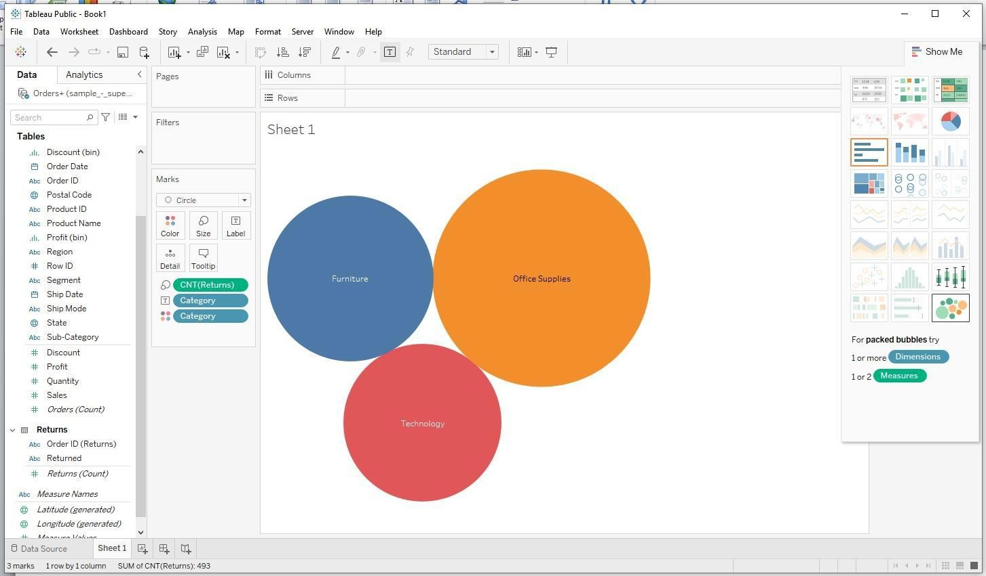

**Dashboards**

Dashboard is a way of displaying various types of visual data in one place. Usually, a dashboard is intended to convey different, but related information in an easy-to-digest form. And oftentimes, this includes things like key performance indicators (KPI)s or other important business metrics that stakeholders need to see and understand at a glance.

Dashboards are useful across different industries and verticals because they’re highly customizable. They can include data of all sorts with varying date ranges to help you understand: what happened, why it happened, what may happen, and what action should be taken.

For example, category of sales across months in a year, region is the field added. The first view is shown below. This can be renamed at the bottom of the screen.

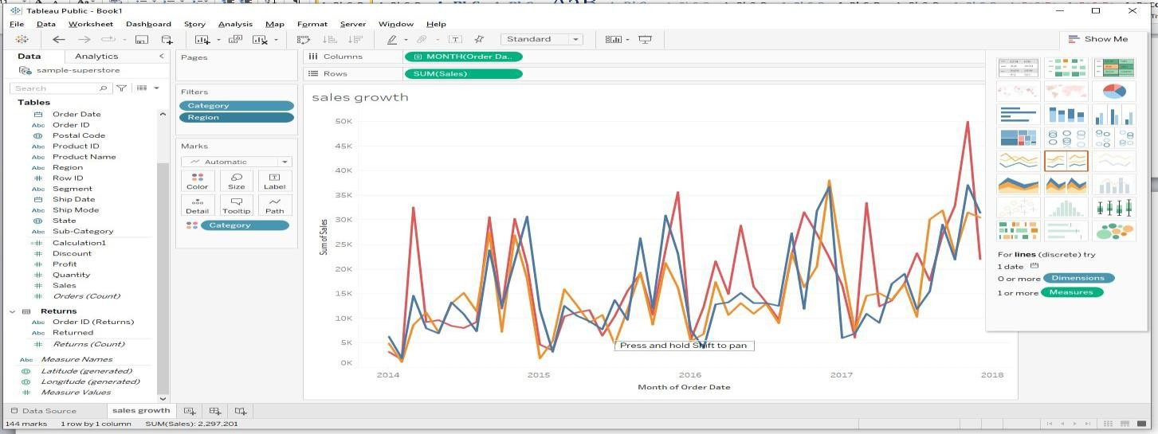

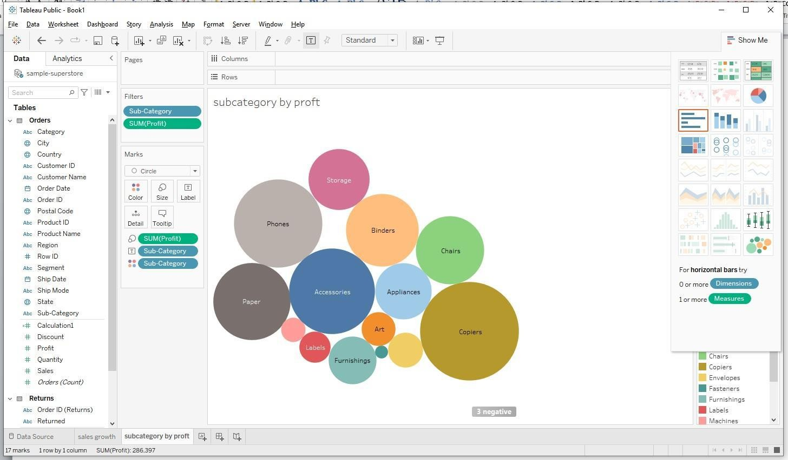Now go to 2nd sheet for creating the 2nd view. The second view is shown below. A bubble chart was drawn between profit and subcategory. Then rename the sheet.

Next 3rd view is created as follows for profit for each subcategory in the category with averages.

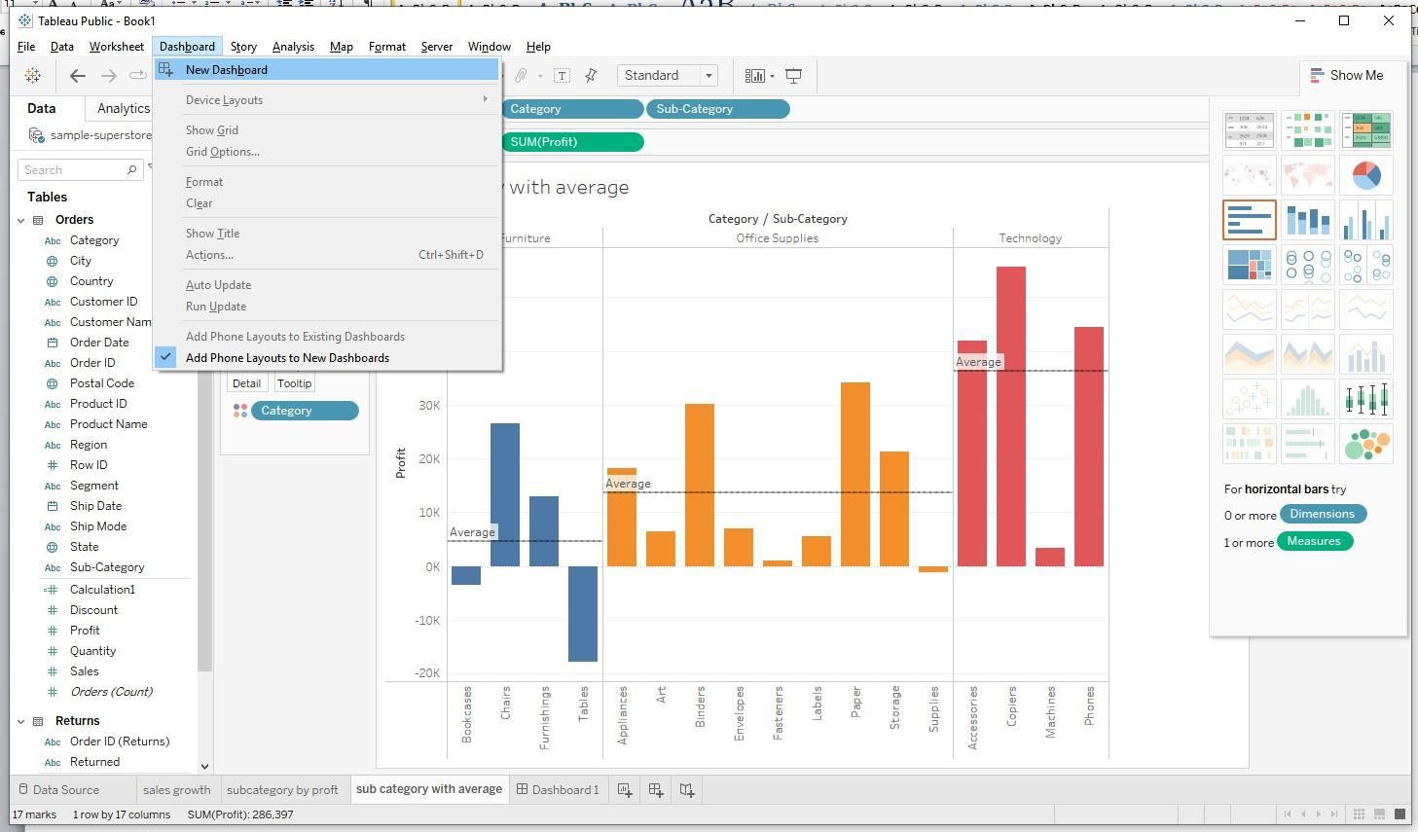After creating individual views, now a Dashboard can be created by clicking on create dashboard at the toolbar.

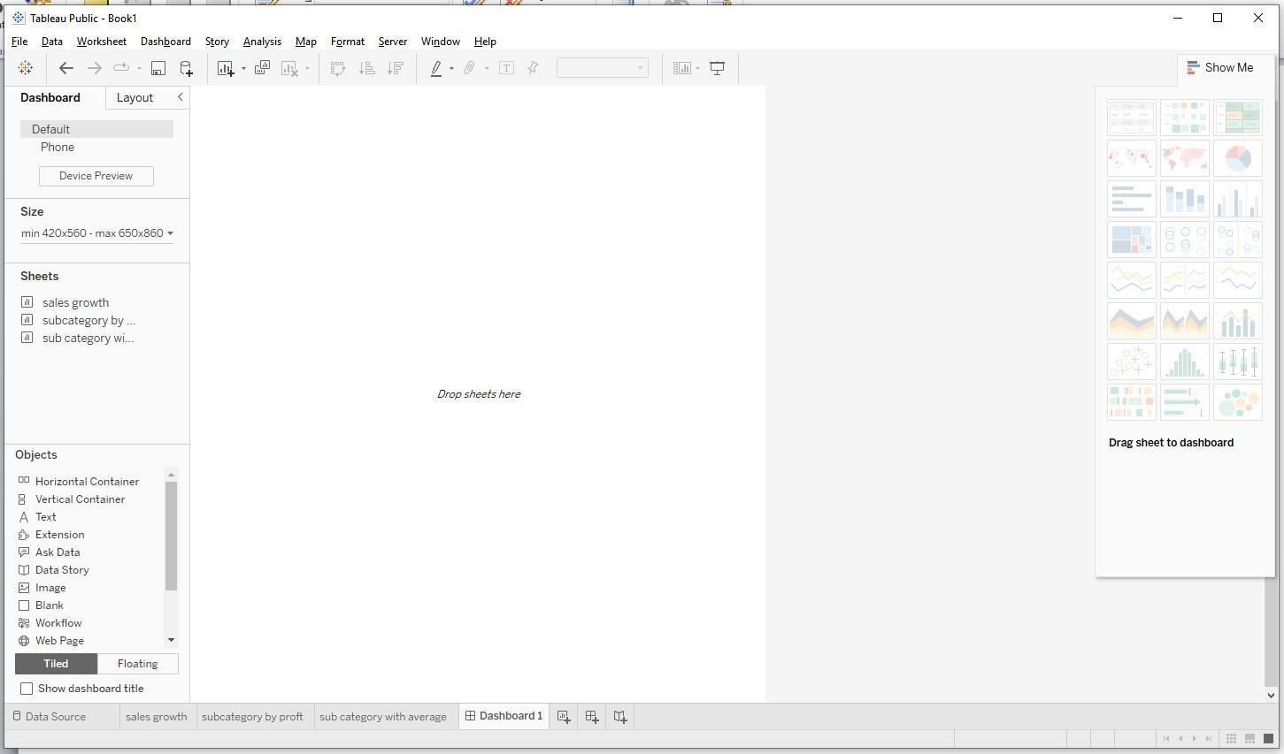after clicking on new dashboard option, the screen is shown below.

now the sheets or views which are created earlier can be drag and dropped on this dashboard. The above three created views are placed in the dashboard as follows. One can follow their own way of importing sheets on the dashboard. After creating dashboard, title can be given to the dashboard from Dashboard tab. Dashboard can be customized in terms of its appearance by the user if required. Dashboard once created can be saved on users system and can be retrieved whenever required.

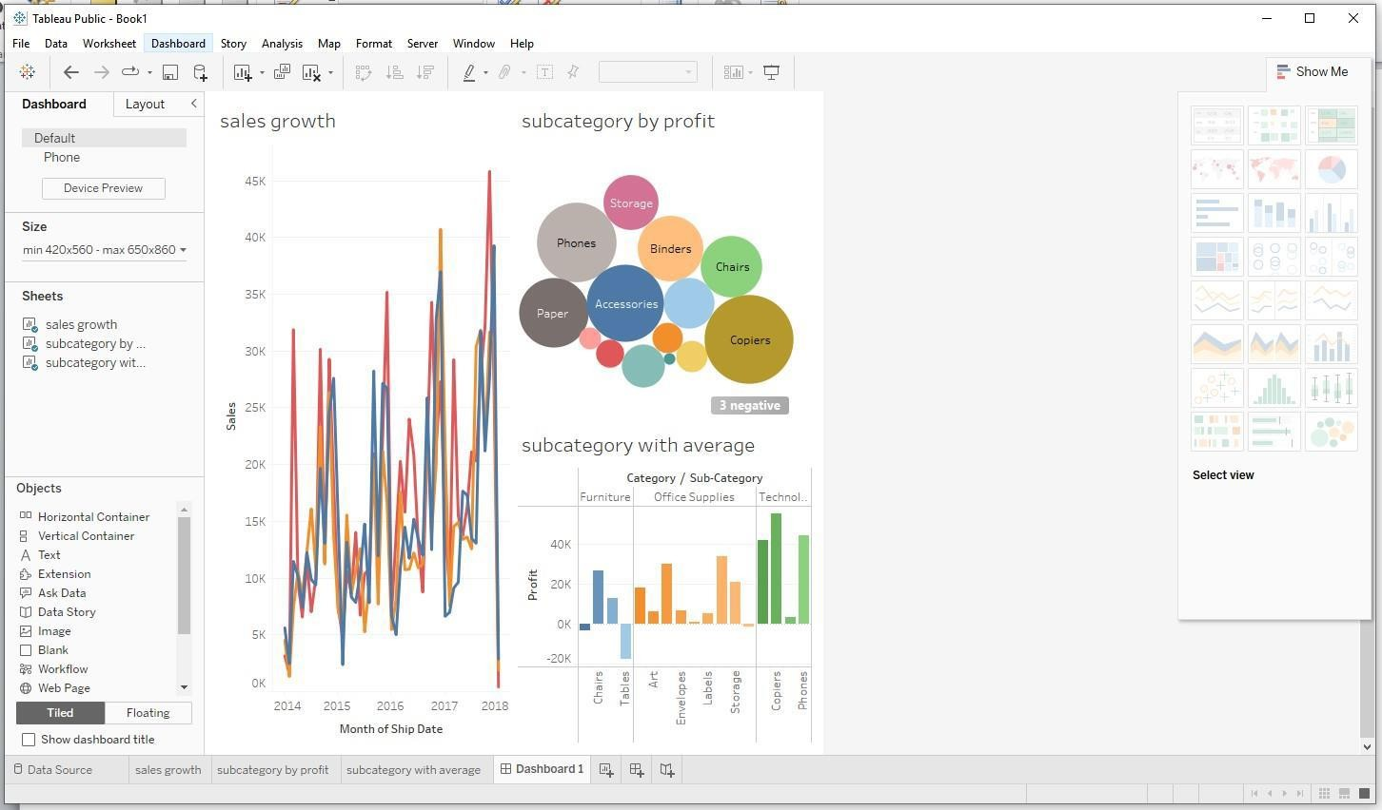

## POWER BI

**What is Power BI?**

Power BI is a[business intelligence tool](https://www.datacamp.com/blog/top-business-intelligence-tools)that allows you to connect to various data sources, visualize the data in reports and dashboards, and then share them with anyone you want.

Power BI is a Data Visualization and Business Intelligence tool that converts data from different data sources to interactive dashboards and BI reports.

### What is Power BI Used For

Power BI is a tool in the category of Business Intelligence (BI). The purpose of BI is to track Key Performance Indicators (KPIs) and uncover insights in business data so as to better inform decision-making across the organization.

Power BI is used in different ways depending on the role of the individual, from developers, analysts, managers, and directors, to everyone in between.

**How Does Power BI Compare to Other Tools Like Tableau and Excel?**

Power BI and Tableau are both business intelligence tools and have a lot of overlap in terms of their capabilities. There are 2 key differences between Power BI and Tableau:

1. Power BI only works on Windows, whereas Tableau supports both Windows and MacOS.
2. Pricing options differ between Power BI and Tableau. However, Tableau is generally the more expensive option. **Why Power BI?**

### “DATA “-------Analysis and Decision Making

Organizations need a tool that can help them understand the large amount of data that they are collecting. It is a powerful data visualization and analysis tool that allows businesses to turn raw data into actionable insights and reports.

Microsoft Power BI comes with a free or paid version. The free version only provides Power BI tools like Power BI Desktop and Power Q&A to dashboards. Whereas, in the Pro version they provide services like live report sharing, Power View, and more Power BI apps.

**Key Differences between Power BI and Tableau**

|  |  |
| --- | --- |
| Power BI | Tableau |
| Power BI uses DAX for measuring and calculating columns. | Tableau deploys MDX for dimensions and measures. |
| Power BI is best for a limited volume of data. | Tableau can handle huge columns of data and still offer better performance. |
| Power BI offers many data points for data visualization. | Tableau has better data visualization. |

**Program 1:**

**Getting Started - Tableau Workspace, Tableau terminologies, Basic functionalities.**

Working with Tableau that focuses on understanding the Tableau Workspace, Tableau terminologies, and basic functionalities.

**Dataset used: vgsales.csv**

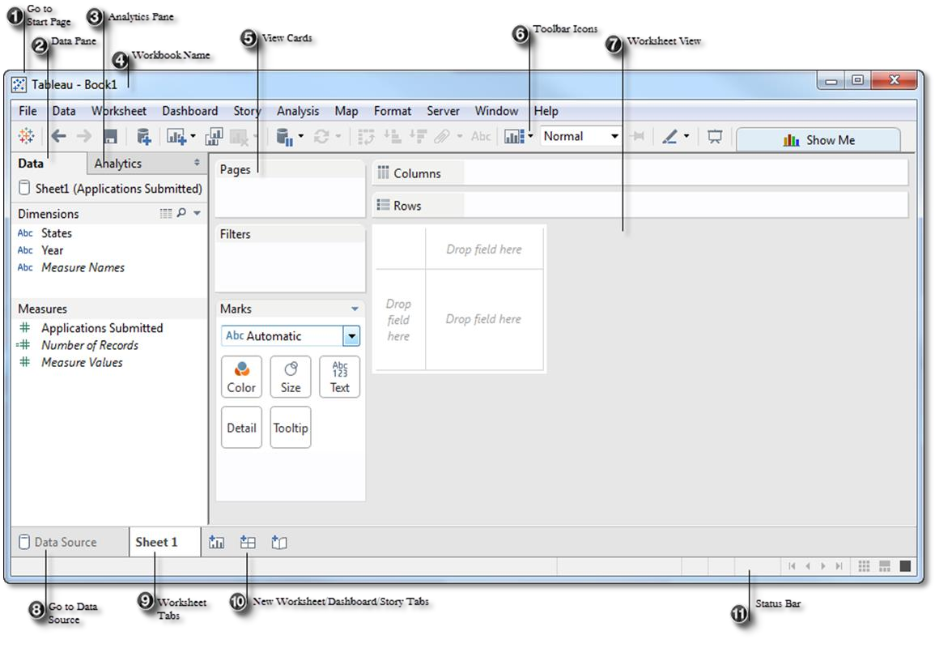

1. Go to Start Page: Toggle between the active sheet and the Desktop Start Page.
2. Data Pane: Includes dimensions and measures, populated from your selected data source. May also include calculated fields, parameters, or sets.
3. Analytics Pane: Includes options you can use to apply reference lines, forecasts, trend lines, to add totals to crosstabs, and to build boxplots.
4. Workbook Name: The file name of our workbook.
5. View Cards: Used for modifying the worksheet.
6. Toolbar Icons: Icons are available for quick access to popular features.
7. Worksheet/View: Workspace for building your visualizations.
8. Go to Data Source: Returns you to the data source specification page.
9. Worksheet Tabs: Click to view a specific worksheet, dashboard, or story
10. New Worksheet, Dashboard, and Story Tabs: Click to create a new Worksheet, Dashboard, or Story.
11. Status Bar: Displays data about the fields and marks included in the view.

**Steps:**

1. **Tableau Workspace Setup:**

* **Connect to Data:**
* Open Tableau, and on the "Start Page," select Connect -> To a File -> Text File.
* Browse to the location of vgsales.csv and open it.
* **Data Preview:**
* After loading, Tableau will show a preview of the data. You can rename columns if necessary.
* Click on the "Sheet 1" tab at the bottom to go to your first worksheet.

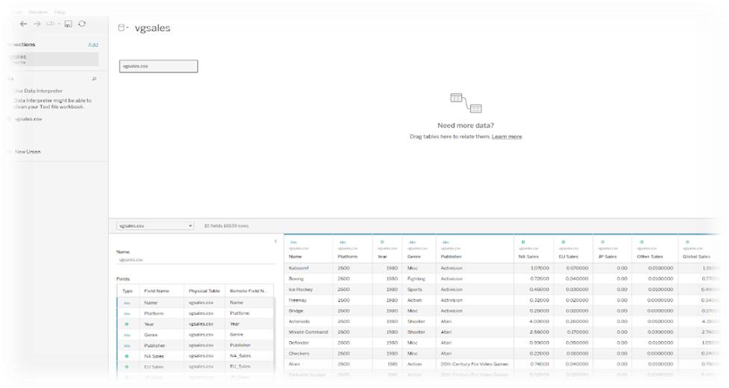

**2. Tableau Terminologies:**

* **Dimensions:** These are qualitative fields. In vgsales.csv, examples include Platform, Genre,andPublisher.
* **Measures:** These are quantitative fields used for calculations. Examples are Global_Sales, NA_Sales, and Year.
* **Rows and Columns Shelf**: Drag dimensions and measures to the Rows or Columns shelves to build the structure of your visualization.
* **Marks:** Controls the appearance of the data. You can set marks to be circles, bars, or other shapes and control size, color, and label.
* **Filters:** Used to limit the data displayed in the view.
* **Pages Shelf:** Used for creating animations or segmenting your view by categories.

**3. Basic Functionalities:**

**a. Basic Visualization (Bar Chart of Global Sales by Genre):**

* In your worksheet, drag Genre to the Columns shelf.
* Drag Global_Sales to the Rows shelf.
* You should see a bar chart. If the data isn’t aggregating correctly, check if the aggregation is set to SUM by right-clicking Global_Sales -> Measure -> Sum. b. Sorting:
* Click on the Global_Sales axis and sort descending to show the genres with the most sales first.

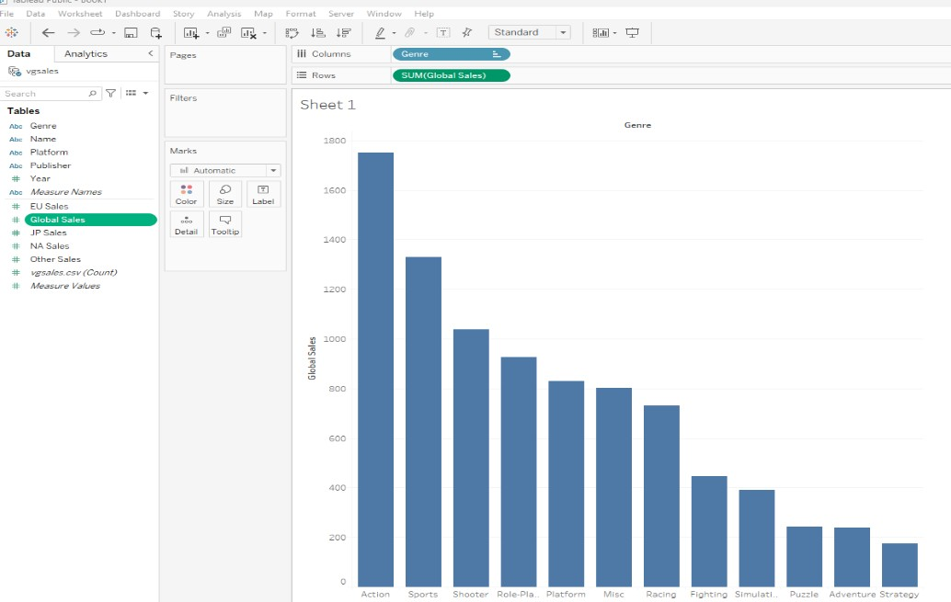**c. Filtering:**

* Drag Year to the Filters shelf.
* Choose the range of years you want to display (e.g., 2000-2016).
* Add Year to the Pages shelf to create a dynamic view of how sales changed over time.

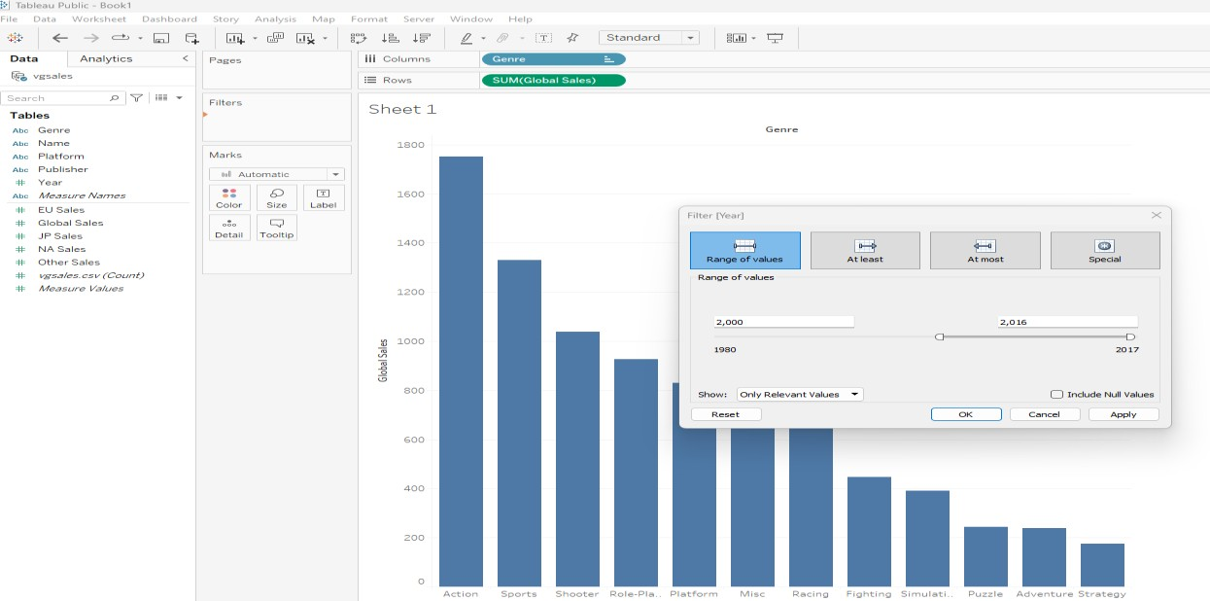

**4. Additional Functionalities:**

**Dashboards:** Combine different sheets to create a comprehensive dashboard. Go to the Dashboard tab, drag your created sheets to the layout, and arrange them accordingly.

**a. Add one more worksheet - Global Sales Trend by Year**

* Drag Year to the Columns.
* Drag Global_Sales to the Rows.
* Create a line chart to show how global sales have trended over time.
* Add Genere to the Marks
* Apply color to Genere

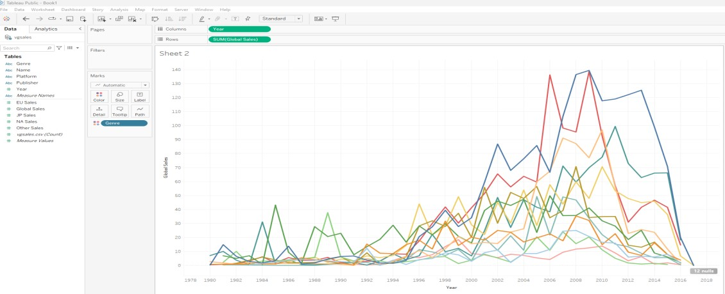

b. Go to the Dashboard tab in Tableau.

1. Add multiple visualizations to a single dashboard. (To increase dashboard size - select size-Automatic)
2. Arrange charts (e.g., a line chart for yearly sales, a bar chart for top genres, etc.).

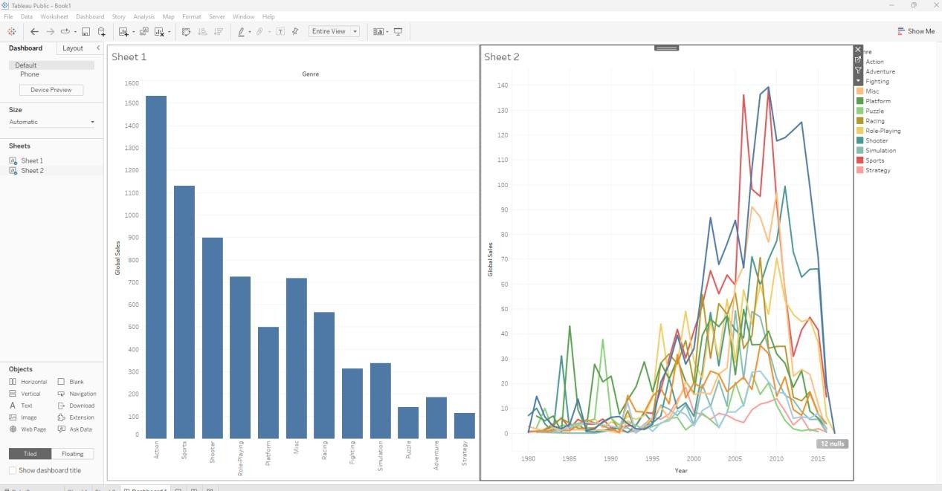

Reference Video Link -[https://www.youtube.com/watch?v=6xv1KvCMF1Q&list=PLUaB1hjhk8GwbqoVmo_5zuhOa0Tcl3xC&index=3](https://www.youtube.com/watch?v=6xv1KvCMF1Q&list=PLUaB-1hjhk8GwbqoVmo_5zuhOa0Tcl3xC&index=3)

**Program 2 :**

**Connecting to Data Source – Connecting to Database, Different types of Tableau Joins.**

Dataset used: Tableau Joins File: Contains 3 sheets : Demographics, Salary, Job Title

**1.Connecting to Excel Files in Tableau:**

* + Open Tableau and click on **Connect** in the left pane.
  + Under **To a File**, choose **Microsoft Excel**.
  + Browse and select your Excel file (Tableau Joins File.xlsx).
  + Tableau will display the sheets from the Excel file in the Data Source tab.
  + Drag the relevant sheets to the workspace.
  1. **Tableau Joins File.xlsx Dataset: has three Excel sheets**

**Demographics**:

* + EmployeeID
  + NameofEmployee
  + EmployeeAge•
  + EmployeeGender

**Salary:**

* + EmployeeID
  + EmployeeSalary

These sheets have a relationship based on the EmployeeID, and you can join them using this field.

Drag and drop Demographics table- Right click-select open- that allows you to do following types of joins.

Now Drag and drop Salary table - That allows you to do join of your choice.

* 1. **Types of Joins in Tableau:**

Once both tables are in the Data Source tab, Tableau automatically suggests an inner join, but you can modify the type of join depending on the scenario.

**a. Inner Join:**

* + **Description**: Returns only records where there is a match in both tables.
  + **How to Create in Tableau**:
  + Drag Demographics and Salary sheets into the canvas.
  + Tableau automatically detects the common field (EmployeeID). If not, manually select it.
  + Choose **Inner Join** in the **Join Type** options.
  + Result: You will see only employees whose employee id matches in both Demographics and Salary table.

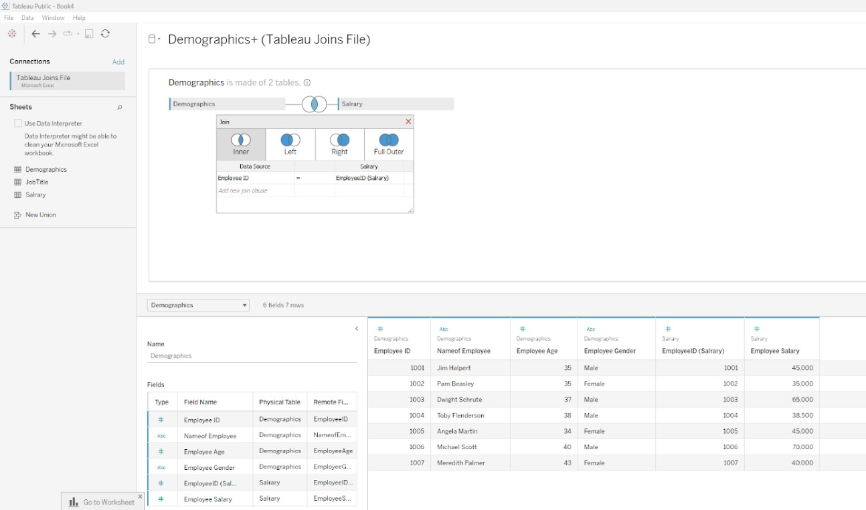

**b. Left Join:**

* + **Description**: Returns all records from the left table (Demographics), and matched records from the right table (salary). If there’s no match, NULL values are returned for fields from the right table.
  + **How to Create in Tableau**:
  + In the join settings, select **Left Join**.
  + Result: All employees will be returned, even if data missing in Salary. Salary information will be NULL for those without a match.

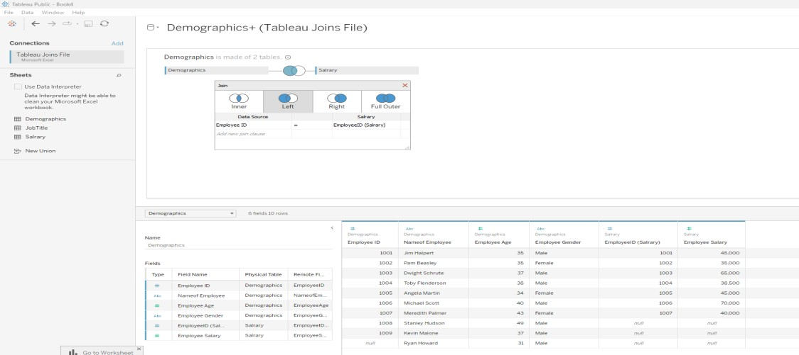

**c. Right Join:**

* + **Description**: Returns all records from the right table (Salary), and matched records from the left table (Demographics). If there’s no match, NULL values are returned for fields from the left table.
  + **How to Create in Tableau**:
  + Select **Right Join**.
  + Result: You will see all salary, even if they don't have employee id. Employee information will be NULL for those salary with no matching employee id.

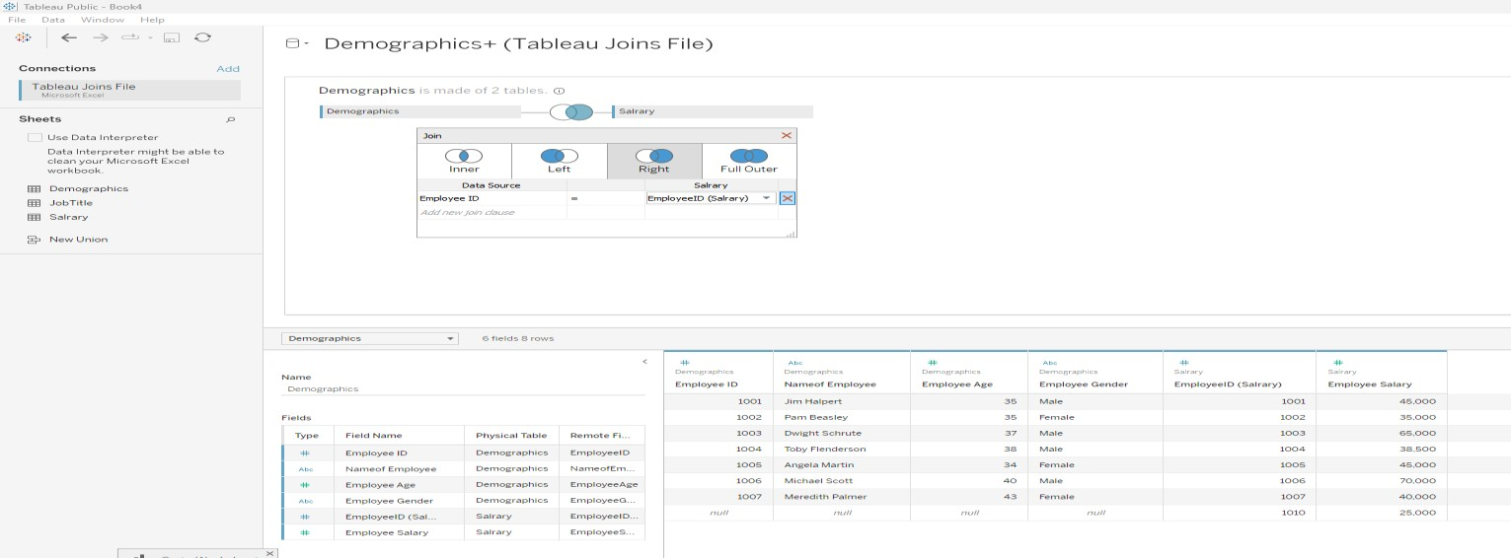

**d. Full Outer Join:**

* + **Description**: Returns all records when there is a match in either the left (Demographics) or right (Job Title) table. If there’s no match, NULL values are returned for the missing side.
  + **How to Create in Tableau**:
  + Select **Full Outer Join**.
  + Result: You will see all employees and all salary, even if they don’t have a match in the other table. NULL values will appear where there’s no corresponding record.

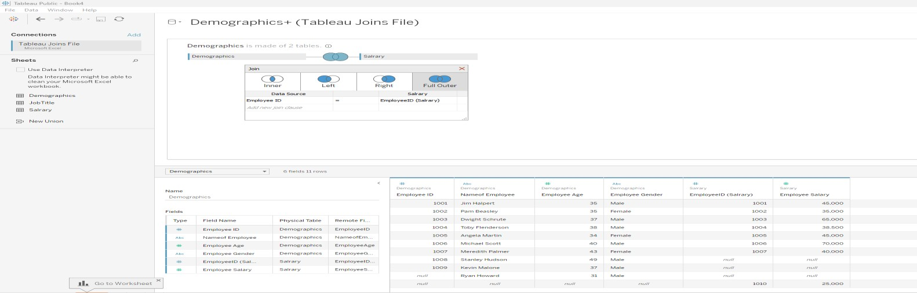

**4. Creating a Visualization Based on Joins:**

After performing the joins, you can build different visualizations.

Press on Sheet 1:

For example:

* **Bar Chart**: Number of employees and their salary.
* Drag NameofEmployee to **Columns**.
* Drag EmployeeSalary to **Rows.**
* This chart will display the number of employees and their salary based on the type of join.
* Sort it in decending
* Drag EmployeeSalary to Marks - Select colorColor, Label

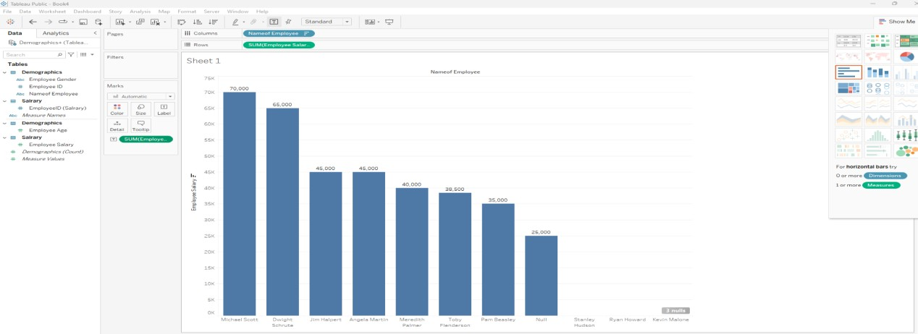

Reference Video Link -

[https://www.youtube.com/watch?v=A4SVUF-fTwc&list=PLUaB1hjhk8GwbqoVmo_5zuhOa0Tcl3xC&index=4](https://www.youtube.com/watch?v=A4SVUF-fTwc&list=PLUaB-1hjhk8GwbqoVmo_5zuhOa0Tcl3xC&index=4)

This same procedure we can do by connecting to any database server .

We should initially connect to driver by installing it for example if you are planning for mysql

* Install mysql driver connector as in link below.
* <https://dev.mysql.com/downloads/connector/odbc/>It is available in Drive Link also

[https://drive.google.com/drive/folders/1kG25wextZcEOsjfXdr5VcrwW3Dp53jBf?usp=drive_](https://drive.google.com/drive/folders/1kG25wextZcEOsjfXdr5VcrwW3Dp53jBf?usp=drive_link)

[link](https://drive.google.com/drive/folders/1kG25wextZcEOsjfXdr5VcrwW3Dp53jBf?usp=drive_link)

* After installing it we have to connect to Mysql.

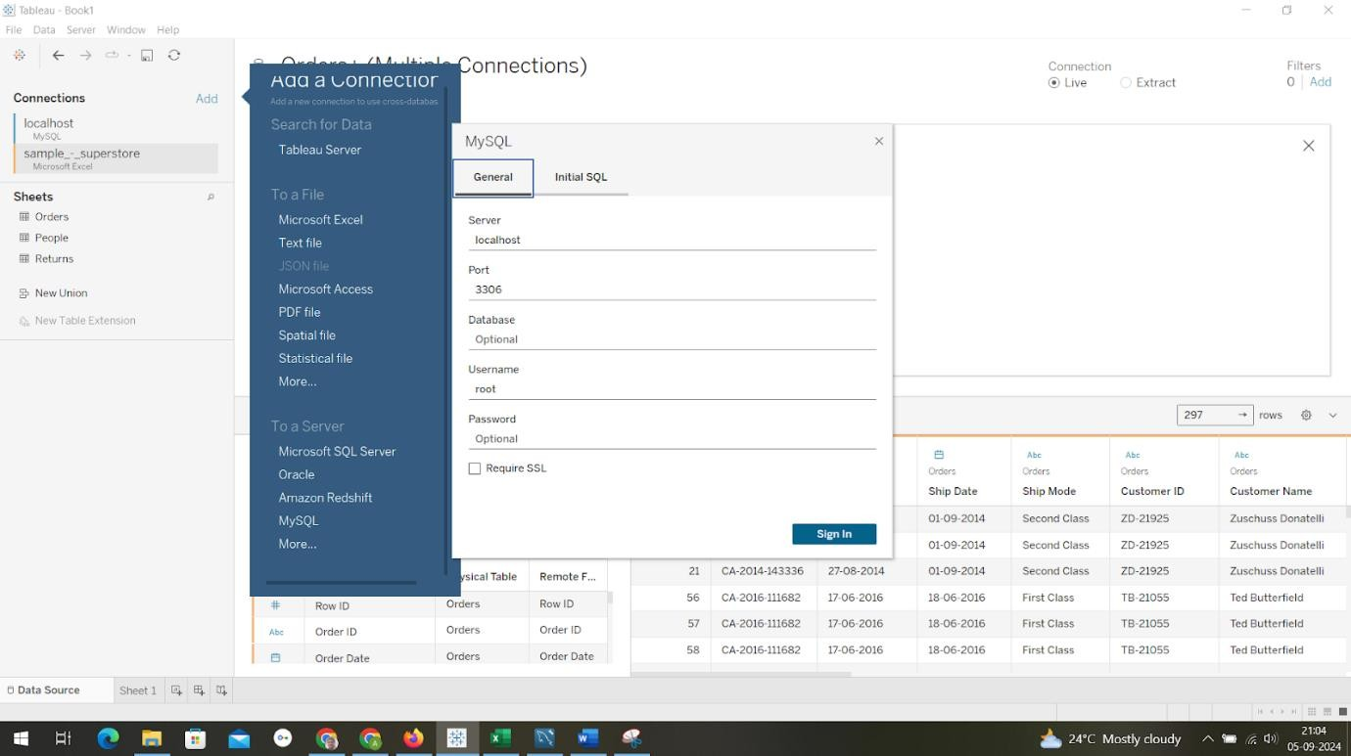

**For More Info :** Refer Tableau Handouts and Tableau Tutorial.

**Program 3:**

**Creating a View - formatting charts, adding filters, creating calculated fields and defining parameters**

**Step 1: Connect to Data**

* 1. Open Tableau Desktop.
  2. Connect to Your Data Source:

a)Click on Connect on the left sidebar.

b)Choose your data source by selecting text file and load your vgsales dataset into Tableau. **Step 2: Create a Basic Visualization**

* **Create a New Worksheet**:

a)Click on the Sheet tab at the bottom of the screen.

* **Drag Fields to Shelves**:
  + 1. Drag Year to the Columns shelf.
    2. Drag Global Sales to the Rows shelf.
    3. Drag EU Sales to the Rows shelf.

That gives the line graph visualization.

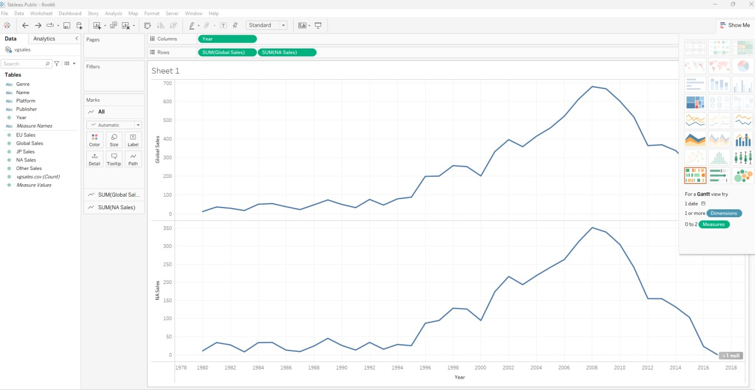

* **Change Visualization Type**:

In the Show Me panel on the right, select a bar chart or any other type that suits your needs.

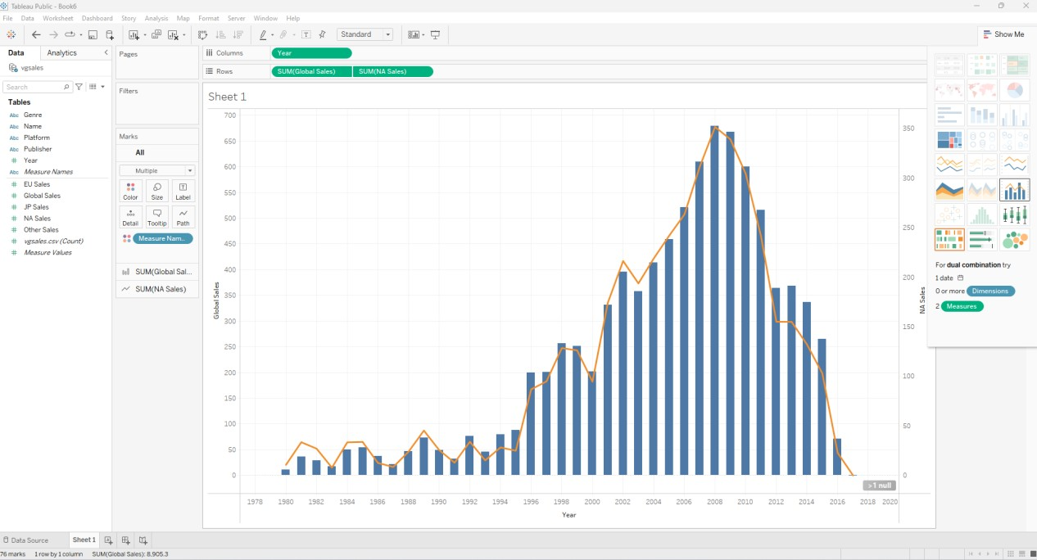

**Step 3: Format the Chart**

* **Format Axes**:

1. Right-click on the Global Sales axis and select Format.
2. In the Format pane, adjust the font style & size as needed.

* **Add Titles and Annotations**:
  1. Click on the chart title area and enter a descriptive title - Global Sales by Year.
  2. Add annotations if needed to highlight specific data points – Right click the on the chart which you want to highlight - Select Annotate - Select Mark - Press Ok

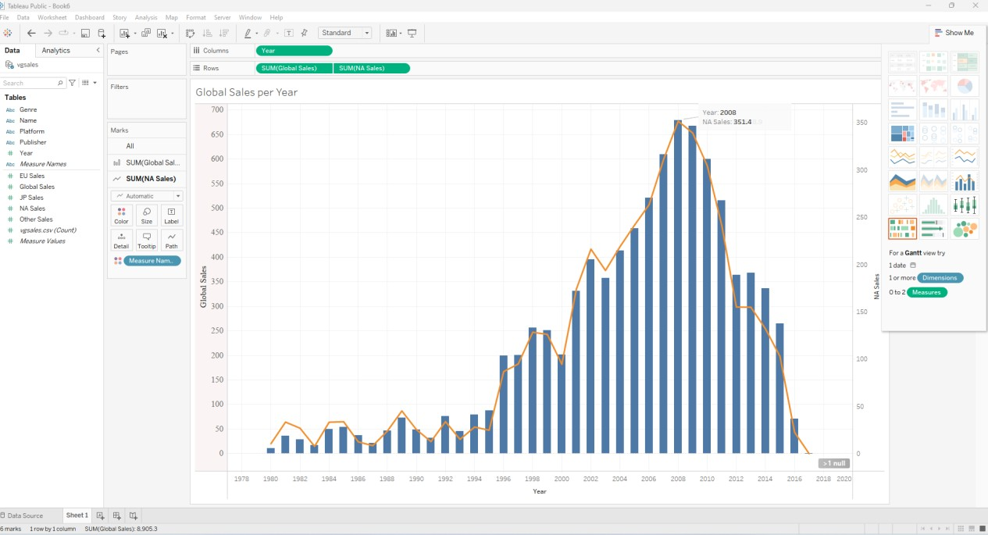

**Step 4: Add Filters**

**Add a Filter for Year**:

Drag Year to the Filters shelf.

Choose the range of years you want to display (e.g., 2000-2016).

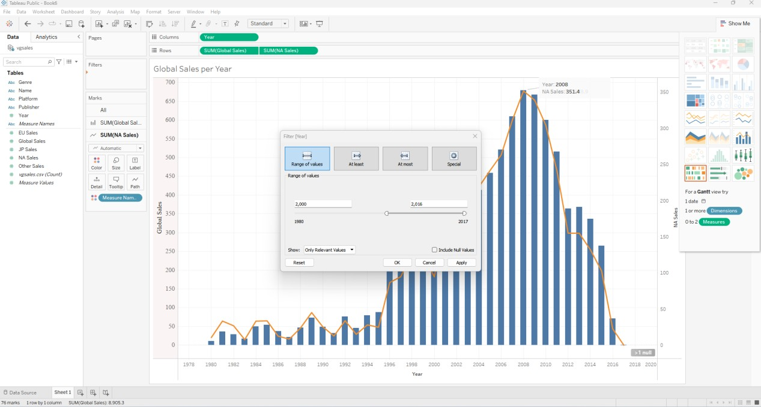

**Step 5: Create Calculated Fields**

* **Create a Calculated Field for Sales Category**:

1. Right-click on Global Sales - Select Create - Calculated Field.
2. Give name to your calculations as Global Sales - EU Sales
3. Do calculations as per your need - [Global Sales] - [EU Sales] d) Press Ok

**Add Calculated Fields to Visualization**:

a)Drag Global Sales-EU Sales to the Rows shelf to show Global Sales over Year with Global Sales-EU Sales over Year.

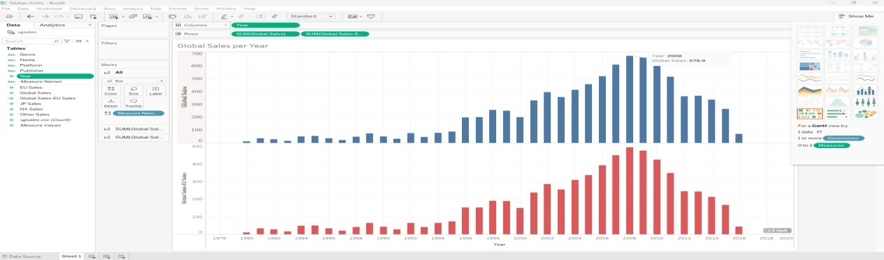

**Step 6: Create a Parameter**:

**Name**: "Select Genre"

* **Data Type**: String
* **Values**: List (e.g., "Action", "Adventure", "Shooter") or Add values from Genre.
* **Create a Calculated Field**:
* **Name**: "Sales by Genre"
* Formula: IF [Genre] = [Select Genre] THEN [Global Sales] ELSE 0 END
* **Build the Visualization**:
* **Columns**: Drag "Year".
* **Rows**: Drag "Sales by Genre".
* At the right side of your sheet you can select required Genre and can see different Visualization by Genre: Fighting

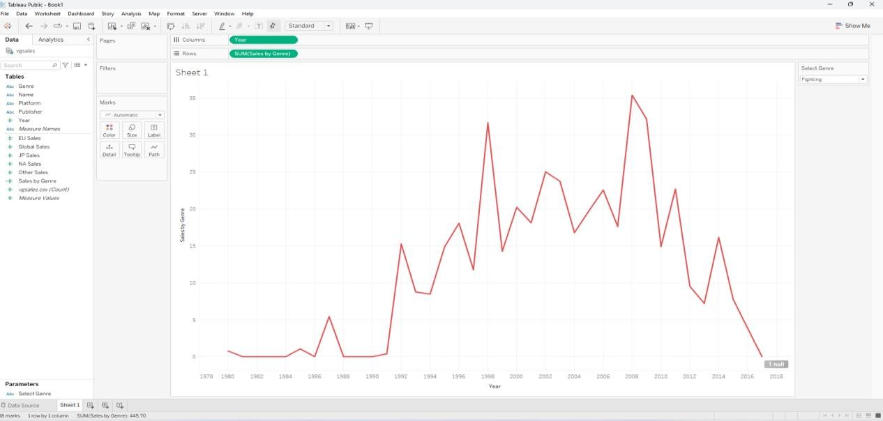

Visualization by Genre: Puzzle

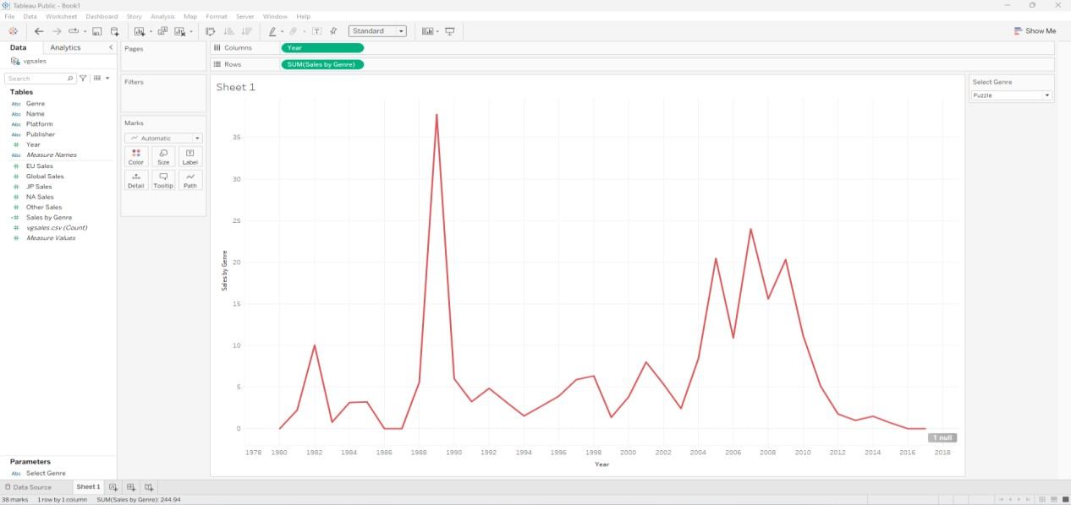

Reference Video Link -<https://www.youtube.com/watch?v=_n5saTnxeoE>

**Program 4:**

**Dashboard Design and Storytelling – Components of Dashboard, Understanding how to place worksheets in Containers, Action filters and its types.**

**CREATING A STORY WITH TABLEAU PUBLIC**

With Tableau public, you are able to organize your data in order to tell a meaningful story. This is beneficial when you are doing a presentation, creating an article, or uploading to a website, as it helps your audience understand your data.

Stories are created through assembling the different worksheets and dashboards. We can highlight important data points, add text box and pictures to help convey our story. However, there are many different ways to tell a story. For example, one technique is called “tailoring in” where the story starts with a big picture view and zooms in on a specific detail.

In contrast, a story can also be told by starting with a case and zooming out to that big picture view. We are going to return to our health expenditure worksheets to create a tailoring in story and illustrate the changes in Canada’s spending in a meaningful way.

To begin, select “New Story” at the bottom right of your screen.

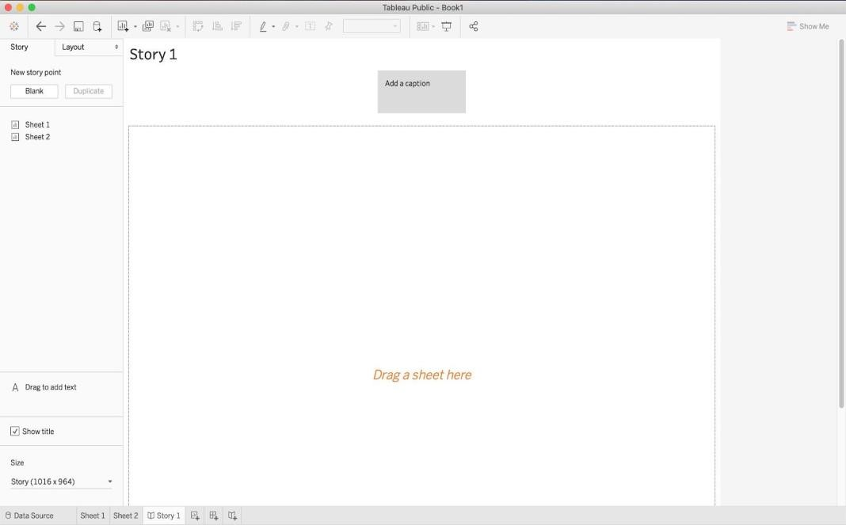

Drag “Sheet 1” and “Sheet 2” on to “Drag a sheet here”. We can rename each storyboard by clicking “Add a caption”. Rename Sheet 1 to “Provincial Health Expenditure in 2016”.

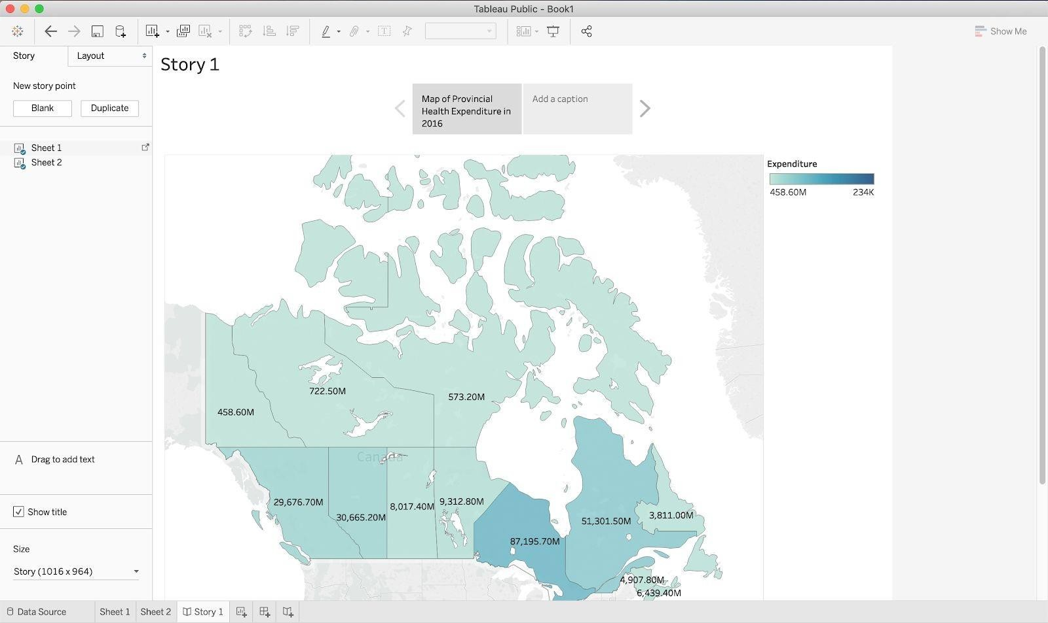

Use the arrows located on the side of the caption field to navigate to Sheet 2. Click on “Add a caption” and rename Sheet 2 to “Provincial Health Expenditure from 1975-2018”.

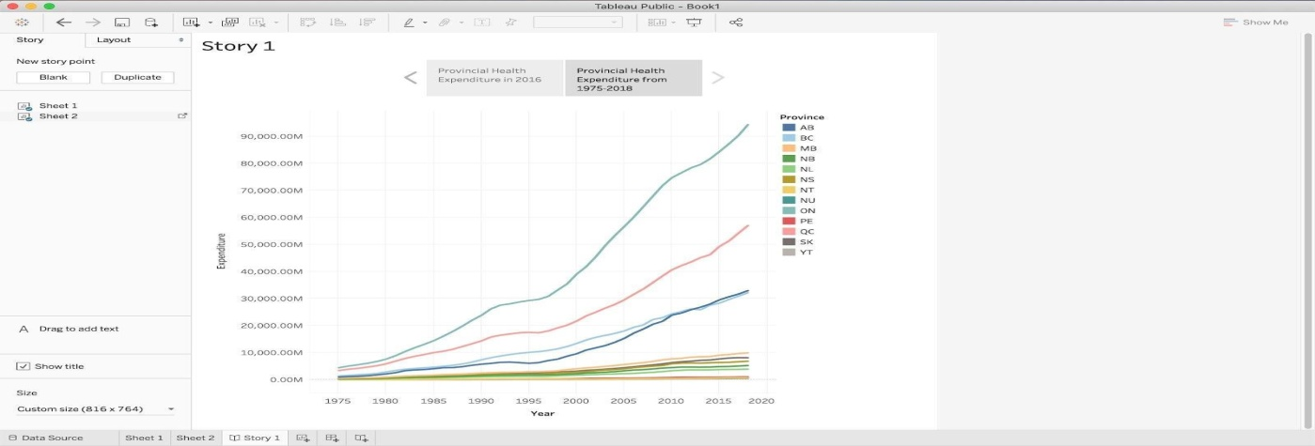

In this story, we are going to narrow in and draw attention to the province or territory that is spending the most amount of money on health. Drag an additional copy of “Sheet 1” and drop it between the two existing sheets. Select “Add a caption” and rename it to “Ontario”.

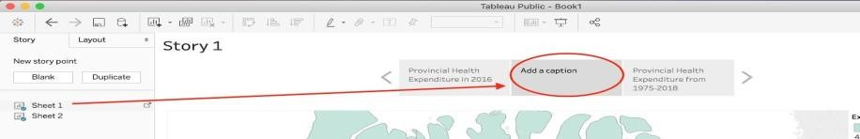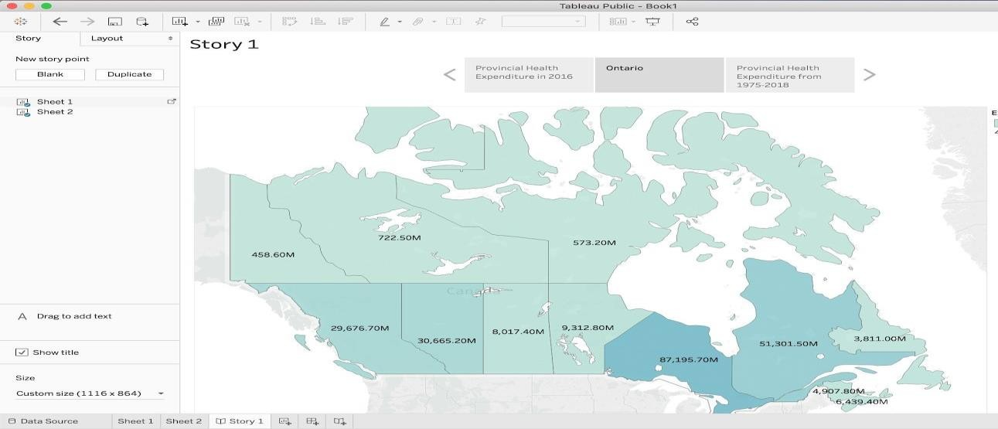

On the map, click on the province Ontario and then navigate to the caption field and select “Update”. Your screen will show Ontario highlighted from the rest of Canada

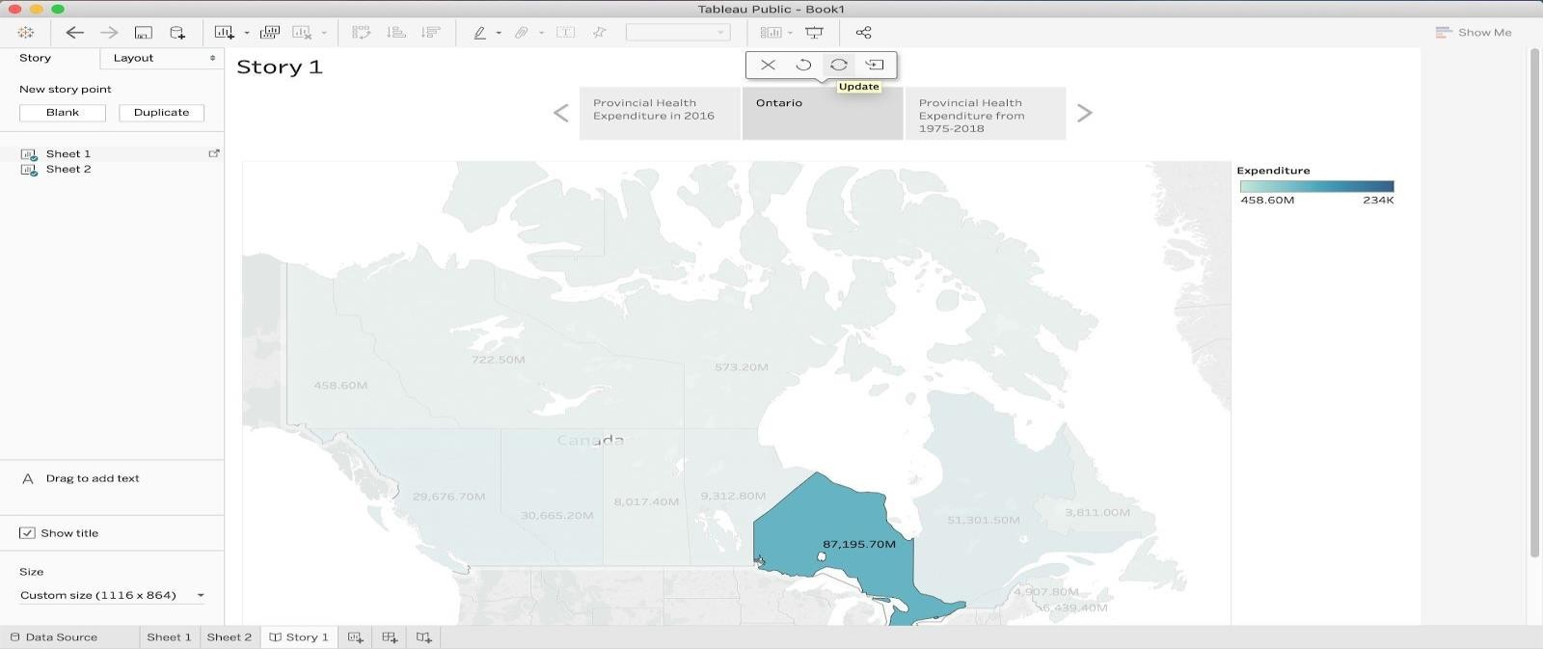

Select the right arrow to navigate to “Provincial Health Expenditure from 1975-2018”. Hover over the line representing Ontario and select the data point representing health expenditure during the year

2016. Then click “Update”. Your screen should look like this:

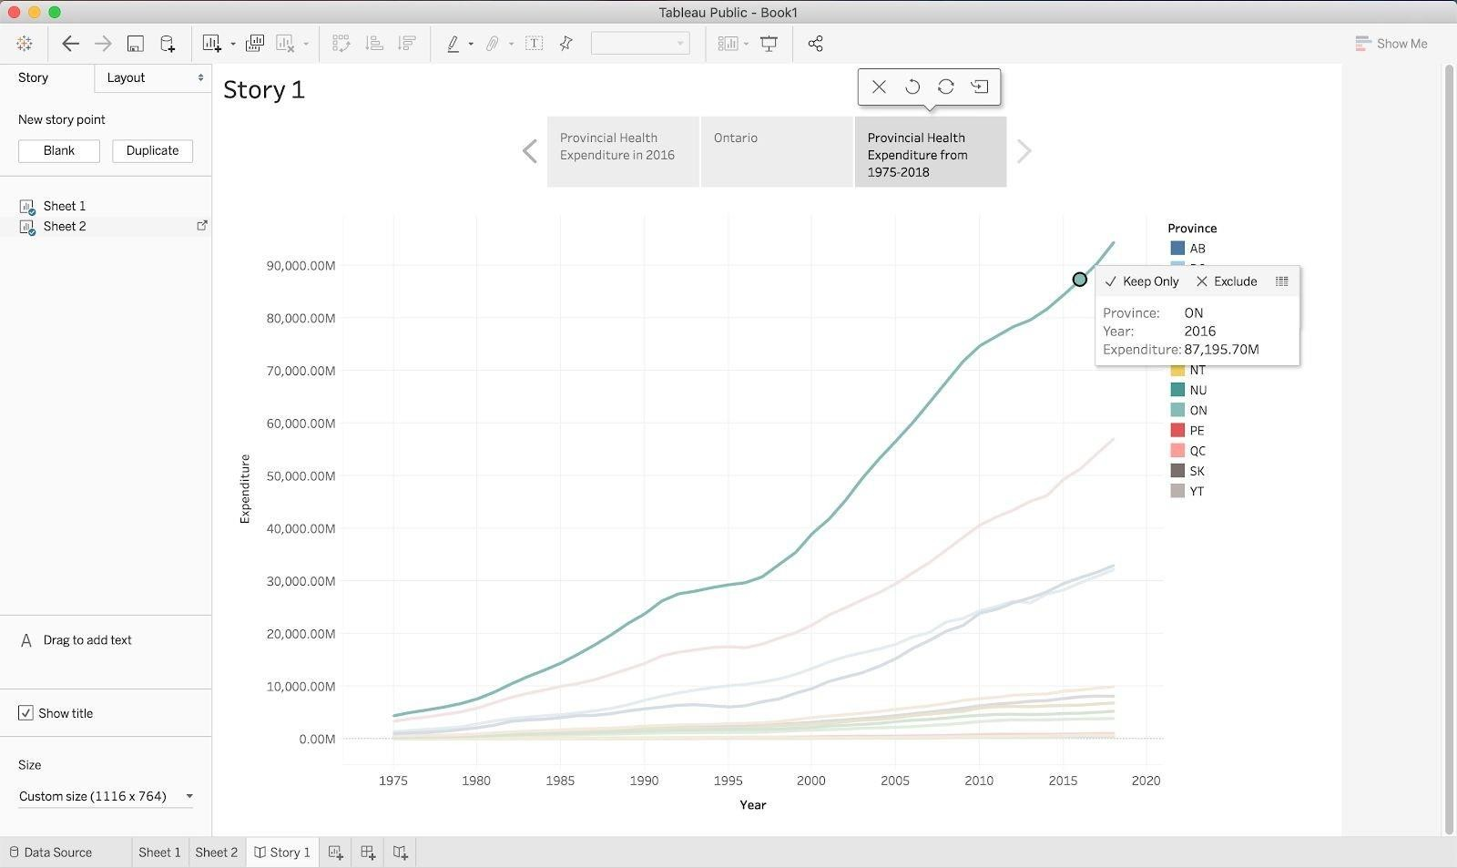

We can add a textbox to label the highlighted pointed by dragging “Drag to add text” on to the line graph. Write a key message in the textbox, such as “Ontario had the highest health expenditure in Canada in 2016, spending $87,195.70M”. Select “OK”.

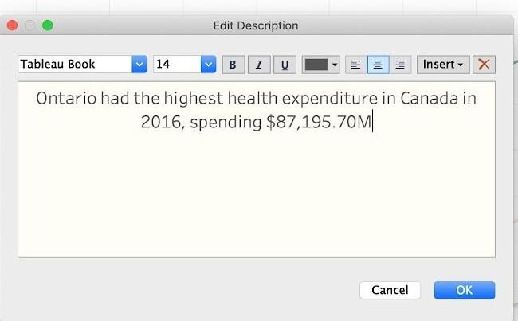

You can the edit the text box by selecting “More options” which will open a drop-down menu.

Expand the text box by dragging the borders in order to show the full message.

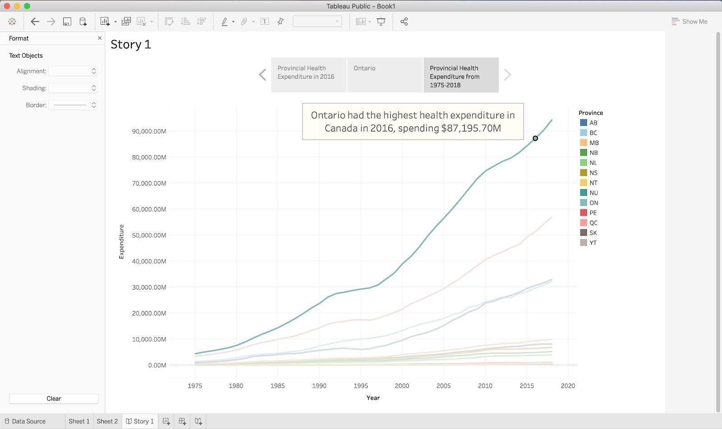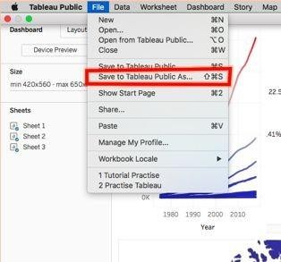

We have now created a story with three sheets of how Ontario had the highest health expenditure in the year 2016. If you choose to add a dashboard, it will allow your audience to play with data. You can navigate between the story as shown below:

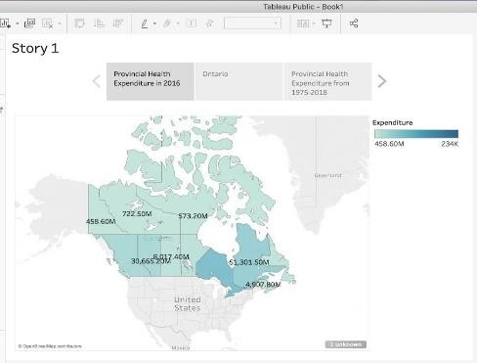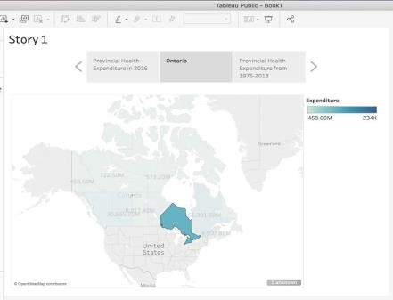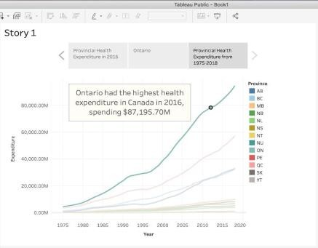

**Saving and publishing your tableau public workbook**

Once satisfied with your workbook, which includes sheets, dashboards, and stories, you can publish it to the Tableau Public website. This is the only way to save your work when using Tableau Public, so make sure to do it if you wish to return to the workbook in the future.

Once ready to publish, select the “Save to Tableau Public As…” option under the “File” tab.

**Creating a dashboard with tableau**

Dashboards are a great way to combine your data visualizations and have them interact with one another. A lot of businesses use dashboards to keep up-to-date in real time about key performance indicators at a glance. In this example, we will combine just two of our data visualizations, the map and the line graph from the first section of the tutorial, but in reality, it can be used to combine many visualizations at once.

The first step in creating your dashboard is to open up the Dashboard tab at the bottom of the screen:

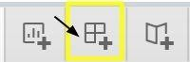

After clicking this icon, your screen should open to this:

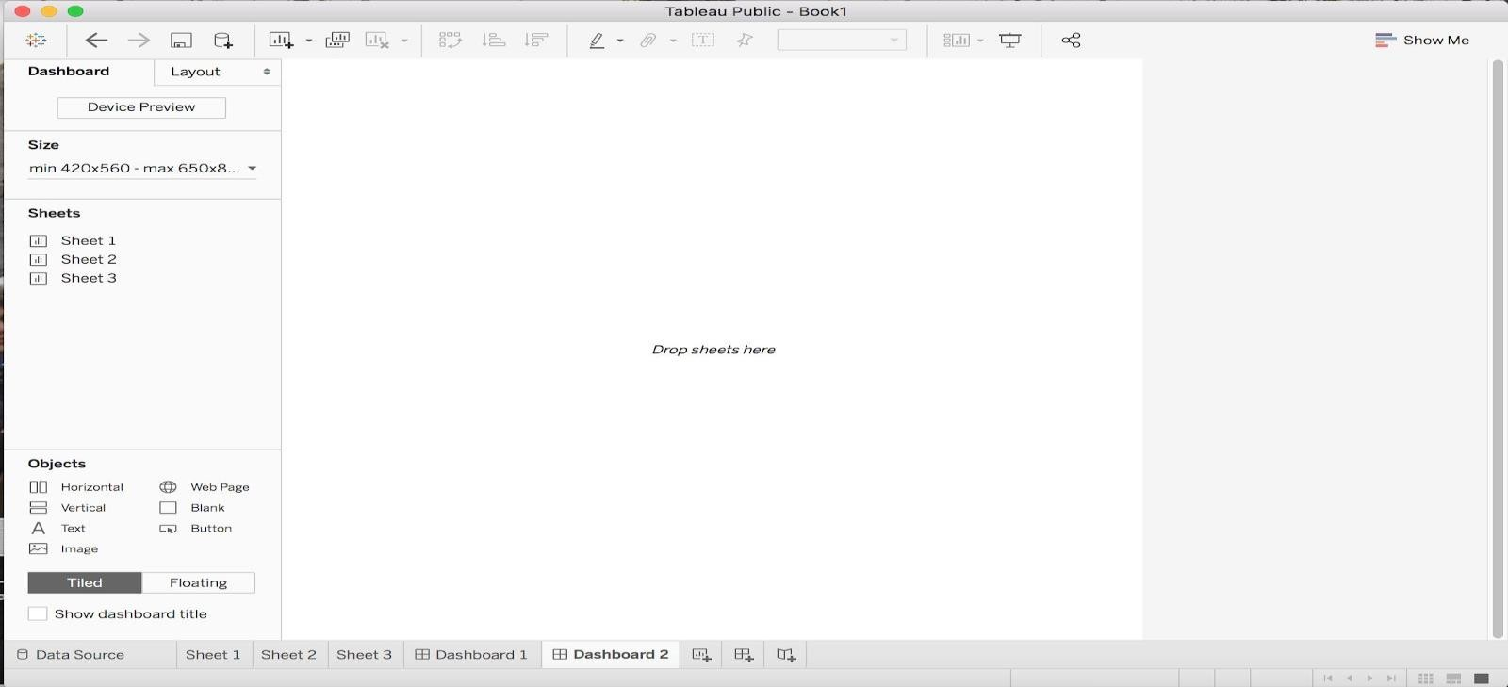

This is your Dashboard Sheet. On the left side you can see that there is a list of the sheets you have made from your current data source.

To build your dashboard, drag the sheet you want in to the center where it says *Drop sheets here.*

For our purposes, we will need to drag Sheet 1 and Sheet 2 where the map and line graph are saved. When you drag, you will notice an area of your screen will shade over where your graph will drop when you put it down. Organize your dashboard to look like the following:

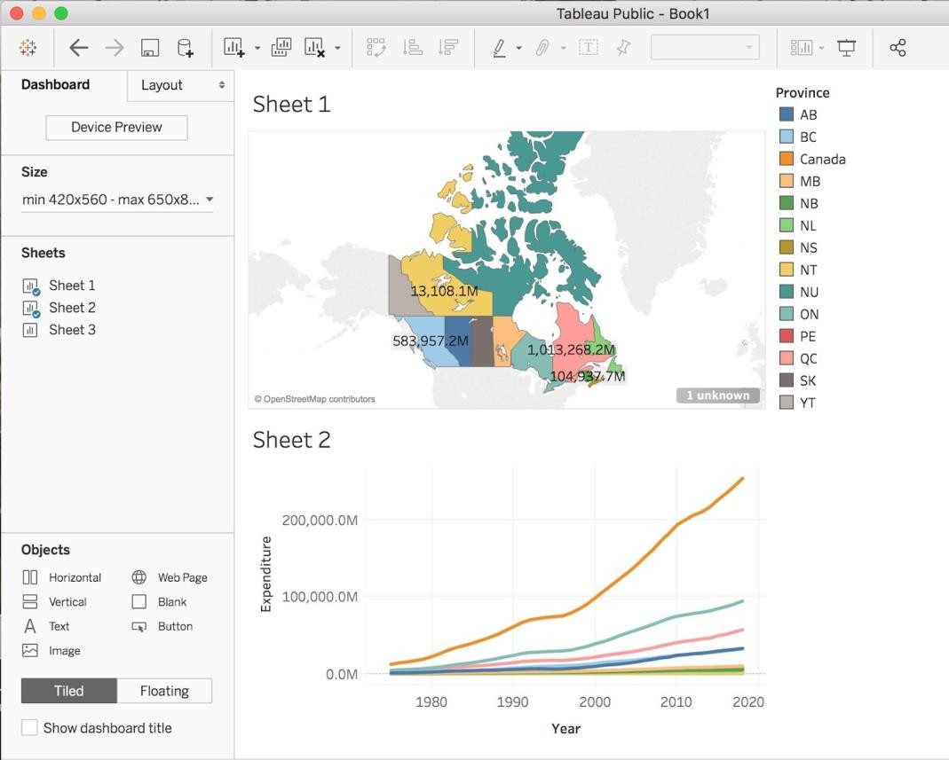

Now to add titles to the graphs that were chosen, double click on the automatic titles generated based on the sheet name, and a new window should appear, type in a title that describes the graph like so:

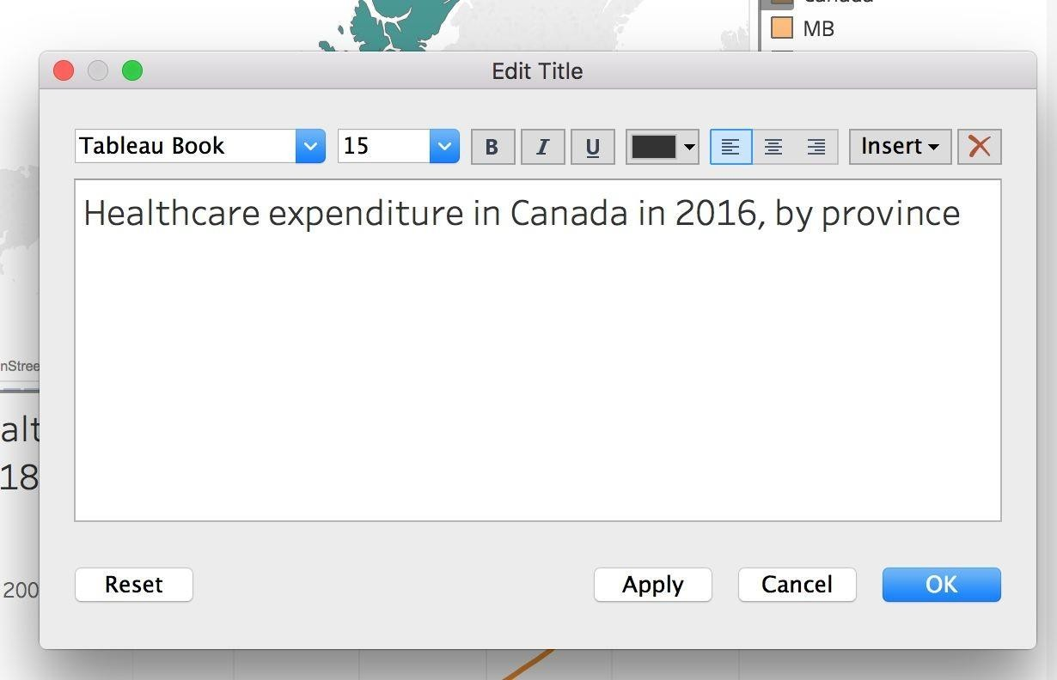

We can also add additional titles and objects to the dashboard by choosing an object from the Objects side panel and dragging it to the dashboard. We are going to add titles to the bottom line graph to differentiate between the Canada line and the provinces. To do this, drag

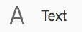to the area near the orange line that corresponds to the sum of all provinces

expenditure throughout the years. Type in “Canada”. Drag

once more to label the remaining provinces. Your bottom graph should look like this:

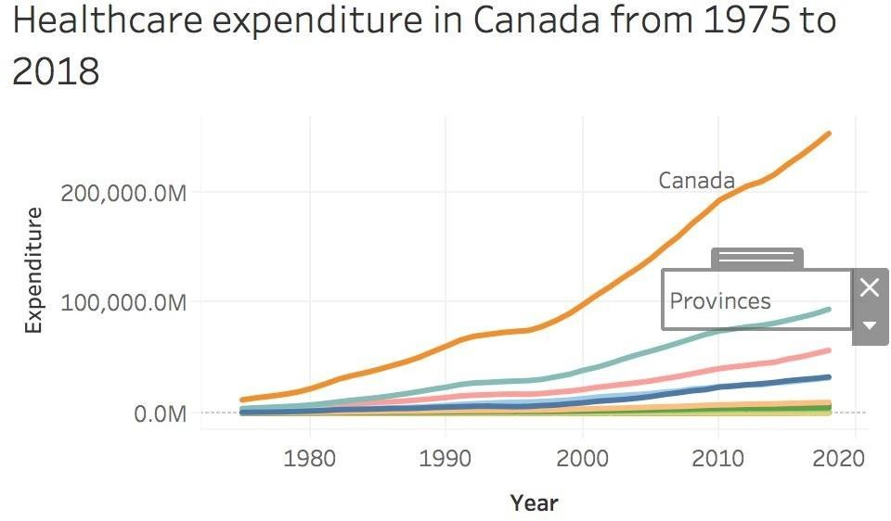

Now, to add an interactive layer between the graphs, we can choose a graph that can act as a filter to the other. We will choose the line graph to act as a filter to the map. To do this, click on the line graph and a grey sidebar should appear. From this bar, click the filter icon to use this graph as a filter:

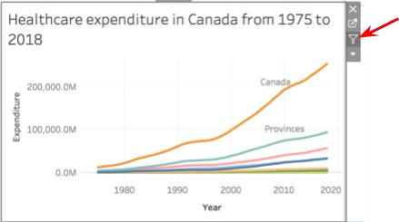

Now, when you click a given line, it will be highlighted on the above map:

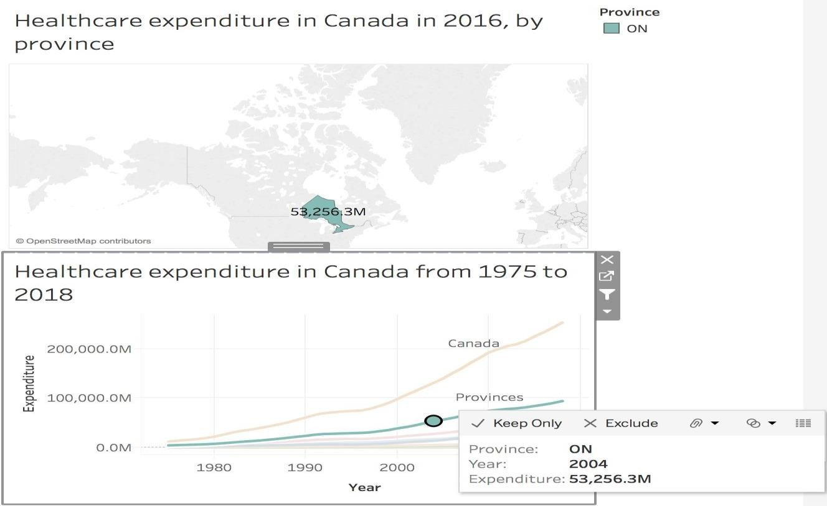

Congrats, now you have an interactive dashboard that is ready to be published or saved!

## Program 5 :

**Introducing Power BI –Components and the flow of work. Power BI Desktop Interface-The Report has five main areas.**

**Solution :**

**Power BI includes the following components** −

* **Power BI Desktop** − This is used to create reports and data visualizations on the dataset.
* **Power BI Gateway** − You can use Power BI on-premises gateway to keep your data fresh by connecting to your on-premises data sources without the need to move the data. It allows you to query large datasets and benefit from the existing investments.
* **Power BI Mobile Apps** − Using Power BI mobile apps, you can stay connected to their data from anywhere. Power BI apps are available for Windows, iOS, and Android platform.
* **Power BI Service** − This is a cloud service and is used to publish Power BI reports and data visualizations

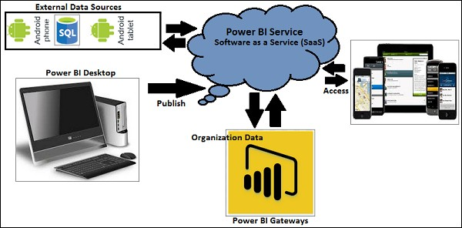

**Fig 1 : The Components of Power BI**

**Flow of work**

* A typical Power BI workflow involves more than one type of content.
* A Power BI designer (yellow in the diagram) collects data from semantic models, brings it into Power BI Desktop for analysis, and creates reports full of visualizations that highlight interesting facts and insights.
* The designer pins visualizations from reports to dashboards, and shares the reports and dashboards with business users like you (black in the diagram).

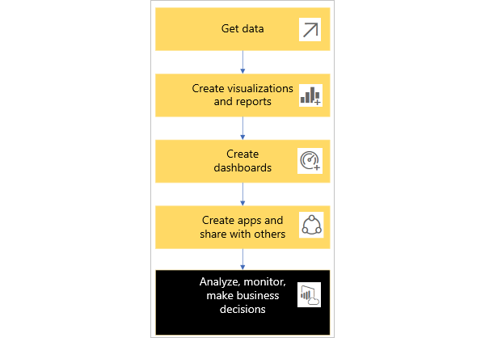

**Fig 2: Flow of work**

* 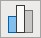 A visualization (or visual), is a type of chart built by Power BI designers. The visuals display the data from reports and semantic models. Because they're highly interactive, you can slice, filter, highlight, change, and even drill into visualizations.
*  A semantic model is a container of data. For example, it might be an Excel file from the World Health Organization. It might also be a company-owned database of customers, or it might be a Salesforce file. And it might be all three if the designer combines them into a single model. Designers manage semantic models. The data contained in semantic models is used to build reports, dashboards, and apps that designers share with you.
*  A dashboard is a single screen with tiles of interactive visuals, text, and graphics. A dashboard collects your most important metrics, or a focused set of metrics, on one screen, to tell a story or answer a question. The dashboard content comes from one or more reports and one or more semantic models.
*  A report is one or more pages of interactive visuals, text, and graphics that together make up a single report. Power BI bases a report on a single semantic model. Often, the designer organizes report pages to each address a central area of interest or answer a single question.
*  An app is a way for designers to bundle and share related dashboards, reports, and semantic models together. Business users receive some apps automatically but can go search for other apps created by colleagues or by the community. For example, out-of the-box apps are available for external services you may already use, like Google Analytics and Microsoft Dynamics CRM**.**

**Power BI Desktop Interface-**

The Report has five main areas.

**Downloading and Installing Power BI Desktop**

Power BI Desktop is available in both 32-bit and 64-bit versions. To download the latest version, you can use the following link –

### The Steps to be followed

1.**Download from the link** [**https://www.microsoft.com/en-us/power-platform/products/power-bi/downloads**](https://www.microsoft.com/en-us/power-platform/products/power-bi/downloads)

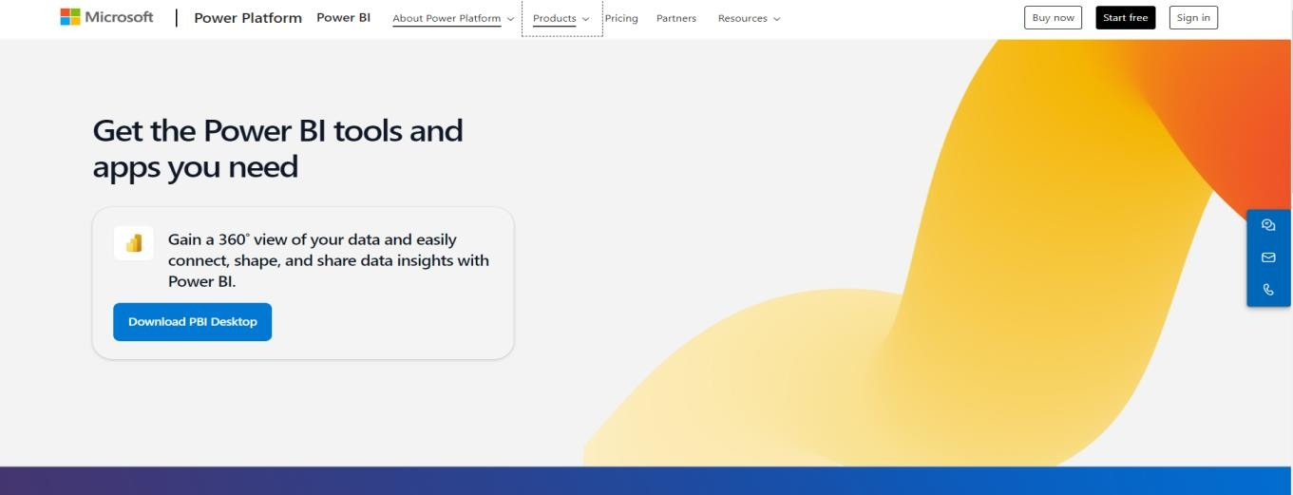

### 2.Click on Products- Power BI-- Desktop

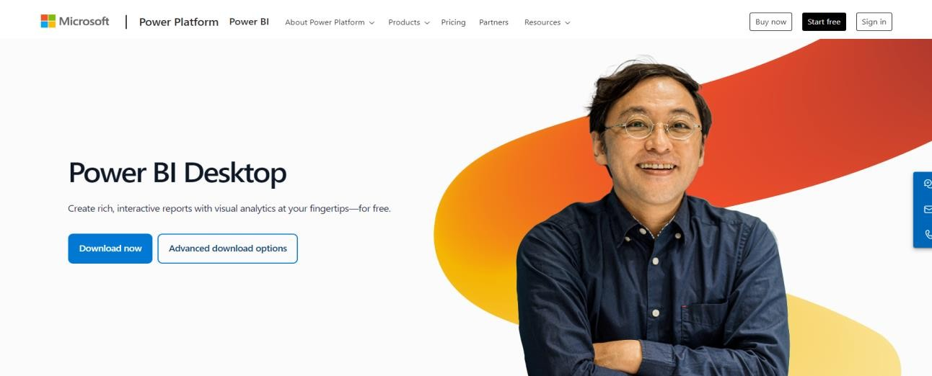

### 3.Click on Advanced Download option

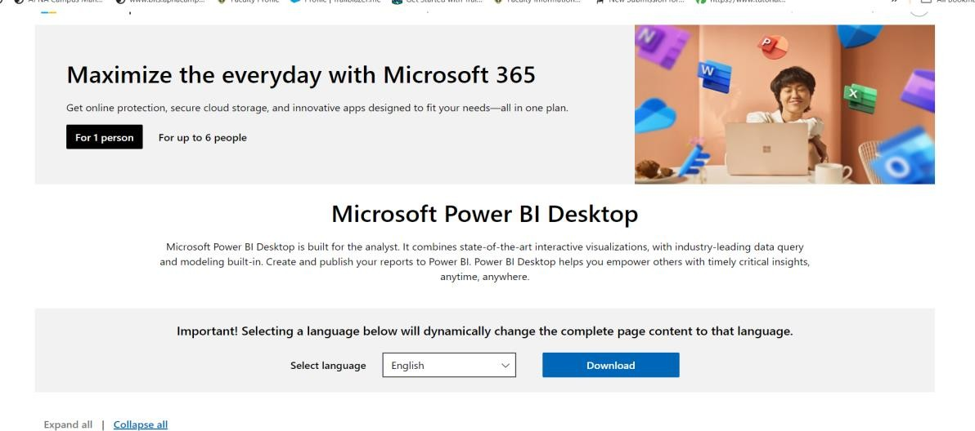

1. **Select the Language as English and Click on download , choose PBIDEsktopSetup_x64.exe**

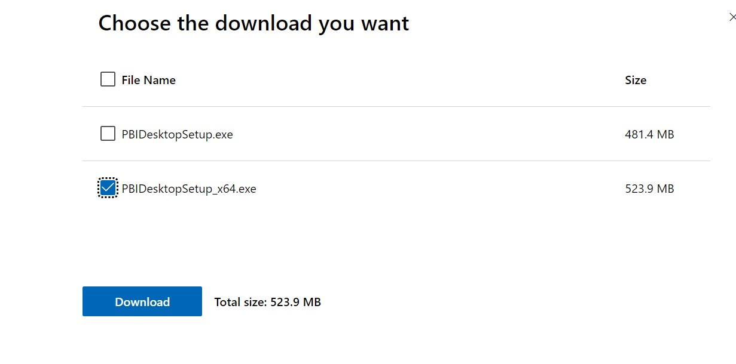

1. **Download Begins and you will get exe file which will be downloaded in your downloads folder**
2. **Double click on the .exe file ,to get the installation wizard**

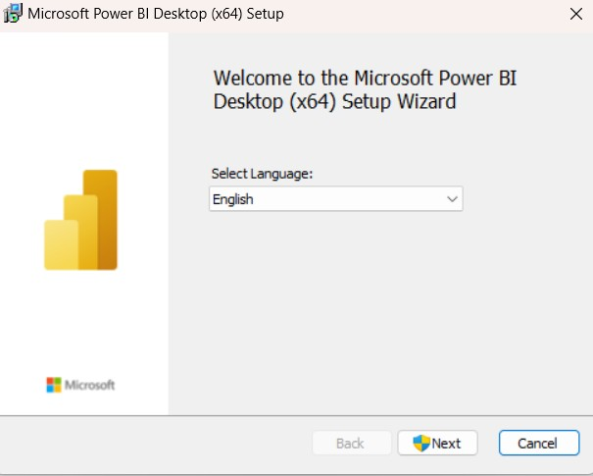

1. **Click on Next button until you get Finish button and finally installation will be done.**
2. **Once the Installation is done ,double click on Power BI App.**

**The screen appears as below**

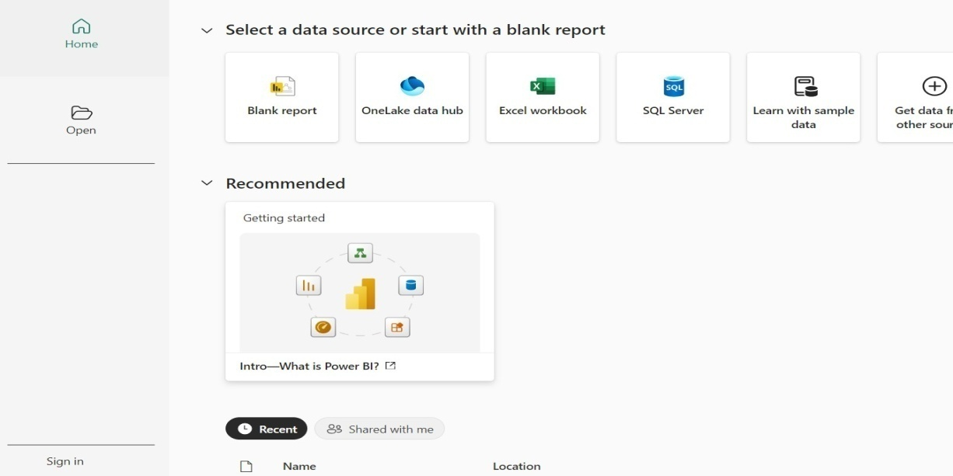

**9. When you launch the application, Power BI Desktop will start with a blank report. Let's go over the components of the Power BI Desktop Interface**

* **Ribbon** - the top ribbon contains most of the controls and options needed for building the report.
* **Views** - this is made up of the report view, the data view, and the model view.
* **Canvas** - this is the main design area where visualizations and other elements are added.
* **Page selector** - for navigation to other pages in the report.
* **Filters** - fields can be added here to filter the data.
* **Visualizations** - this contains the list of available visualizations.
* **Fields** - this section contains the tables and fields that are available in the data model.

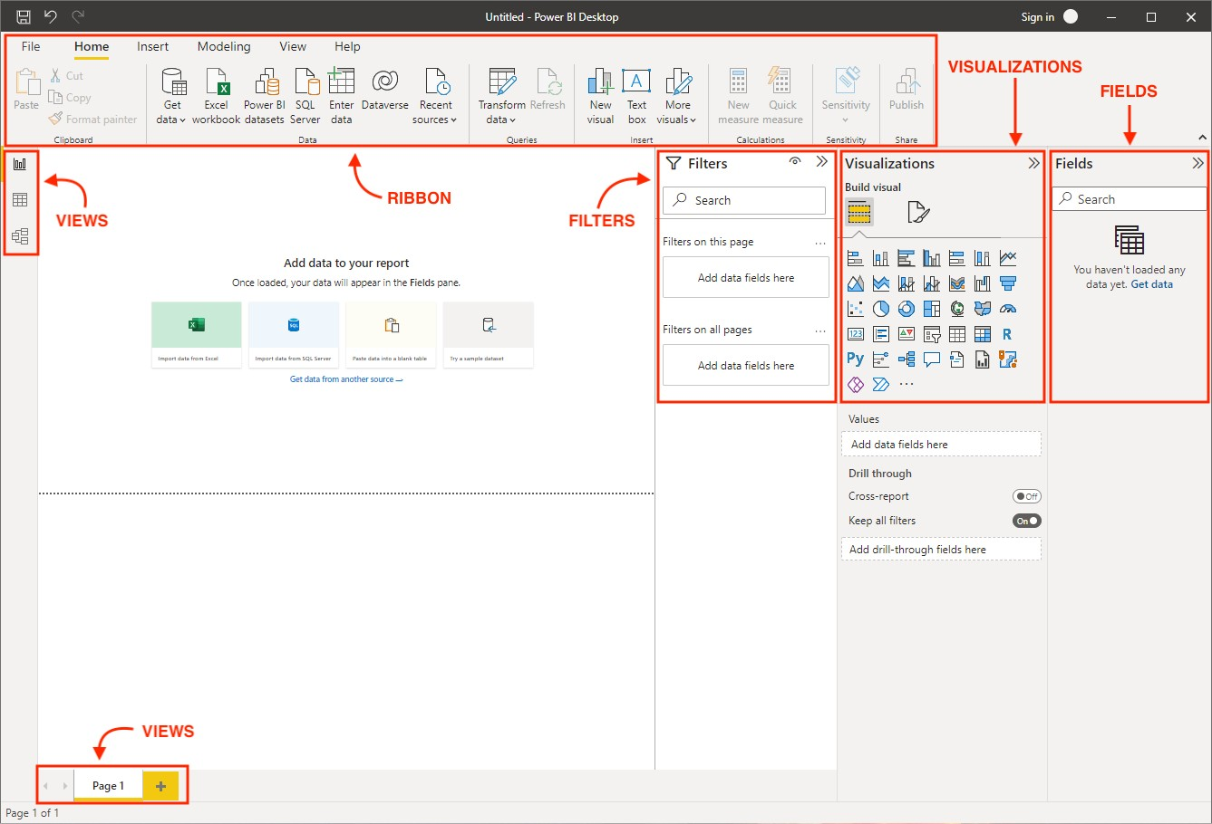

The Major Components of Power BI Desktop Interface are

**Power Query Editor**

It is the process of cleansing and transforming data and permits users to access datasets connecting from multiple sources. It is included on the Power BI desktop. Business users may view the data from distinct databases like MySQL, SQL servers, DB2, and many more.

**Power View**

It is a data visualization tool that assists users in developing stunning charts, and colourful maps, that turn data into a story.

**Power Map**

It is a 3D map visualization tool to identify geospatial data on Map visuals. It helps organizations to examine the maximum sales production geographically, visualizing the demographic populations of specific regions.

**Power Pivot**

It is a Data Modelling technique that is used to create relationships between datasets. It performs complex computations by utilizing DAX functions.

**Power Q & A**

When dealing with giant datasets, it becomes crucial to get to know the in-depth details of the data. Luckily, it is done through natural language where users may ask questions and obtain the answer through Power Q & A.

**Build reports:**

**In Power BI Desktop Report view, you can build visualizations and reports. The Report view has six main areas**:

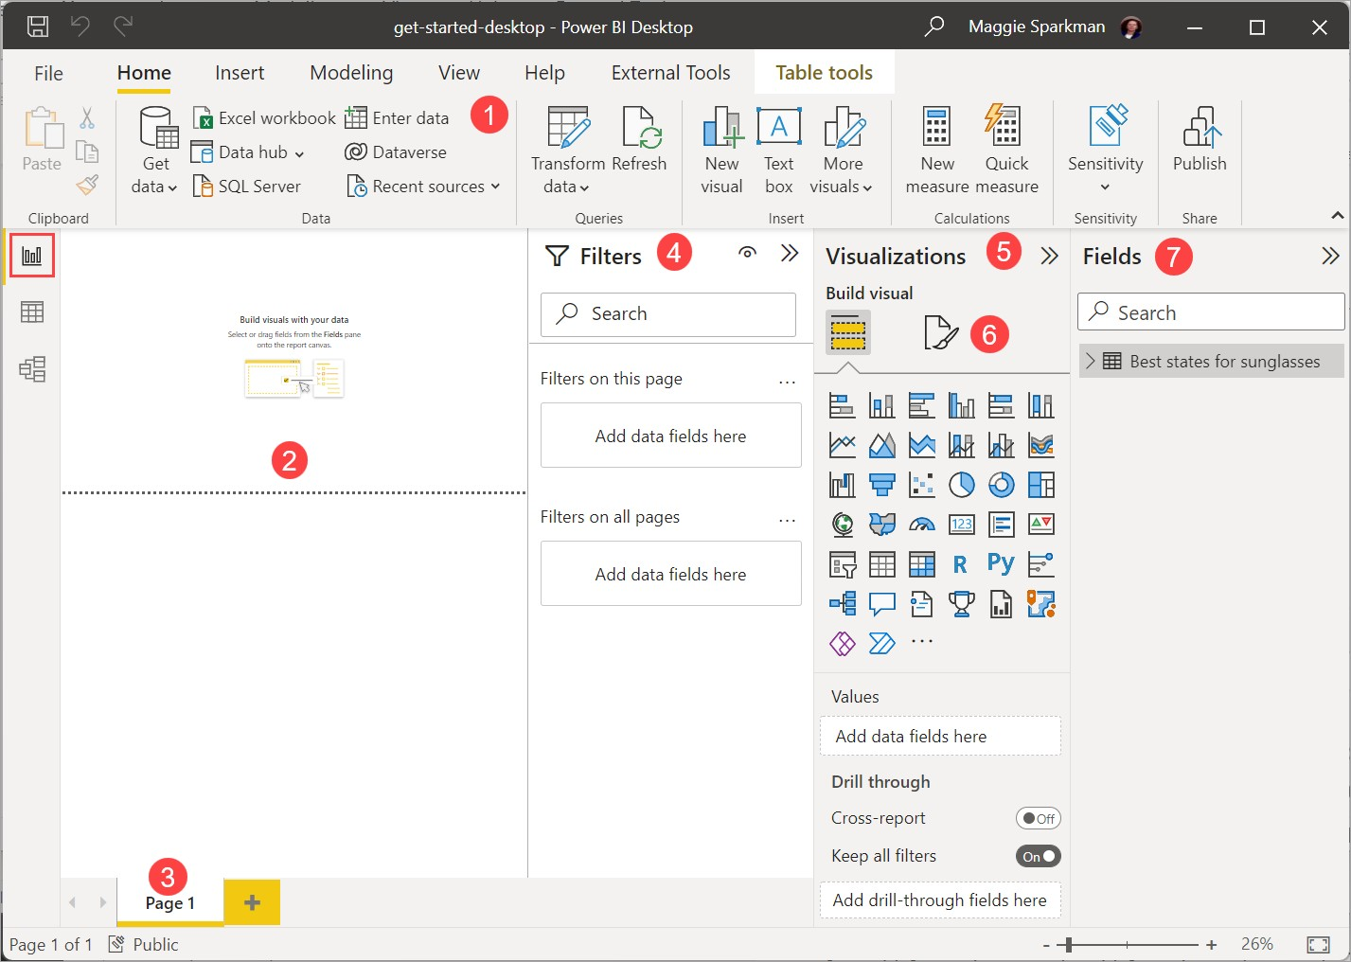

1. The ribbon at the top, which displays common tasks associated with reports and visualizations.
2. The canvas area in the middle, where you create and arrange visualizations.
3. The pages tab area at the bottom, which lets you select or add report pages.
4. The Filters pane, where you can filter data visualizations.
5. The Visualizations pane, where you can add, change, or customize visualizations, and apply drill through.
6. The Format pane, where you design the report and visualizations.
7. The Fields pane, which shows the available fields in your queries. You can drag these fields onto the canvas, the Filters pane, or the Visualizations pane to create or modify visualizations.

**Program 6 :**

**Querying Data from CSV - Query Editor, Connecting the data from the Excel Source, Clean, Transform the data.**

**Solution:**

Power BI Desktop also includes the Power Query Editor, which opens in a separate window. In Power Query Editor, you can build queries and transform data, then load the refined data model into Power BI Desktop to create reports**.**

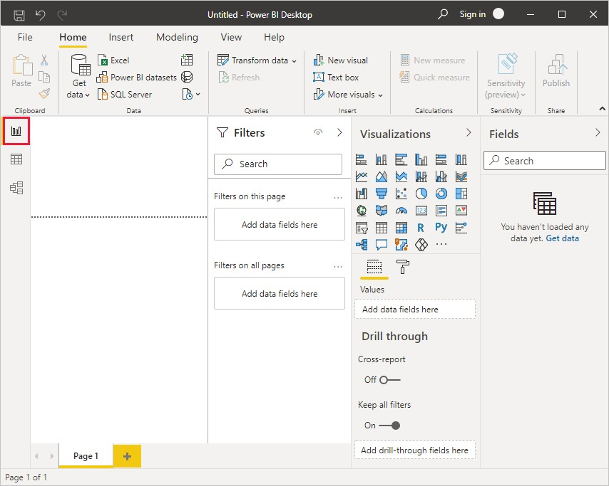

Along the left side of Power BI Desktop are icons for the three Power BI Desktop views:

Report,Data, and Model, from top to bottom. The current view is indicated by the yellow bar along the left, and you can change views by selecting any of the icons.

**Report view is the default view.**

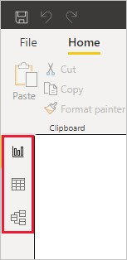

**Connect to data (Get Data from different Sources)**

With Power BI Desktop installed, we can connect to the world of data. To see the many types of data sources available,

**Once Power BI screen is seen click on blank Report**

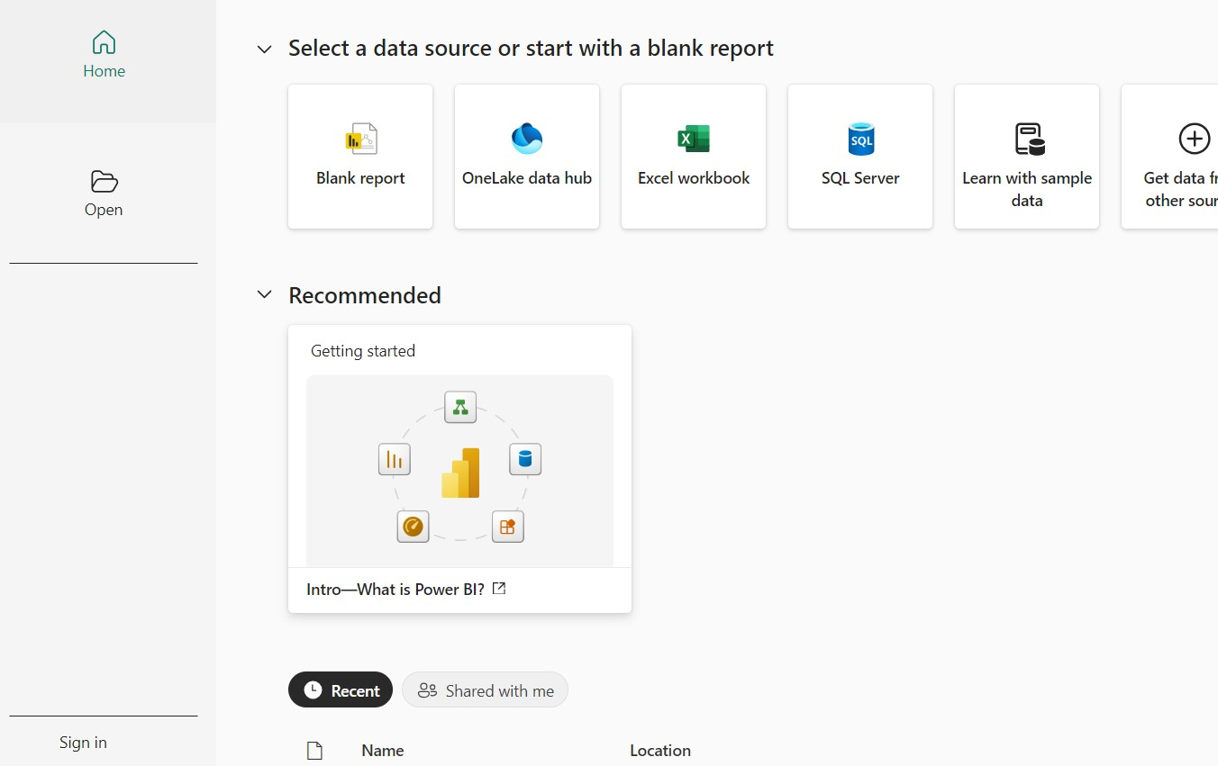

After clicking on blank Report the below screen appears .

**NOW TO GET DATA FROM DIFFERENT SOURCES ------**

**The steps**

**Step 1 :** Select **Get Data** in the Power BI Desktop Home tab, and in the Get Data window, scroll through the list of All data sources.(like Excel, CSV, Oracle….)

On the Power BI Desktop Home tab, select Get Data > Excel workbook

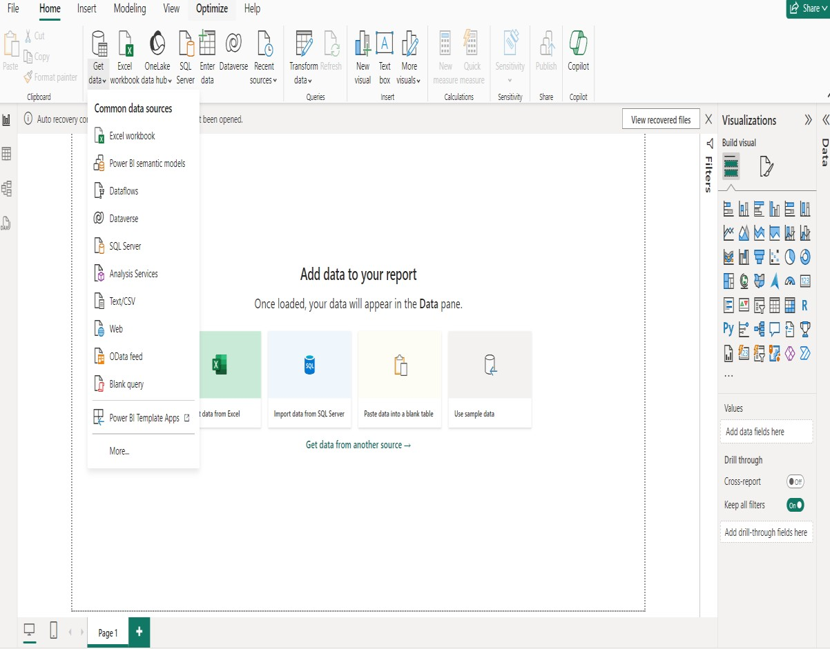

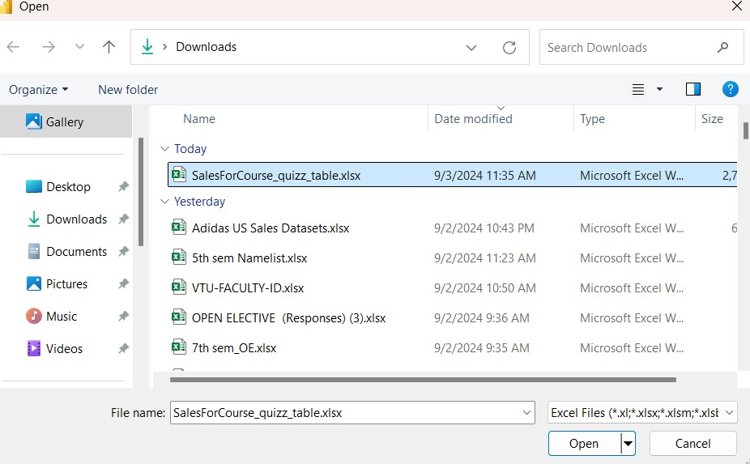

1. Click on the file you need and open the file ,once you open the file below window with navigator appears ,select the file (2nd option to see the contents of the file)

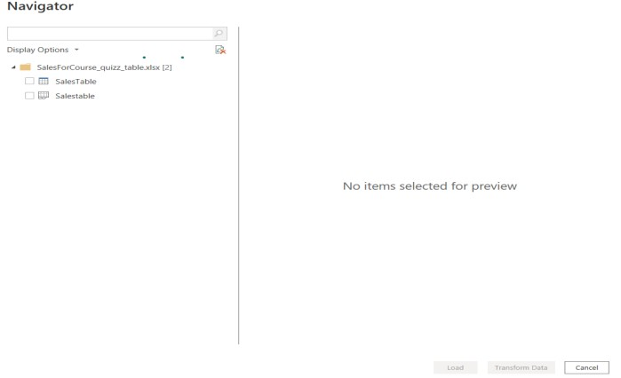

3. At this point you can select Load to load the table, or Transform data to make changes in the table before you load it.

4.When you select Transform data, Power Query Editor launches, with a representative view of the table. The Query Settings pane is on the right, or you can always show it by selecting Query Settings on the View tab of Power Query Editor.

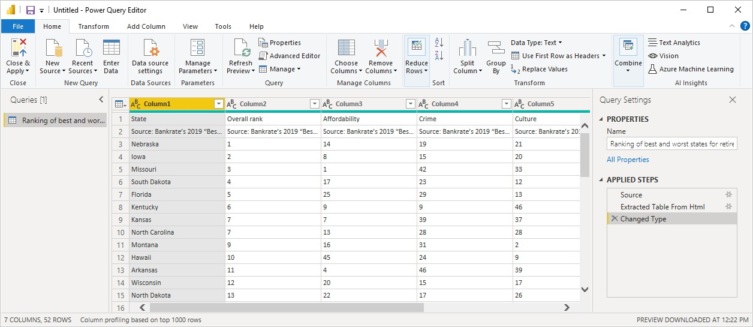

**Transforming the data**

Once connected to a data source, you can adjust the data to meet your needs.

To transform the data, you provide Power Query Editor with step-by-step instructions for adjusting the data while loading and presenting it.Transforming doesn't affect the original data source, only this particular view of the data.

Transforming the data, includes **renaming columns or tables, removing rows or columns, or changing data types.**

Power Query Editor captures these steps sequentially under Applied Steps in the Query Settings pane.

Notice that the Applied Steps in Query Settings already contain a few steps. You can select each step to see its effect in the Power Query Editor

**To Change a data type**

* Select the column or columns to change.
* Hold down the Shift key to select several adjacent columns, or Ctrl to select nonadjacent columns.
* Either right-click a column header, select Change Type,
* choose a new data type from the menu, or drop down the list next to Data Type in the Transform group of the Home tab,
* select a new data type.

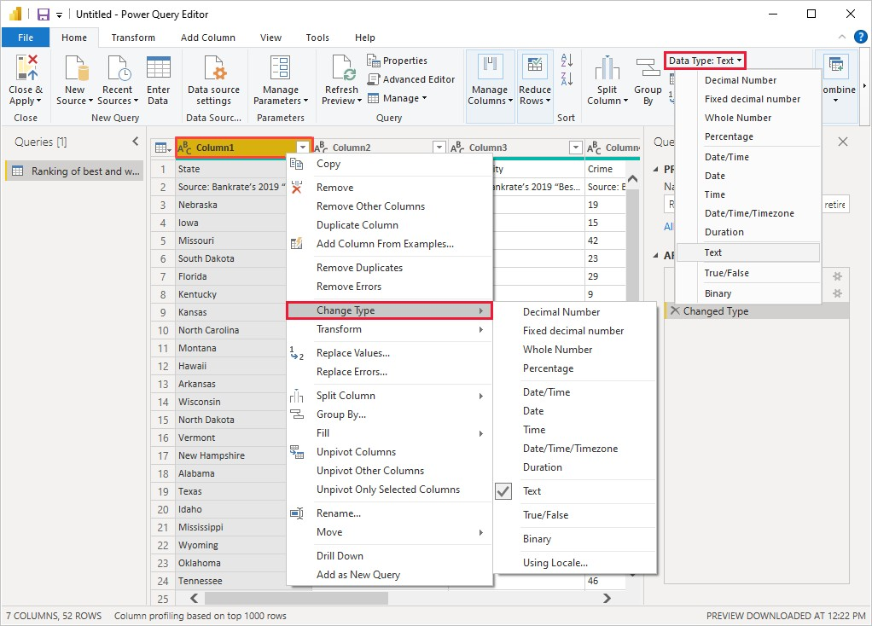

**To Reduce/Delete the Rows**

* From the Home tab select
* Reduce Rows > Remove Rows > Remove Bottom Rows.
* In the Remove Bottom Rows dialog box, enter *10*, and then select OK.

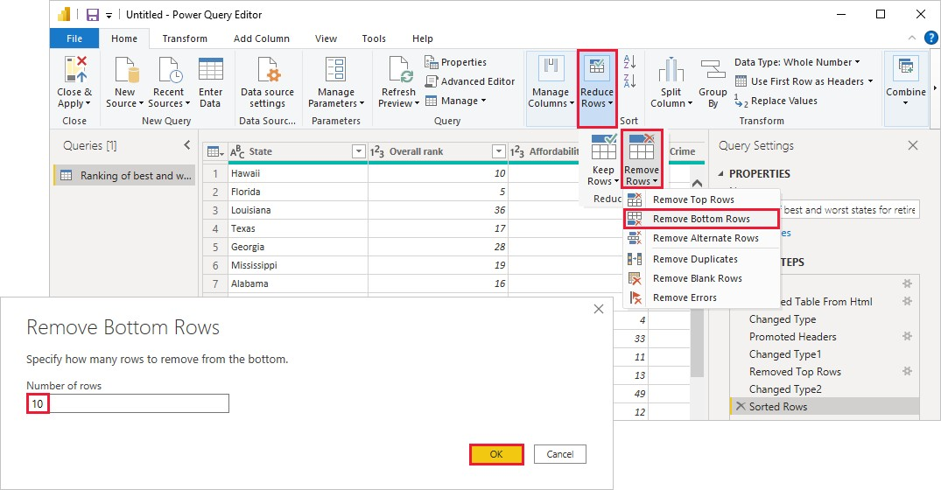

The bottom 10 worst rows are removed from the table, and the step Removed Bottom Rows appears in Applied Steps.

**To remove columns**

* From Home Tab Select Manage Columns group select Remove Columns.
* You can also right-click one of the selected column headers and select Remove Columns from the menu.
* The selected columns are removed, and the step Removed Columns appears in Applied Steps.

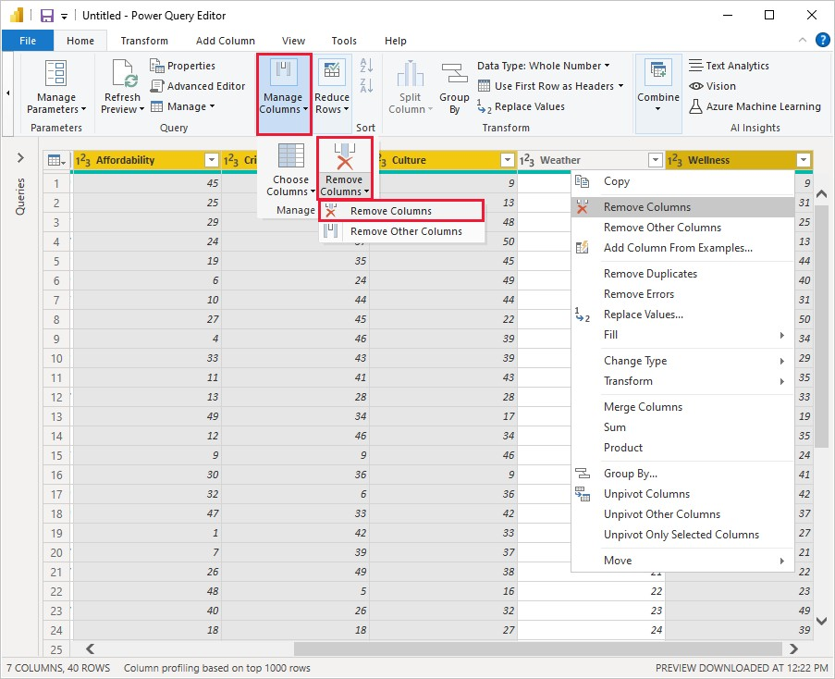

**Applied steps in the Query setting pane**

Right-click any step in the Applied Steps pane and choose to delete it, rename it, move it up or down in the sequence, or add or delete steps after it.

For intermediate steps, Power BI Desktop will warn you if the change could affect later steps and break your query**.**

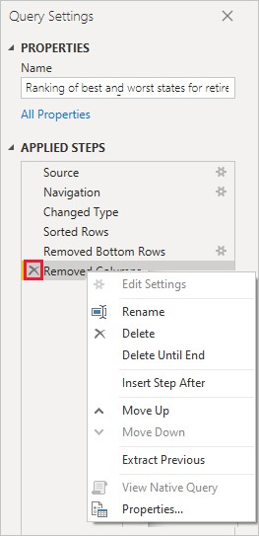

**Once all the required transformations are done the report should be created in the**

**Power BI Desktop**

* Apply the changes in Power Query Editor and load them into Power BI Desktop Selecting Close & Apply from the Home tab of the ribbon.
* You can also select just Apply to keep the query open in Power Query Editor while you work in Power BI Desktop.

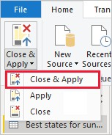

**To reopen Power Query Editor from Power BI Desktop**

Select **Transform Data** on **the Home tab** of the Power BI Desktop ribbon.

You can expand and collapse the **Filters**, **Visualizations**, and **Fields** panes by selecting the arrows at the tops of the panes. Collapsing the panes provides more space on the canvas to build cool visualizations.

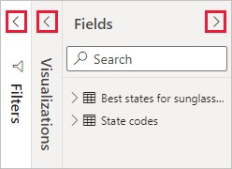

**The Visualizations pane shows information about the visualization and lets you modify it.**

1. The Fields option in the Visualization pane lets you drag data fields to Legend and other field wells in the pane.
2. The Format option lets you apply formatting and other controls to visualizations.
3. The icons show the type of visualization created. You can change the type of a selected visualization by selecting a different icon, or create a new visualization by selecting an icon with no existing visualization selected
4. The options available in the Fields and Format areas depend on the type of visualization and data you have.
5. You want your map visualization to show only the top 10 weather states.

To show only the top 10 states, in the Filters pane, hover over State is (All) and expand the arrow that appears. Under Filter type, drop down and select Top N. Under Show items, select Bottom, because you want to show the items with the lowest numerical ranks, and enter *10* in the next field.

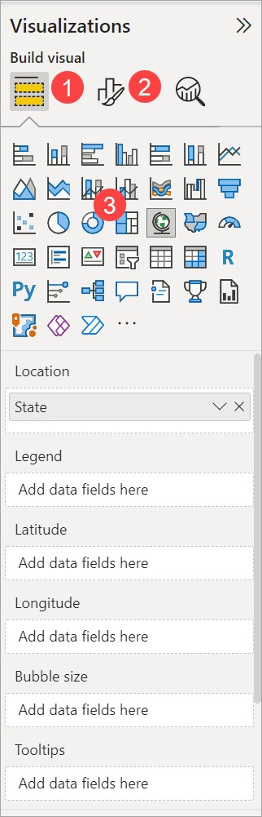

**Program 7: Creating Reports & Visualizations - Different types of charts, Formatting charts with Title, Colours**

17Most Common Charts available in Power BI:

* Bar Chart
* Line Chart
* Scatterplot
* Sparkline
* Pie Chart
* Gauge
* Waterfall Chart
* Funnel Chart
* Heat Map / Matrix
* Histogram
* Box Plot
* Maps
* Tables
* Indicators
* Area Chart
* Radar or Spider Chart
* Tree Map
* Open **Power BI Desktop**
* Click on **Get data** in ribbon pane
* Click on **Excel worksheet** option

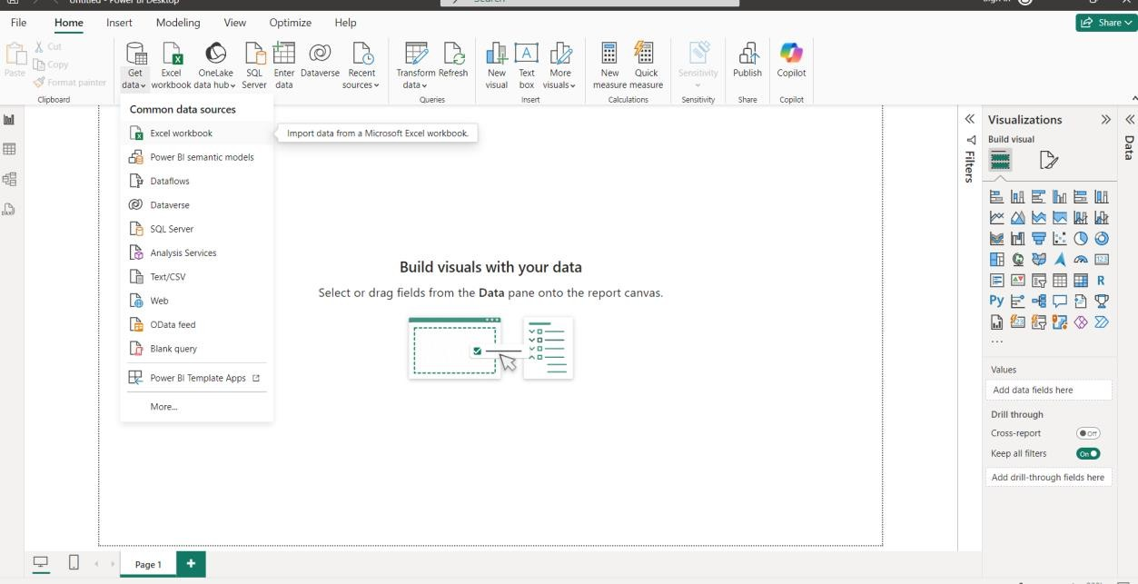

* Choose specific dataset and open it. Example: HR Data.csv
* Click on **Transform Data** button

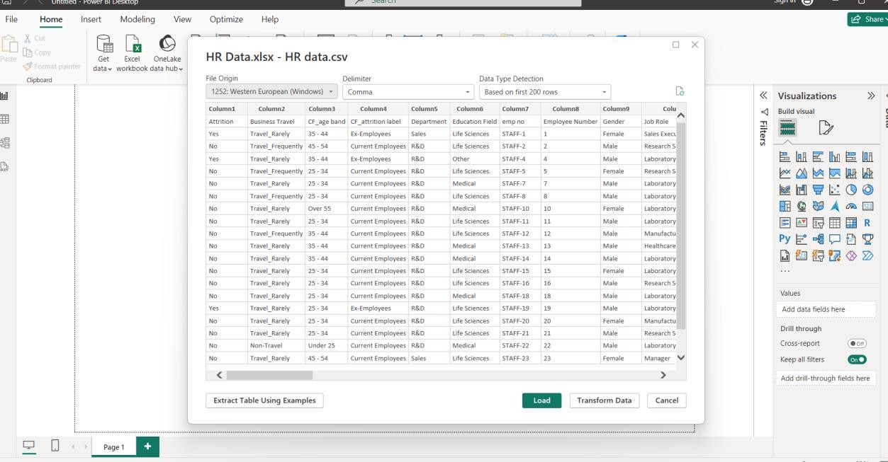

* **Power Query Editor** window will open.

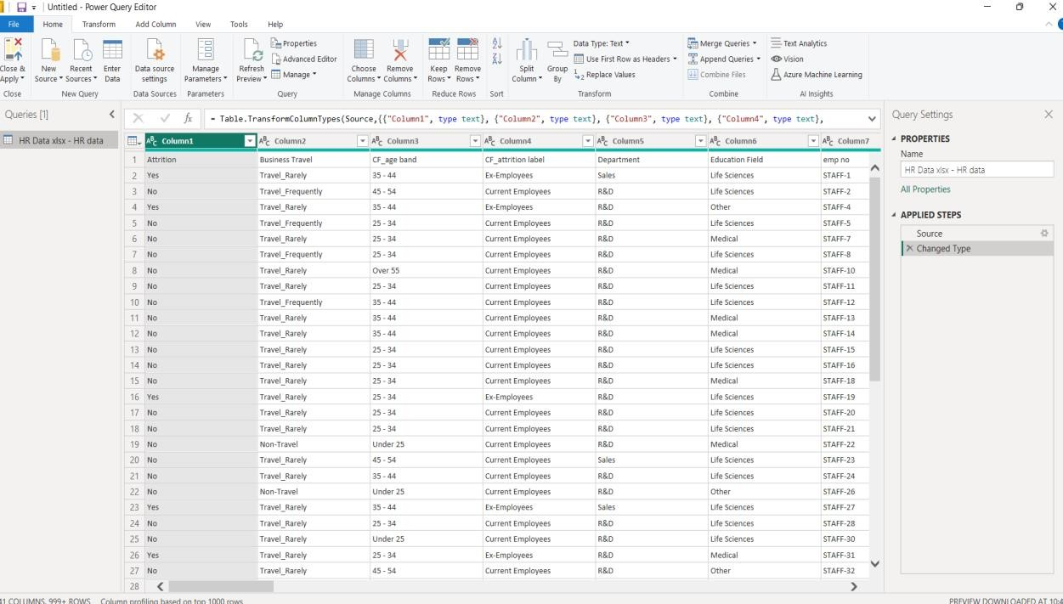

* We have to perform some transformation on this table
* Select row 1 and click on **Use first row as header**

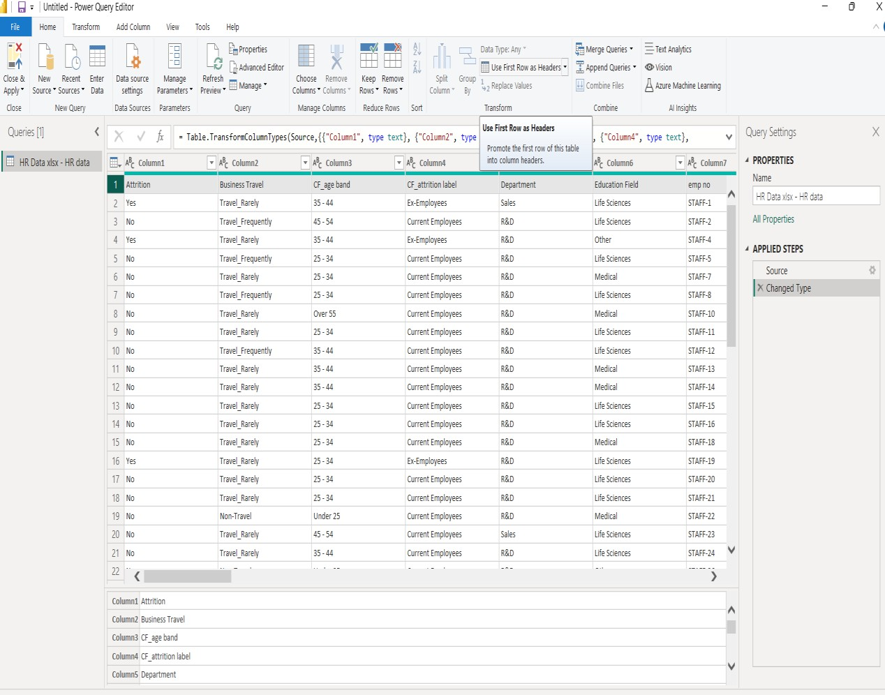

* Then, we have to create new column for attrition count. For this, select attrition column click on Add Column new window will open then add details as follows. Once you are done with this, attrition count column will be added as a last row of the table
* Change the datatype of this column to whole number

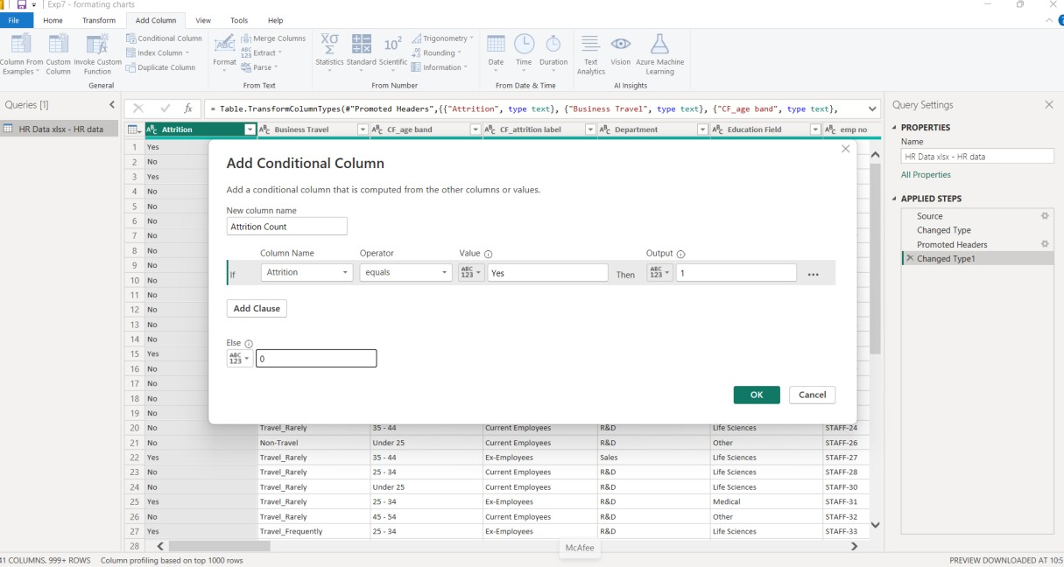

* Click on **Close & Apply.**

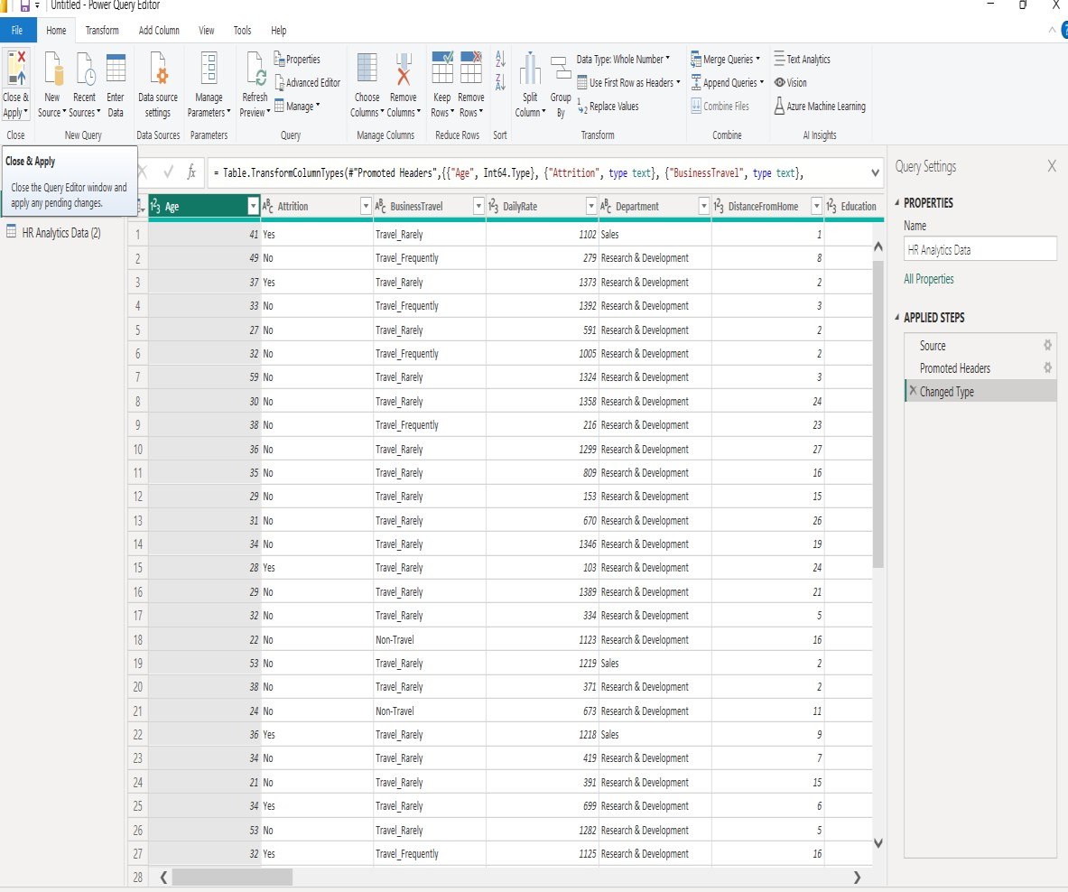

Click on

**“**

**Close &**

**Apply**

**”**

* You will be back on canvas area with table loaded in **Data Pane** (in right side).

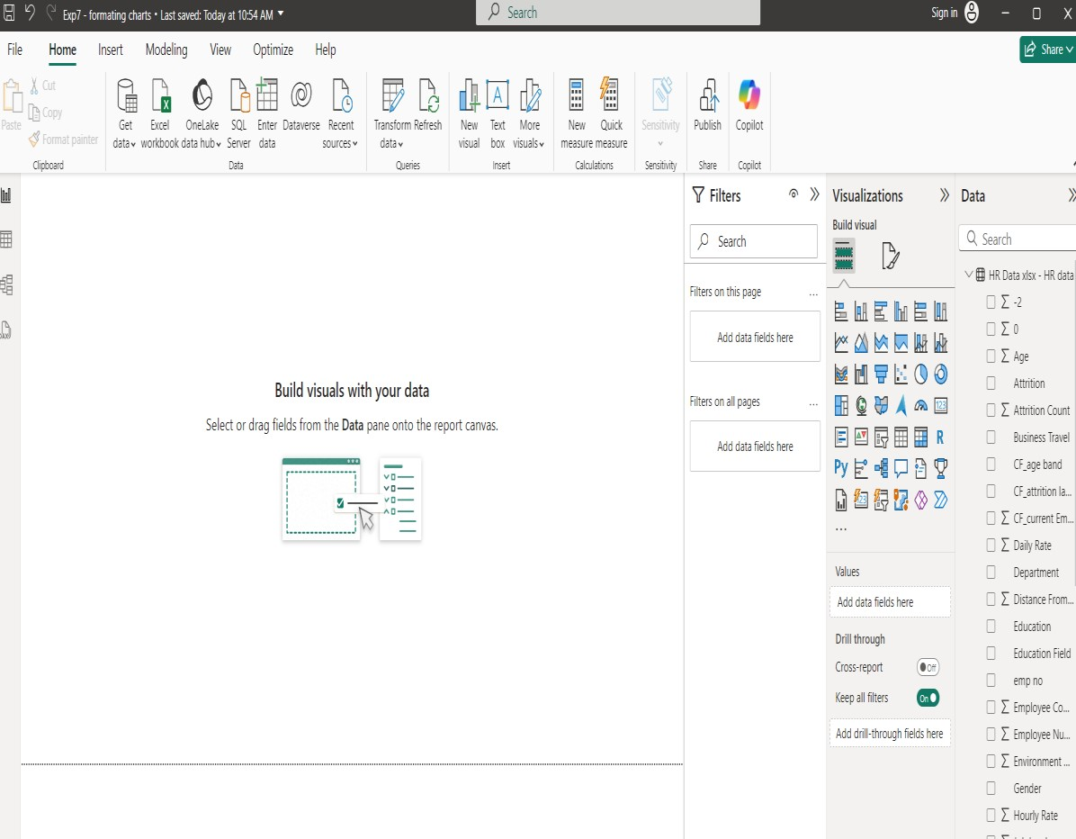

* We will start with **KPI Chart**
* A Key Performance Indicator (KPI) is a visual cue that communicates the amount of progress made toward a measurable goal

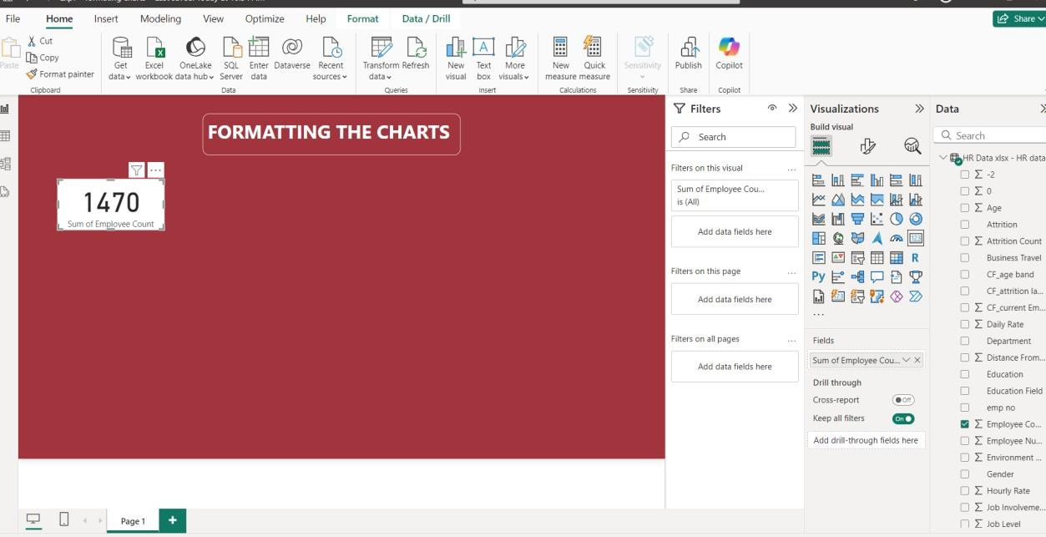

Now format this particular visual with title, size, colour.

1. Click on “Format your visual” in **Visualization Pane**
2. Go to General tab
   1. click on Title type “Overall Employees” in Text box, Horizontal alignment and colour of your choice
   2. expand effects **OFF** the background of KPI chart
   3. Effects **ON** visual border change the color and 20 rounded corners
3. Now, go to Visual tab **OFF** the category label
4. In visual tab, callout value change the font color

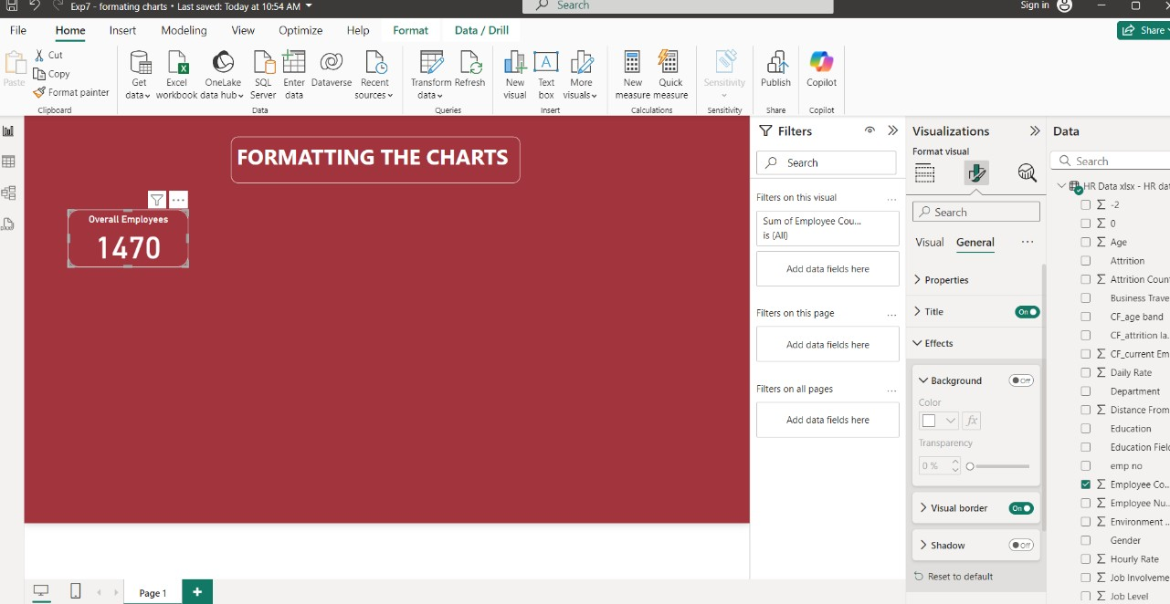

**Kindly Note**: If you want same format for all visuals, complete the formatting with one of the visual, click on format painter and click on the visual for which you want the formatting. Little bit formatting will be required as properties for each visual will be different Select Pie Chart.

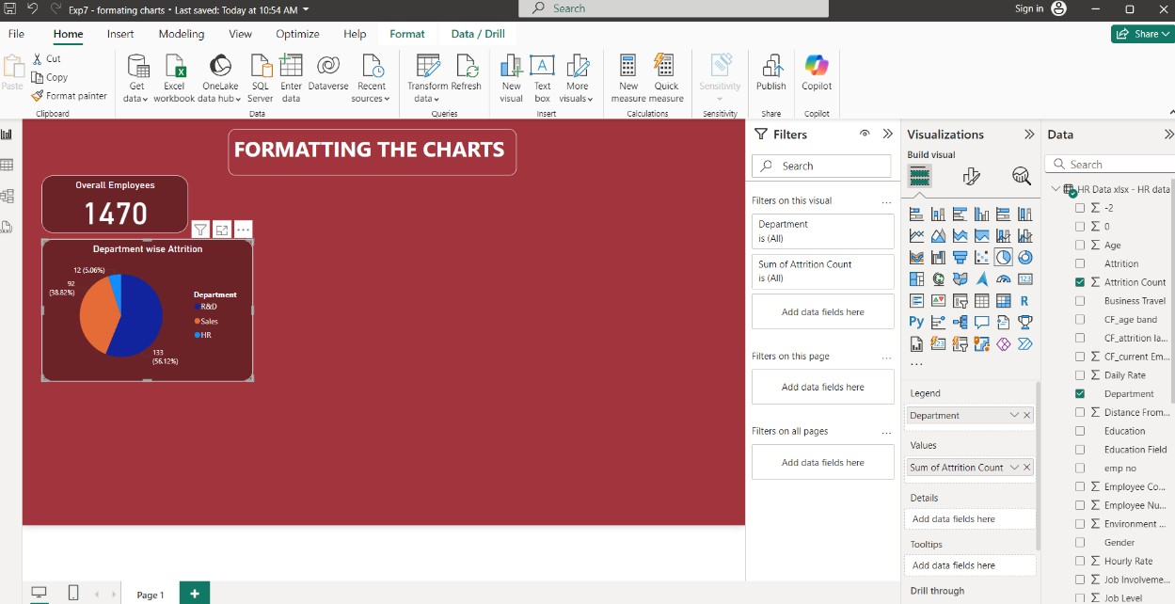

* Now apply same steps for creating **STACKED COLUMN CHART.**

A column chart, commonly referred to as a vertical bar graph, is a visual tool utilized to display and compare numerical data across different categories. Each column within the chart corresponds to a specific category, with the height of the column proportionally representing the associated value.

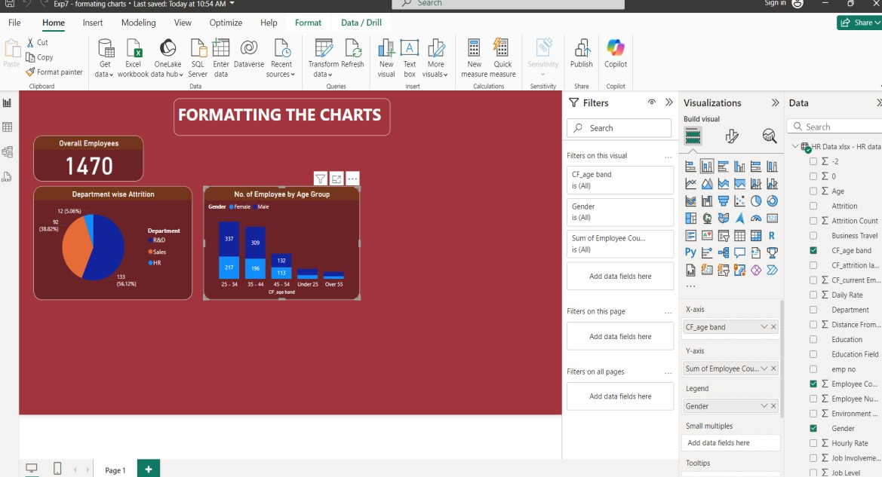

**Optional:** As you can see, age is not sorted correctly, so we have to create additional column.

Once **sort age** column is created change the datatype of column if its not in whole number.

Click on **“Close & Apply”**

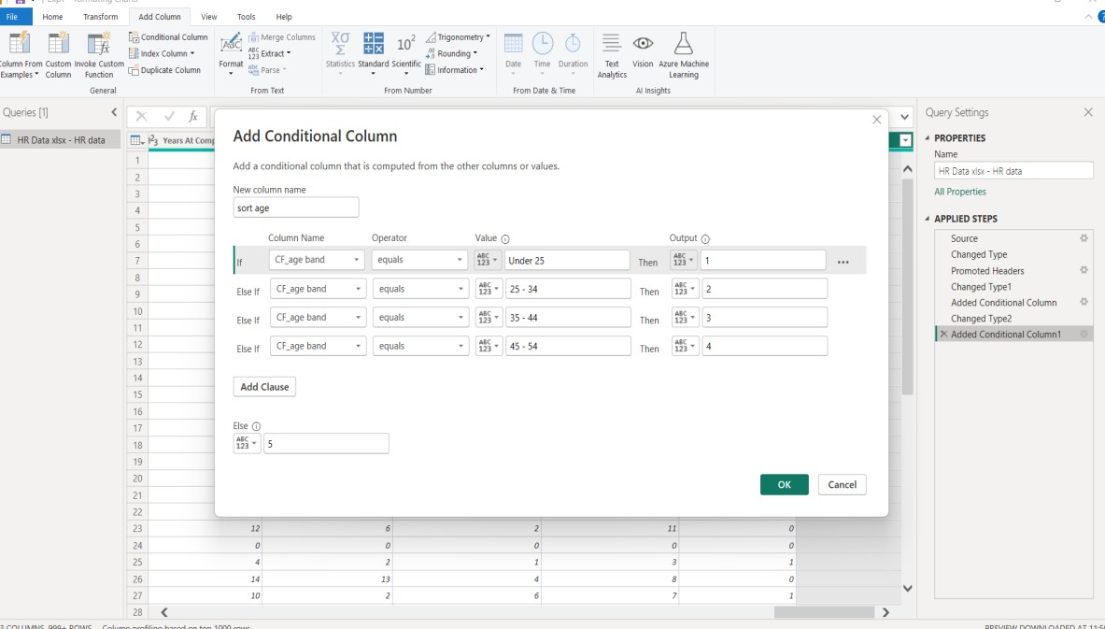

Now, on canvas, in data pane select CP_age_band click on sort by column select newly created column sort age and now click on visual and follow the steps,Finally, output will be as follows:

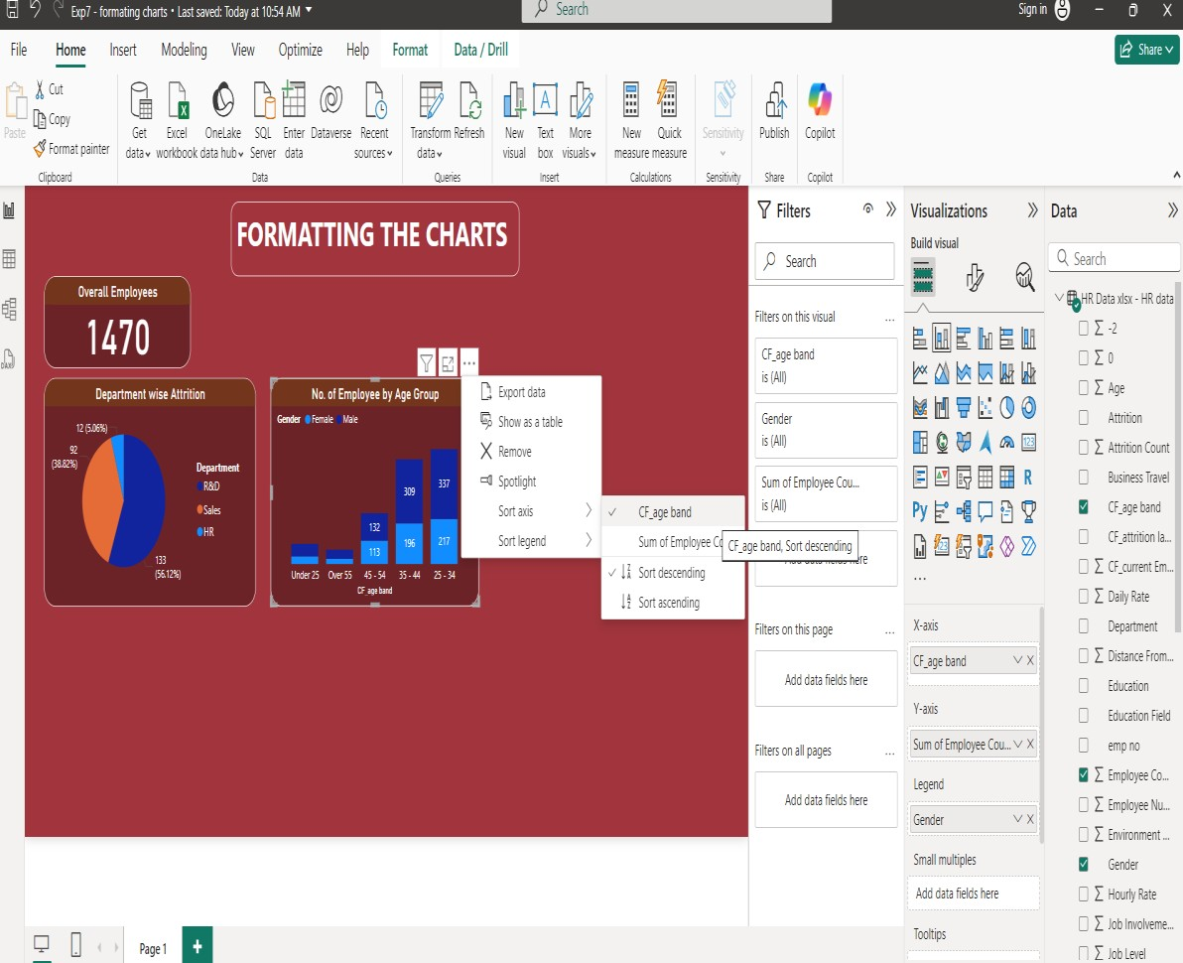

Finally, output will be as follows

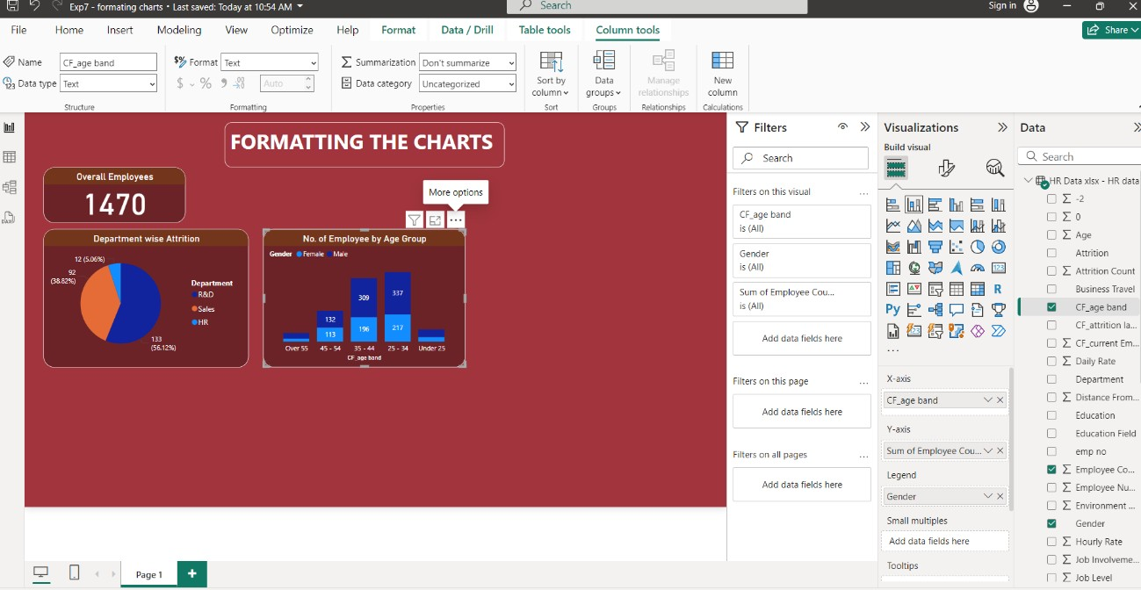

* Now apply same steps for creating **MATRIX.**

The matrix visual is a type of table visual that supports a stepped layout. A table supports two dimensions, but a matrix makes it easier to display data meaningfully across multiple dimensions. Often, report designers include matrixes in reports and dashboards to allow users to select one or more element (rows, columns, cells) in the matrix to cross-highlight other visuals on a report page.

Format the row header & column header text color & background color Also, format the Row grand total & column grand total

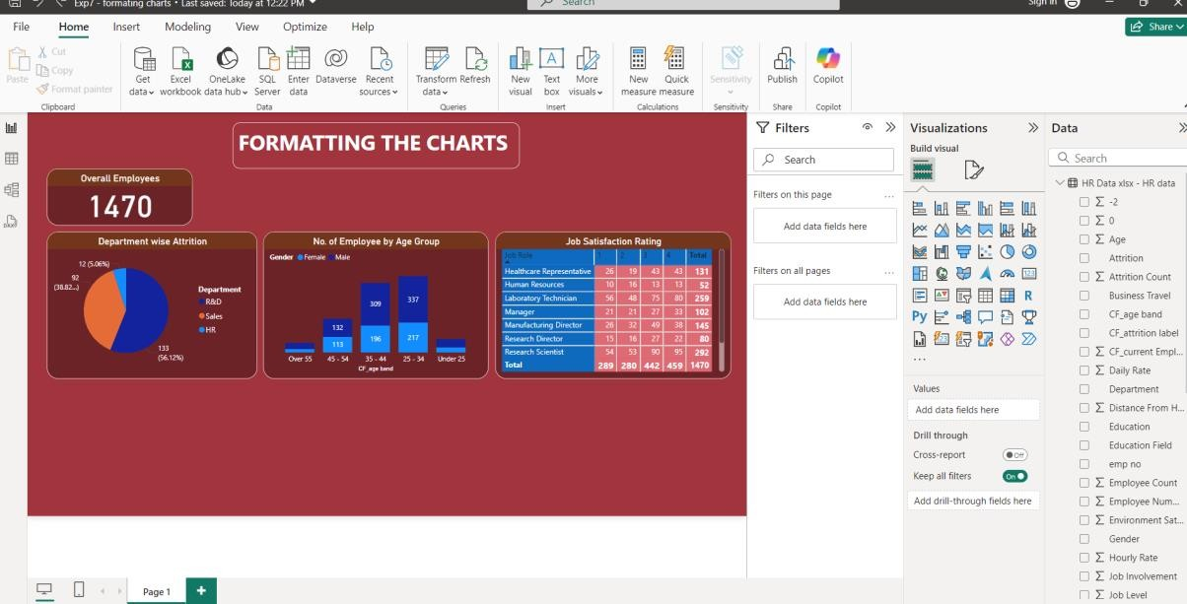

Now apply same steps for creating **Stacked Bar Chart.**

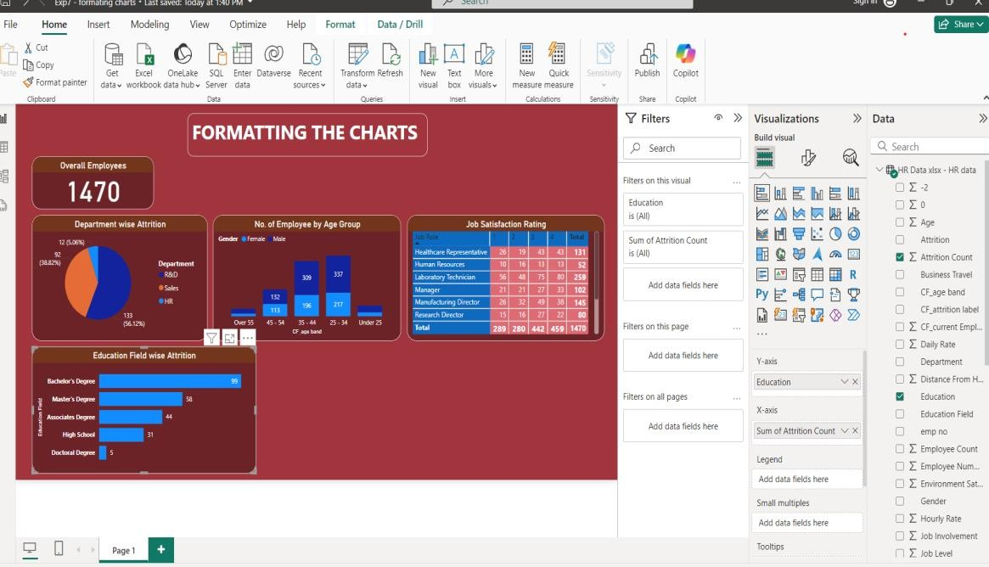

Now apply same steps for creating **Donut.**

A doughnut chart is similar to a pie chart in that it shows the relationship of parts to a whole. The only difference is that the center is blank and allows space for a label or icon.

Doughnut charts work best when you use them to compare a particular section to the whole, rather than comparing individual sections with each other.

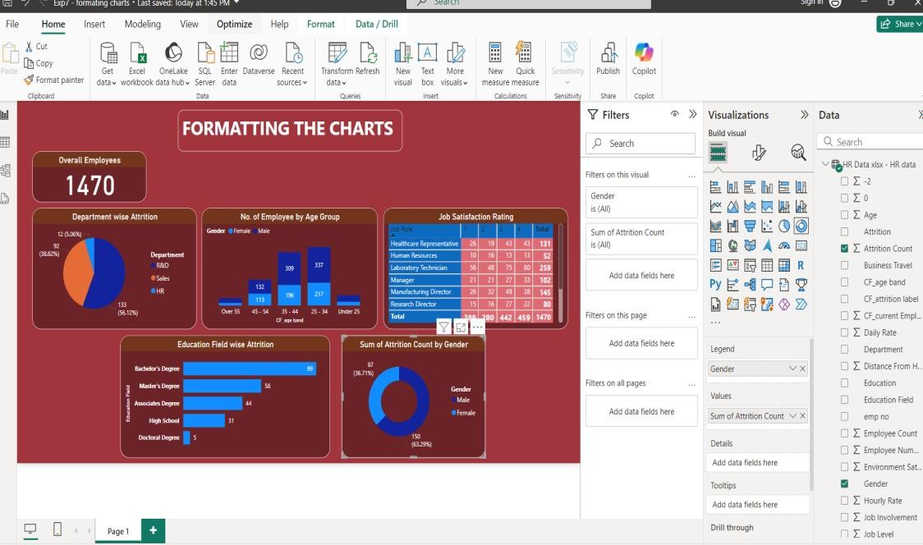

**Slicers:** A slicer is a standalone chart that can be used to filter the other visuals on the page. Slicers come in many different formats (category, range, date, etc.) and can be formatted to allow selection of only one, many, or all of the available values.

Slicers are a great choice to:

* Display commonly used or important filters on the report canvas for easier access.
* Make it easier to see the current filtered state without having to open a drop-down list.
* Filter by columns that are unneeded and hidden in the data tables.
* Create more focused reports by putting slicers next to important visuals.

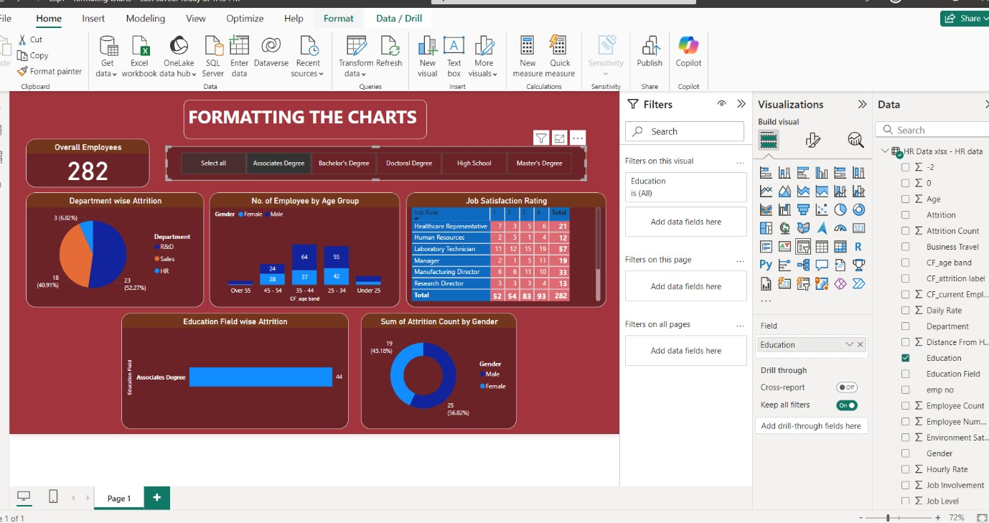

**Program 8:**

**Dashboards - Filters in Power BI, Formatting dashboards *Filters* remove all but the data you want to focus on.**

Filter Pane: You can apply filters in the Filters pane, or make selections in slicers directly on the report page itself. The Filters pane shows the fields in individual visuals and any other filters the report designer adds.

There are four standard types of filters that you create in the Filters pane.

* **Visual filter** applies to a single visual on a report page. You see visual-level filters when you select a visual on the report canvas. Even if you can't edit a report, you can select a visual and filter it.
* **Page filter** applies to all the visuals on the report page.
* **Report filter** applies to all pages in the report.
* **Drill through filter** With drill through in the Power BI service and Power BI Desktop, you create a *destination* report page that focuses on a specific entity, such as a supplier. From the other report pages, users can right-click a data point for that entity and drill through to the focused page.

•

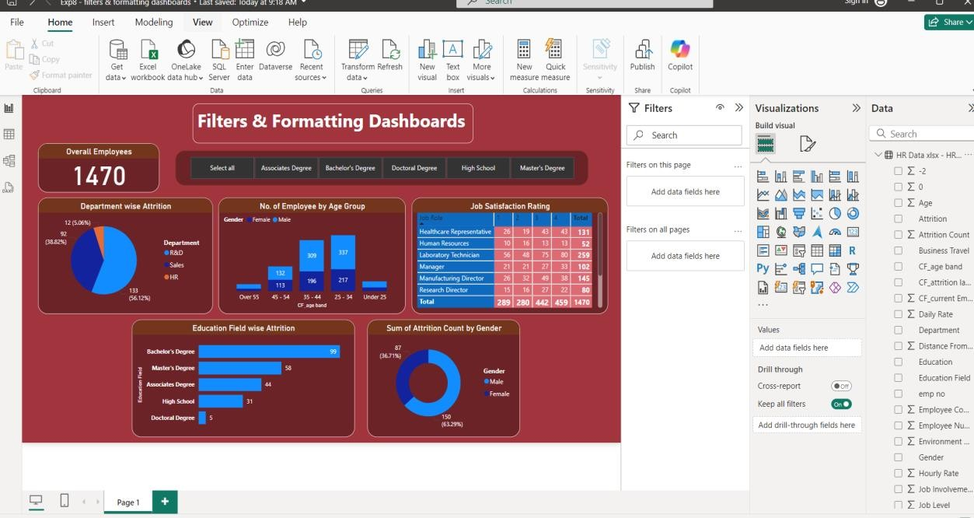

We will be using HR dataset (same used for Exp 7).

Extending same dashboard with using filters & let’s formats the final dashboard.

Let’s apply filter for department (Particular visual).

1. Drag Department from Data Pane to Filters on this page textbox. Basic Filtering
2. Now, you can see, HR dept. is selected and now in below picture, you can see that only HR data is visible, whereas, R&D and Sales data will not be shown.

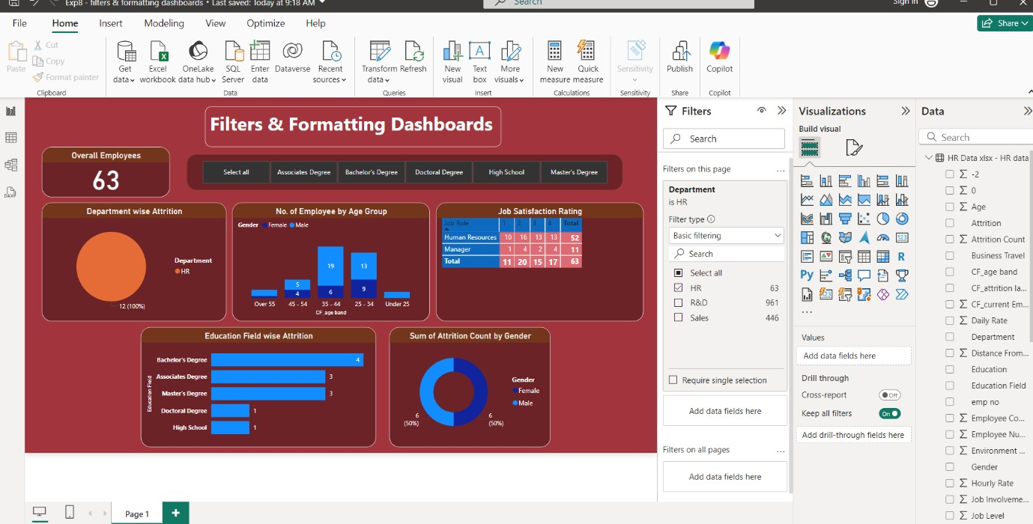

Now, HR and R&D departments are selected.

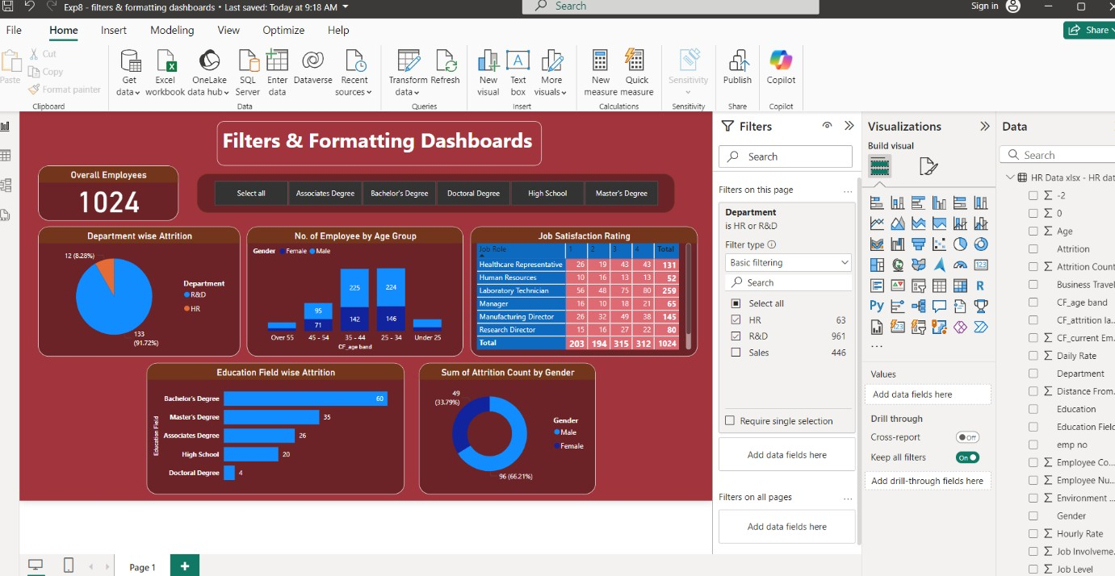

1. Now, lets try for advanced filter

Let’s find out results for **salary greater than equal to 10000.**

Drag and drop **Monthly Income** in filter

Filter type: advanced filtering

Show items when the value: is greater than or equal to

Value: 10000

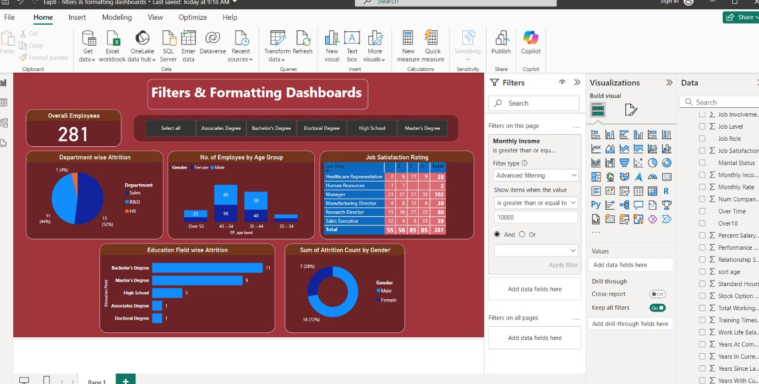

1. Now, try for Top N filtering. Try to display top 4 Job roles having highest job satisfaction.

•Select “Job satisfaction rating” visual In Filters Pane, Filters on this visual

Job Role

Filter type: Top N

Show item: Top : 4

By value: Sum of Job Satisfaction

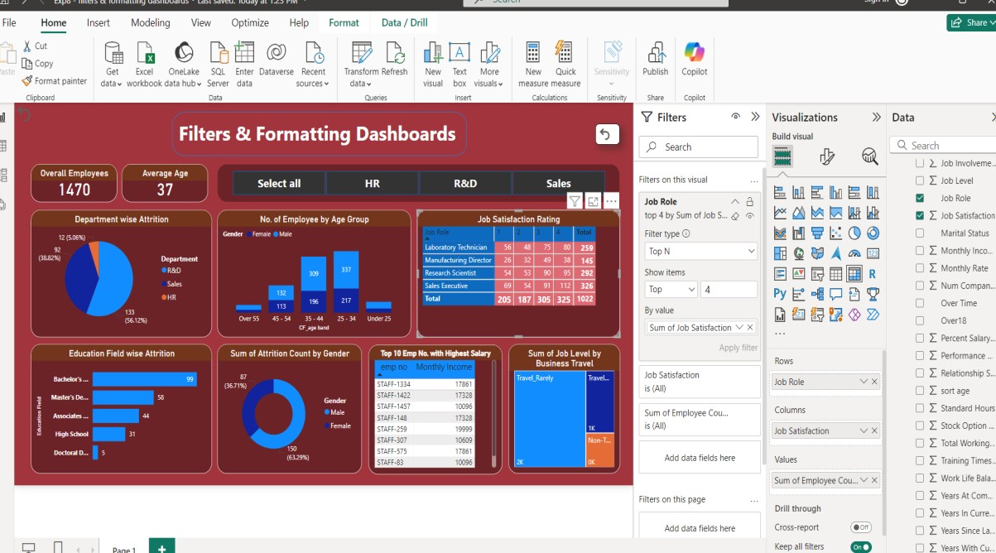

### Program 9:

### BUILDING DASH BOARD

**Analysis of revenue in sales dataset:**

i) Create a choropleth map (fill the map) to spot the special trends to show the state which has the highest revenue. ii) Create a line chart to show the revenue based on the month of the year.

iii) Create a bin of size 10 for the age measure to create a new dimension to show the revenue. iv) Create a donut chart view to show the percentage of revenue per region by creating zero access in the calculated field.

1. Create a butterfly chart by reversing the bar chart to compare female & male revenue based on product category.
2. Create a calculated field to show the average revenue per state & display profitable & non-profitable state.
3. Build a dashboard.

**Solution:**

**Step1:** Upload the revenue dataset

**Step2:** In the power query editor as part of transformation remove the unnecessary columns

(Remove the last null column)

**Question 1: Create a choropleth map (fill the map) to spot the special trends to show the state which has the highest revenue.**

**Step1:**  Select the "Map" visualization from the Visualizations pane.(filled map) Step2: Set **Up the Map**:

* + Drag the state field to the "Location" field well.
  + Drag the revenue field to the "Size" or "Values" field well.

Step3: **Customize**: In the "Format" pane, adjust settings such as color, size, and tooltips to enhance readability. You can use color gradients to indicate different revenue levels, helping to spot trends.

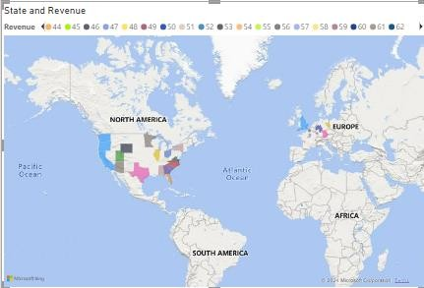

**Question 2:Create a line chart to show the revenue based on the month of the year.**

**Step1:Add a Line Chart**: Select the "Line chart" visualization from the Visualizations pane. **Step2:Configure the Chart**:

* + Drag the month field to the "Axis" field well.
  + Drag the revenue field to the "Values" field well.

**Step3:Format**: In the "Format" pane, you can customize the line color, axis titles, and other aspects to clearly present the revenue trend throughout the year

. 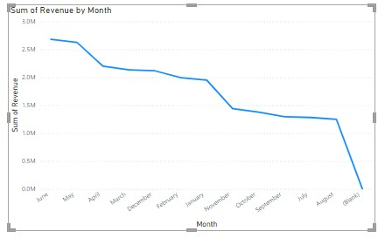

**Question 3: Create a bin of size 10 for the age measure to create a new dimension to show the revenue.**

**Step1:Create Bins for age**

* + Go to the "Data" view and select the age field.
  + Right-click on the age field and choose "New group".
  + In the "Group" window, select "Bin" and set the bin size to 10.

**Step2: Add to Visualization**:

* + Create a new visualization (e.g., bar chart or column chart). Here we used Stacked column chart.
  + Drag the new age bins field to the "X Axis" and the revenue field to the "Y axis”.

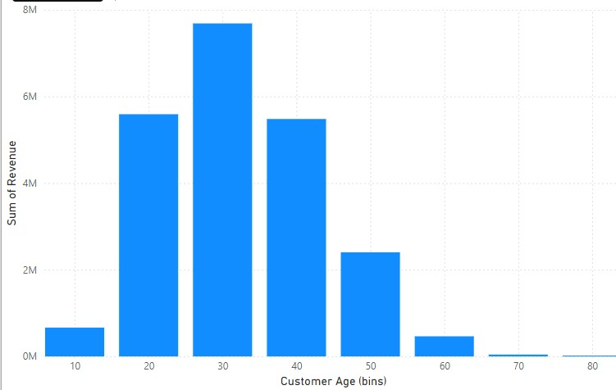

**Question 4: Create a donut chart view to show the percentage of revenue per region by creating zero access in the calculated field.**

**Step1:Add a Donut Chart**: Select the "Donut chart" visualization from the Visualizations pane.

**Step2:Set Up the Chart**:

* + Drag the region field to the "Legend" field well.
  + Drag the revenue field to the "Values" field well.

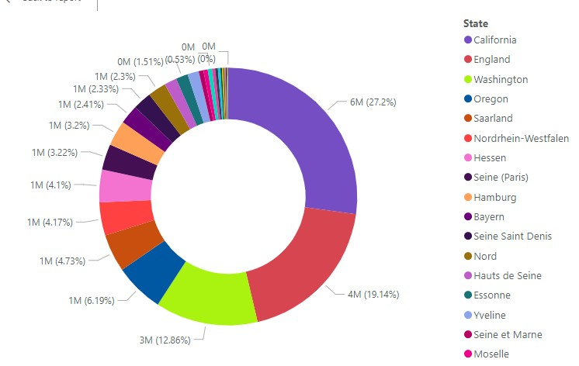

**Step3:Create Zero Access**:

* + Go to the "Format" pane, select "Detail labels", and set the "Label position" to "Inside" to create a zero access effect.
  + Adjust the "Detail" and "Percentage" settings as needed.
  + 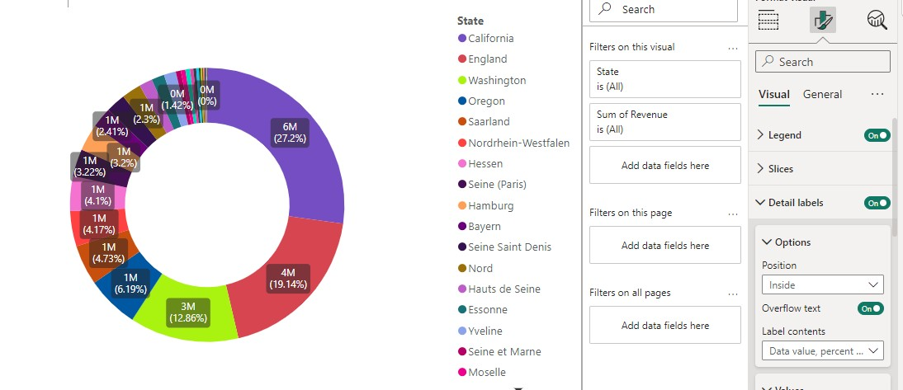

Note: The "zero access effect" is a visual design technique often used in data visualizations to emphasize or clearly show zero values or the absence of certain data. This effect is particularly useful in charts where you want to highlight how values are distributed relative to zero, or where zero plays a significant role in the interpretation of the data.

**Donut Charts**:

In a donut chart, the zero access effect can be used to enhance readability by placing labels or markers at the center of the chart or using a specific design to show where there is no data.

For example, if one segment of a donut chart represents zero revenue, you might design the chart so that this segment is clearly visible or highlighted to indicate no revenue.

**Question 5: Create a butterfly chart by reversing the bar chart to compare female & male revenue based on product category**.

**Step1:** Create a New Measure

TotalRevenue = sum(SalesTable[Revenue])

Method-1: By using stacked column chart

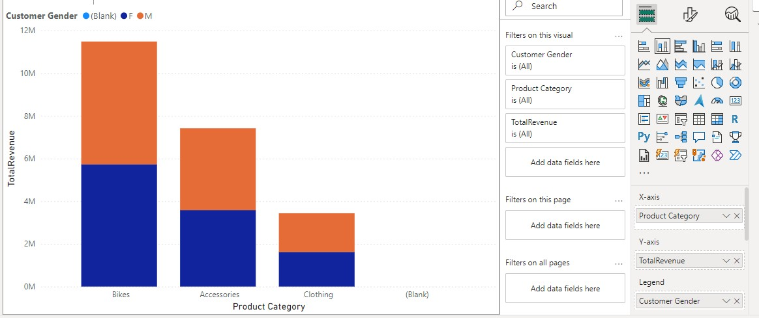

**Method 2: Step 1:**

**Add Two Bar Charts**:

* Create two separate bar charts from the "Visualizations" pane.

**Step 2:**

* Configure the First Bar Chart (e.g., Female Revenue):

Drag Product Category to the "Axis" field.

Drag Total Revenue to the "Values" field.

**Apply a Filter**:

* In the "Filters" pane, add a filter to show only Female revenue. You can drag Gender to the "Filters" pane and set the filter to include only Female.

**Step 3:**

* Configure the Second Bar Chart (e.g., Male Revenue):
* Drag Product Category to the "Axis" field.
* Drag Total Revenue to the "Values" field.

**Apply a Filter**:

* In the "Filters" pane, add a filter to show only Male revenue. You can drag Gender to the "Filters" pane and set the filter to include only Male.

**Step 4:**

**Reversing the Bars**:

* To create the butterfly effect, you need to reverse one of the bar charts. This involves adjusting the direction of the bars so that they face opposite directions from the center.

**Reverse the Bars**:

* For one of the charts (e.g., Male revenue), you will need to use a calculated column or measure to make the bars extend in the opposite direction. In Power BI, this can be achieved by adjusting the data in the chart's settings or using custom visualizations if necessary.

**Add Titles and Labels**:

* Add clear titles and labels to each chart to indicate what data they represent (e.g., "Female Revenue" and "Male Revenue").
* Customize the chart's appearance to enhance readability. 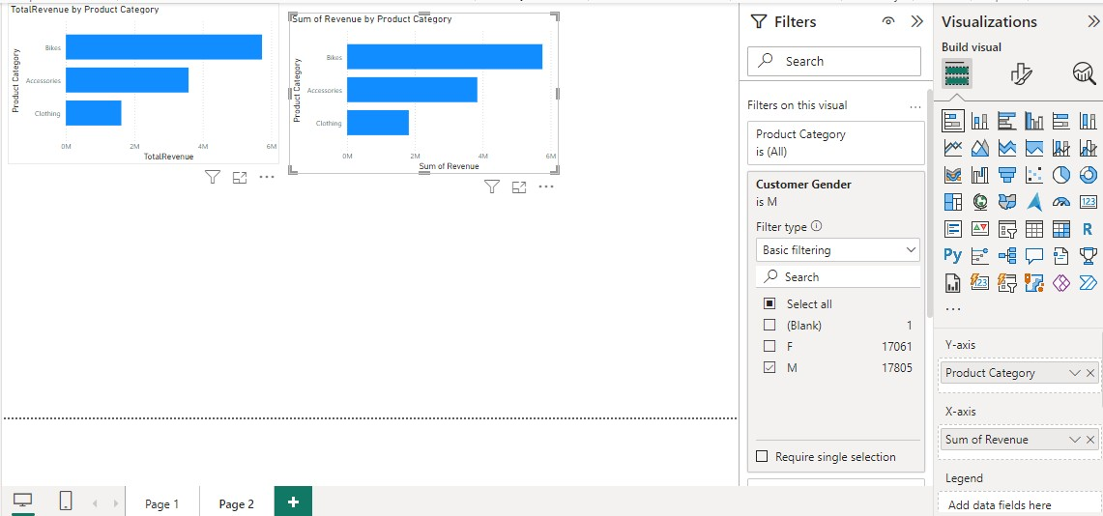

**Question 6:Create a calculated field to show the average revenue per state & display profitable & non-profitable state.**

**Step1: Create a New Measure**

* Go to the Modelling tab and select "New Measure".
* Create the Average Revenue Measure:
* Enter the following DAX formula to calculate the average revenue per state:

Average Revenue Per State =

AVERAGEX(

VALUES(SalesTable[State]),

CALCULATE(SUM(SalesTable[Revenue]))

)

**Step2: Create a Calculated Column to Categorize States**

Next, create a calculated column to classify states as profitable or non-profitable based on the average revenue.

1. **Go to the Modeling tab** and select **"New Column"**.
2. **Create the Profitability Column**:

Enter the following DAX formula to create a column that categorizes states as profitable or non-profitable:

Profitability Status =

IF(Sales Table[Average Revenue Per State]>1000,

"Profitable", "Non-Profitable"

)

**Step 3: Display the Results**

* 1. Add a Table and select state, Average Revenue State and Profitability Status.

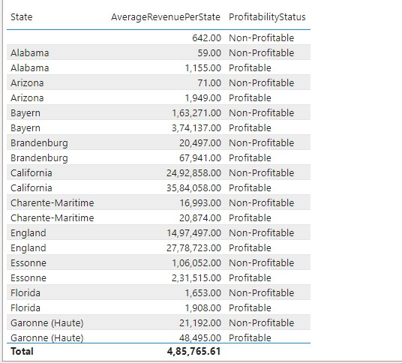

**Extra : To get the Total value or single value**

In Power BI, a **Card** visualization is used to display a single, important piece of data, such as a key metric or a number. It is commonly used to show aggregate values like:

* **Total Sales**
* **Average Profit**
* **Total Units Sold**
* **Number of Customers**

The Card provides a clean and simple way to highlight critical metrics that are important for decision-making. It's ideal for dashboard views where quick insights are needed.

**To show the total revenue**

**Steps :**

**1.Select the card in the visualization pane.**

**2.Drag the Revenue field into the field well**

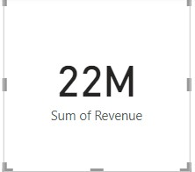

**To Add filter or Slicer**

Filter Data: Slicers filter data across multiple charts and visuals in a report. For example, selecting a specific region or product category in a slicer can update all connected visuals to reflect data only for that selection**.**

**Steps : 1. Select slicer from the Visual pane**

**3. Drag the Country field into the field well**

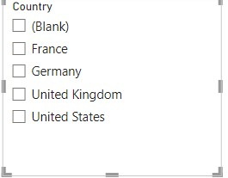

**Question 7:Build a dashboard.**

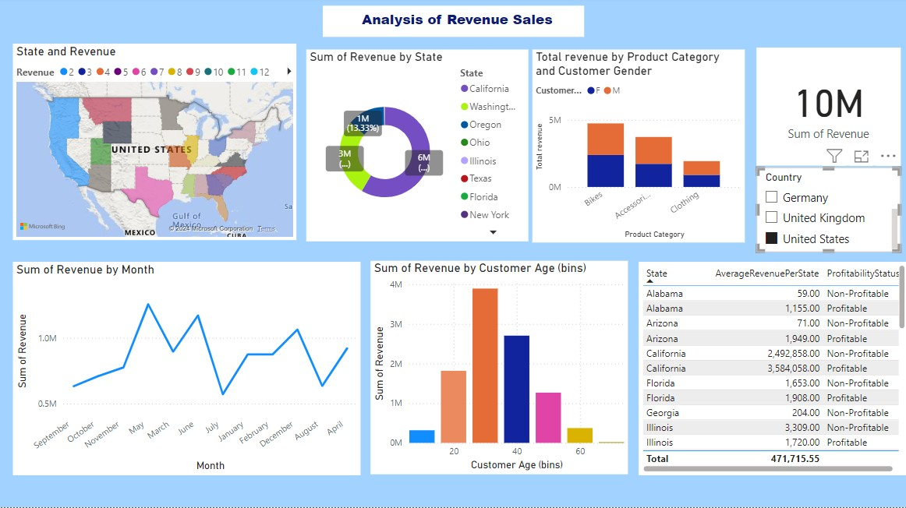

**Program 10:**

**Analysis of GDP dataset:**

**i)Visualize the countries data given in the dataset with respect to latitude and** longitude along with country name using symbol maps

**Step1:** Bring Latitude in Row

Bring Longitude in Column

**Step2:** Bring Country in Color Marks Pane

Bring any Year Measured Value to Label after that You be able to see screen as in below

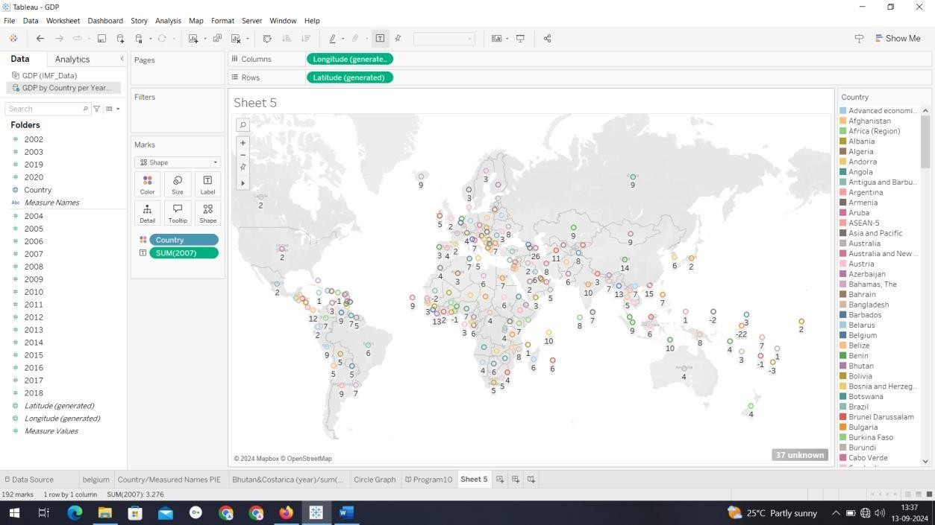

**ii) Create a bar graph to compare GDP of Belgium between 2006 – 2026.**

**Step1:**

Get Measured Names to Filter Pane then select as in years mentioned

2006 – 2026. Get Country to Filter and Select Belgium

**Step2:**

Drag Measured Name and Country into Column

**Step3:**

Drag Measured Value to Row You seeoutputs

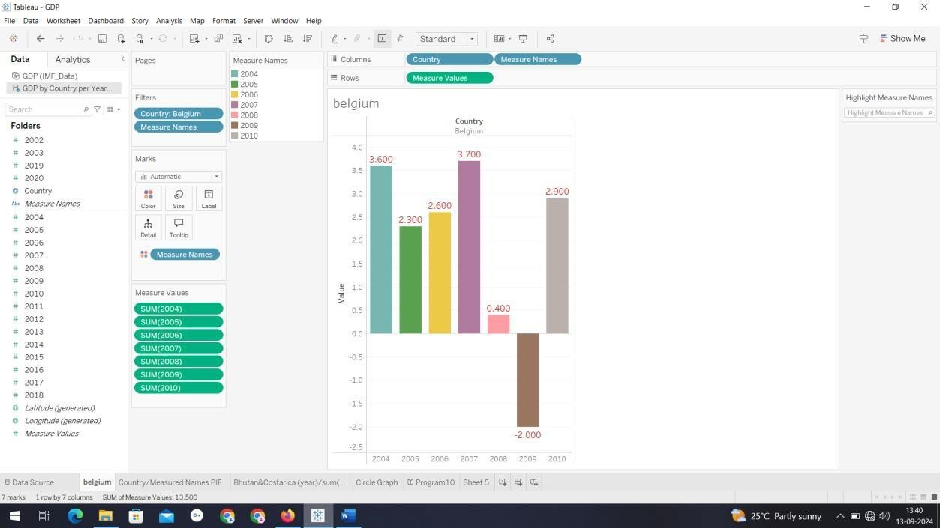

**iii)Using pie chart, visualize the GDP of India, Nepal, Romania, South Asia, Singapore by the year 2010. Step1:**

Get Country to Filter pane and select India, Nepal, Romania, South

Asia, Singapore Get Measure Name to Filter and select 2010 **Step2:** Important Step

Select option of chart as Pie(instead of automatic in Marks Pane) and Drag Country in Color frame

Finaly Sum or avg or anything of your choice to angle Frame ( For sum its SUM[(2010)], For average its AVG[(2010)] from measure value The output result is as in below

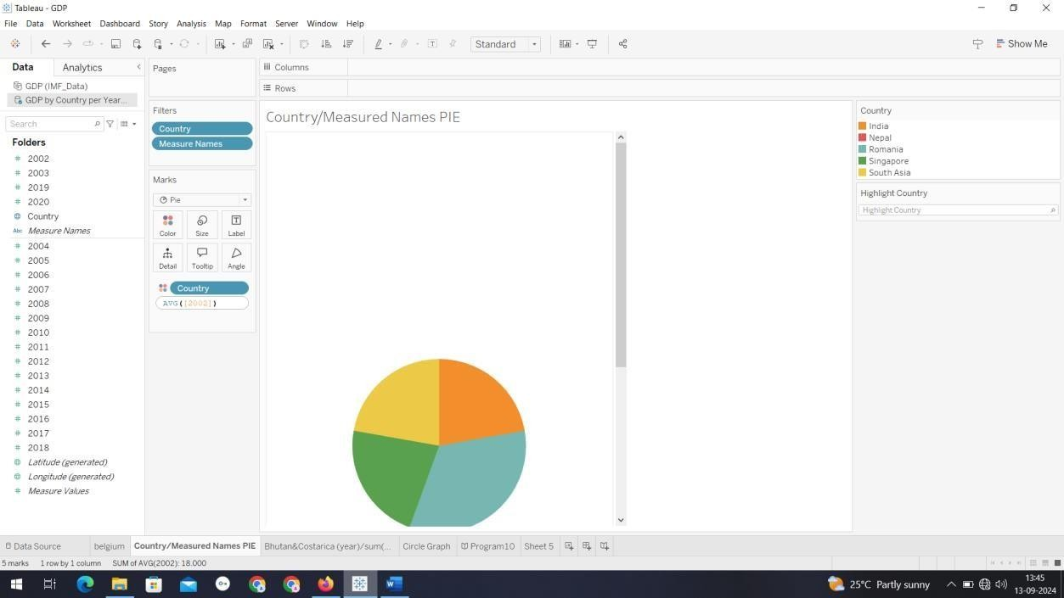

**iv)Visualize the countries Bhutan & Costa Rica competing in terms of GDP. Step1:** Filter Country and Measure name IikeBhutan,Costarics and 2016,2017,2018 as year(Measure name)

**Step2:**Add Country and Measure Names in column, Measure Values in Row

**Step3:**For better view add Measure Names to Color frame in Marks pane

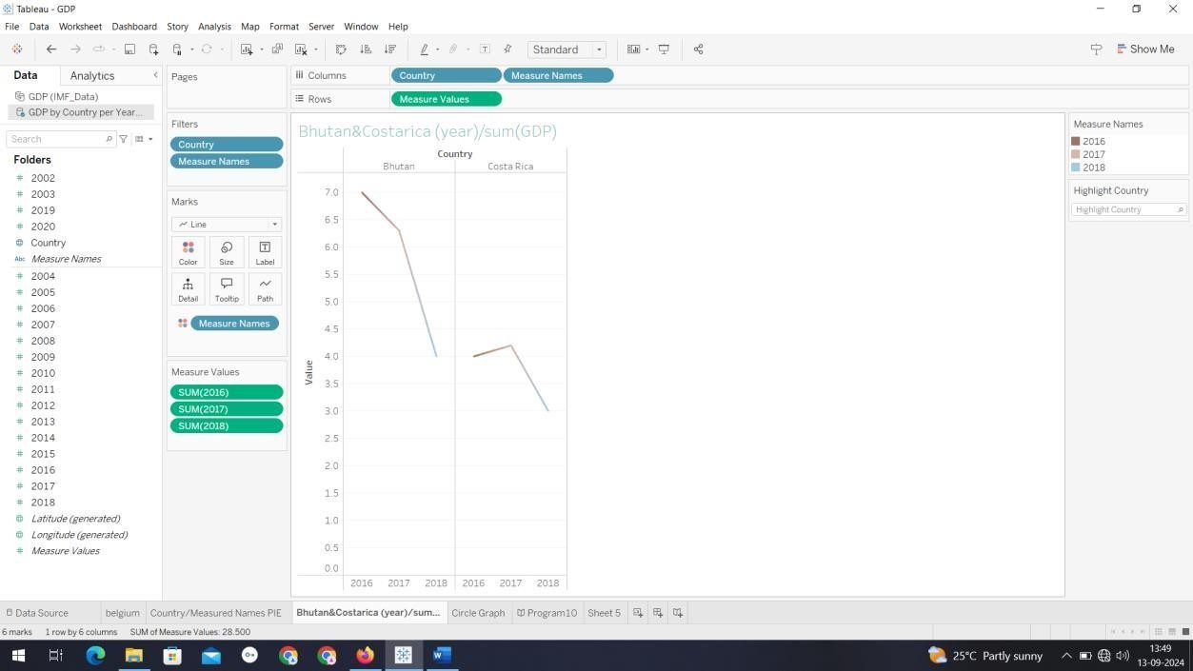

**v) Create a scatter plot or circle views of GDP of Mexico, Algeria, Fiji, Estonia from 2004 to 2006**.

**Step1:**Add Country in filter as per requirement

Add measure names in filter and select as per requirement

**Step2:** Add Measured Name in Column and an add any measured values of year 2004,2005,2006 Finally opt for Circle as option

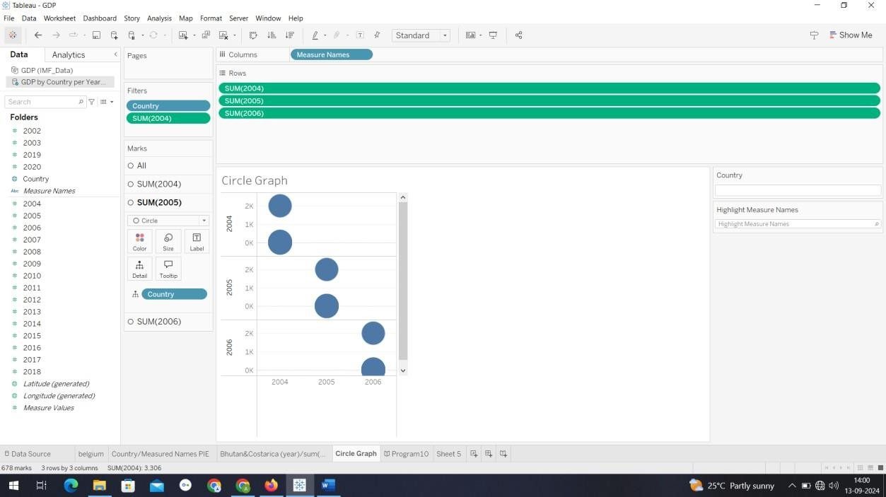

**Program 11:**

**Analysis of HR Dataset**

i)Create KPI to show employee count, attrition count, attrition rate, attrition count, active employees, and average age.

ii) Create a Lollipop Chart to show the attrition rate based on gender category. iii) Create a pie chart to show the attrition percentage based on Department Category- Drag department into colours and change automatic to pie. Entire view, Drag attrition count to angle. Label attrition count, change to percent, add total also, edit label.

1. Create a bar chart to display the number of employees by Age group,
2. Create a highlight table to show the Job Satisfaction Rating for each job role based on employee count. vi) Create a horizontal bar chart to show the attrition count for each Education field Education field wise attrition – drag education field to rows, sum attrition count to col, vii) Create multiple donut chart to show the Attrition Rate by Gender for different Age group.

Solution :

**i) Create KPI to show employee count, attrition count, attrition rate, attrition count, active employees, and average age.**

**Step1:** Create a New measure

Employee Count = COUNT('HR'[Employee Number])

**Step2:** Choose KPI card in the visualization and drag and drop the Employee Count. Format your visuals of your style.

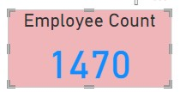

**Step3:** Create a New Measure

Attrition Count = COUNTROWS(FILTER('HR', 'HR'[Attrition]="Yes"))

**Step4:** Choose KPI card in the visualization and drag and drop the Attrition Count. Format your visuals of your style.

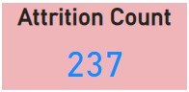

**Step5:** Create a New Measure

Attrition Rate = DIVIDE([Attrition Count], [Employee Count], 0) * 100

**Step6:** Choose KPI card in the visualization and drag and drop the Attrition Rate. Format your visuals of your style.

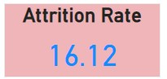

**Step7:** To find active employees create a new measure

Active Employees = [Employee Count] - [Attrition Count]

**Step8:** Choose KPI card in the visualization and drag and drop the Active Employees. Format your visuals of your style.

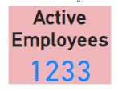

**Step9:** To calculate average age create a new measure

Average Age = AVERAGE(HR[Age])

**Step10:** Choose KPI card in the visualization and drag and drop the Average Age. Format your visuals of your style.

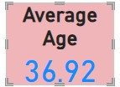

1. **Create a Lollipop Chart to show the attrition rate based on gender category.**

Power BI does not have a native Lollipop Chart, so you will simulate it using (any chart) a Line and Stacked column Chart

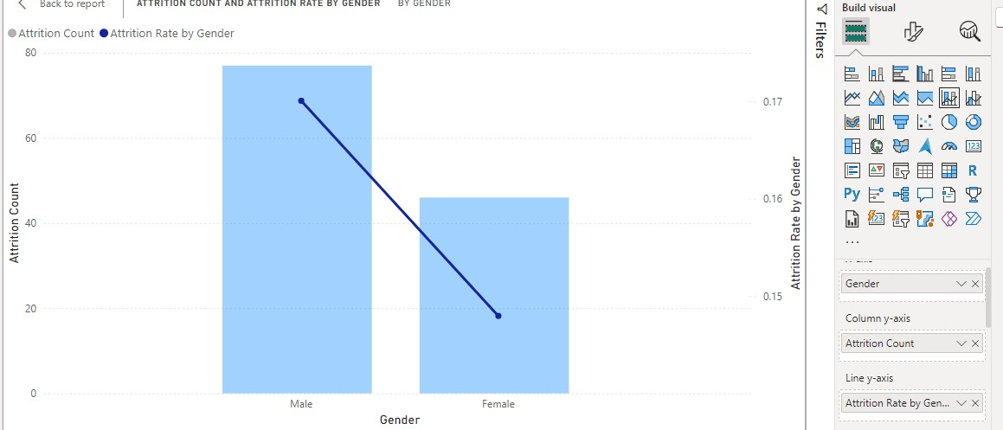

1. **Create a pie chart to show the attrition percentage based on Department Category-**

Drag departmentinto colours and change automatic to pie. Entire view, Drag attrition count to angle. Label attrition count,change to percent, add total also, edit label.

* From the Visualizations pane on the right, select the Pie Chart visual icon. This will add a blank pie chart to your report canvas.

**Set Up the Pie Chart**:

* Drag the Department Field to the Legend area.
* Drag the Attrition Count Measure to the Values area.

**Configure Data Labels and Formatting**:

* Click on the **Pie Chart** to select it.
* Open the **Format Pane** (paint roller icon).

**Change Data Label Settings**:

* **Go to the Data Labels section** in the Format pane.
* Toggle **Data Labels** to **On**.
* In the **Data Label settings**, change **Label Style** to **Percent**. This will show the percentage of each department's attrition relative to the total.
* To show the **Total** alongside the percentages:
* Ensure that **Data Labels** are visible and set to **Show**.
* You can add a **Total Label** in the **Title** or **Tooltips** sections if needed for additional context.

**Format the Pie Chart**:

• Adjust **Colors**:

* Go to the **Data Colors** section in the Format pane.
* You can customize colors for each department by clicking on the color next to the department name and choosing the color you prefer.
* **Edit Labels**: o If you want to customize the text in the labels, you can use the **Data Label** formatting options to adjust font size, color, and display units.

**Finalize Your Visualization**:

* Ensure your pie chart looks as expected with percentages representing the attrition rate for each department.

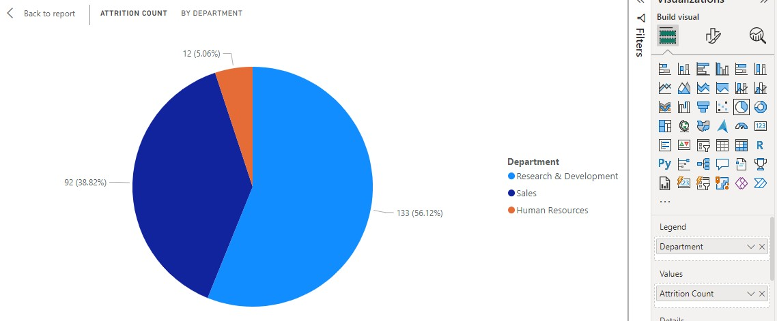

1. **Create a bar chart to display the number of employees by Age group,**

**Step1:** Right click Age and choose new group and set bin size as 5.

**Step2:** Choose any bar chart drag and drop new age bin and employee count.

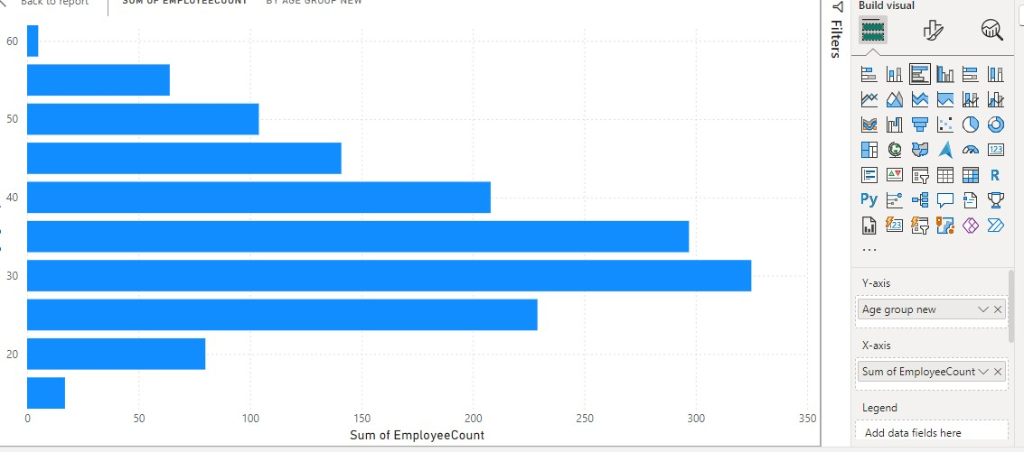

**V) Create a highlight table to show the Job Satisfaction Rating for each job role based on employee count.**

* Create a **Matrix** visual from the Visualizations pane.
* Drag the Job Role field to **Rows**.
* Drag the Job Satisfaction Rating field to **Columns**.
* Drag the Employee Count measure to **Values**.

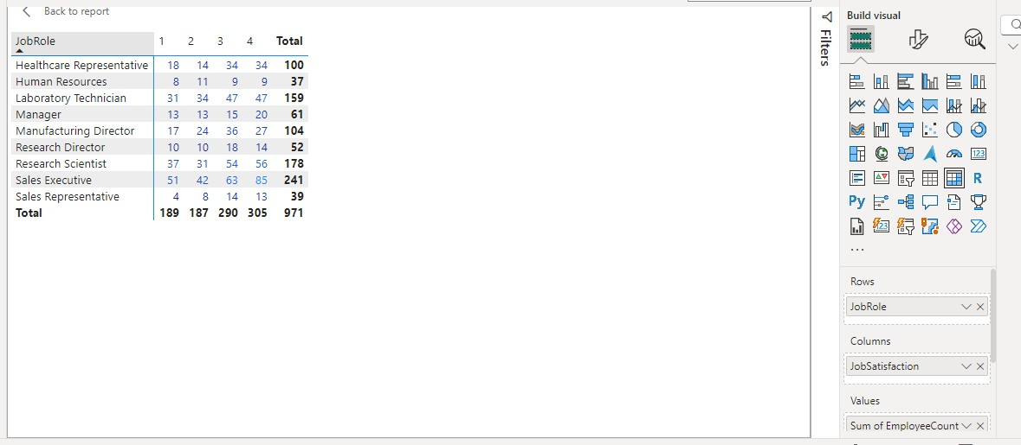

**VI) Create a horizontal bar chart to show the attrition count for each Education field Education field wise**

Attrition – drag education field to rows, sum attrition count to col,

**Step1:** Horizontal bar chart It's called the **Clustered Bar Chart** or **Stacked Bar Chart** in the visualization pane

Choose stacked bar chart and set y axis is education filed and x axis is attrition count.

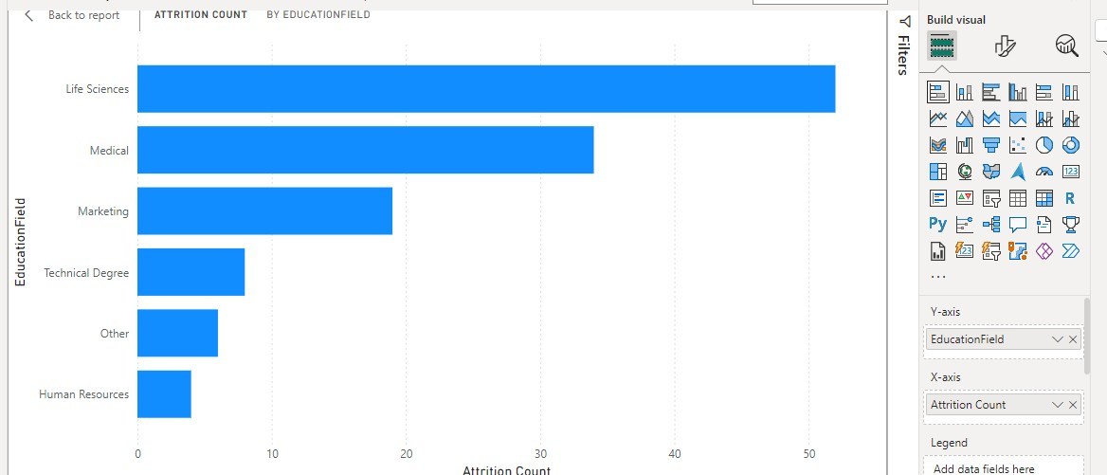

**vii) Create multiple donut chart to show the Attrition Rate by Gender for different Age group. Choose donut chart and drag and drop legend as gender and value as attrition rate.**

1. Select the **Donut Chart** from the Visualizations pane.
2. Create separate **Donut Charts** for different age groups.

• For each chart, filter the dataset based on age group (using the Age Group field created earlier).

1. Drag the Gender field to **Legend**.
2. Drag the Attrition Rate measure to **Values**.
3. Repeat for each age group, ensuring each donut chart represents a different age group with gender breakdown.

**Note:**

* Use **Filters** to dynamically adjust visuals where necessary (e.g., filter by Age Group or Education Field).

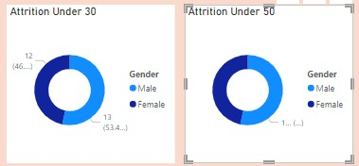

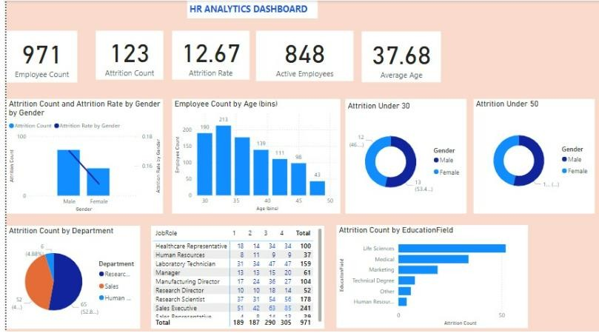

**Program 12:**

**Analysis of Amazon Prime Dataset:**

i) Create a Donut chart to show the percentage of movie and tv shows ii) Create a area chart to shows by release year and type iii) Create a horizontal bar chart to show Top 10 genre iv) Create a map to display total shows by country

* 1. Create a text sheet to show the description of any movie/movies.
  2. Build an interactive Dashboard.

**Step1:** Upload the Amazon CSV dataset.

**Step2:** Transform data and make the data ready for reporting.

As part of Transformation remove you can remove blank, null values and remove columns which is not required for analysis.

**Step3:** Select close and apply.

**i).Create a Donut chart to show the percentage of movie and tv shows**

* From the **Visualizations pane**, select the **Donut chart**.
* Drag the **'Type'** field to the **Legend** section.
* Drag any suitable column (e.g., **ID** or **Title**) to **Values**, then set the aggregation to **Count**.
* Use filters to filter only movie and TV show.This will show the percentage of **Movies** vs **TV Shows**.

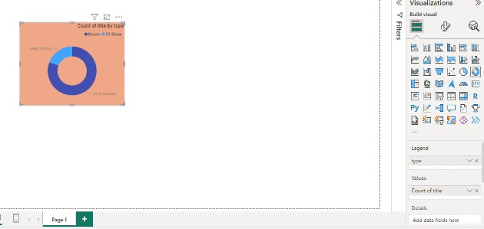

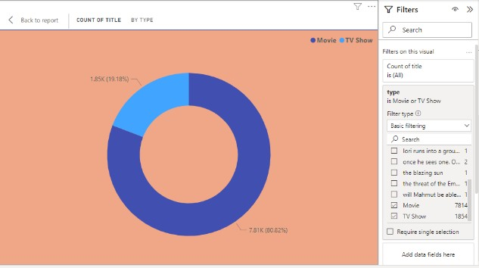

**ii).Create a area chart to shows by release year and type.**

* Ensure your dataset contains a **Release Year** column and a **Type** column (Movies/TV Shows).

**Steps to Create Area Chart**:

* Choose **Area chart** from the Visualizations pane.
* Drag the **'Release Year'** field to the **Axis** section.
* Drag the **'Type'** field to **Legend**.
* Drag the **Title** (or other identifying fields) to **Values(Y Axis)**, and set the aggregation to **Count**.
* You’ll now see an area chart with Movies and TV Shows distributed over the years.

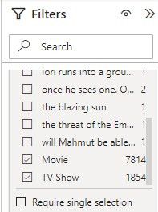

* Note: Use filters to filter only movies and TV show. •

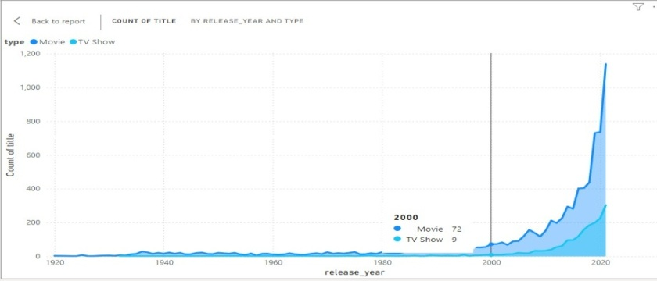

**iii. Create a horizontal bar chart to show Top 10 genre**.

Note: Make sure you have a **Genre** column in your dataset.(Rename the column listed in to Genre)

**Steps to Create Horizontal Bar Chart**:

* From the Visualizations pane, select **Bar chart** and adjust it to display horizontally.
* Drag the **Genre** column to the **Axis** section.
* Drag the **Title** (or other identifier) to **Values**, and set the aggregation to **Count**.
* In the **Filters** pane, filter the **Top N** to display the **Top 10** Genres by the count of content.
* From the Visualizations pane, select **Bar chart** and adjust it to display horizontally.

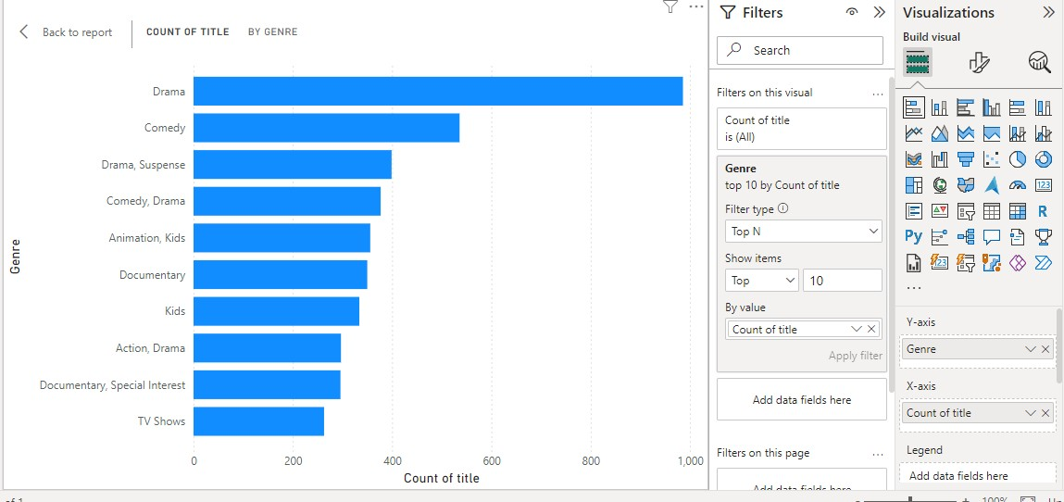

**iv. Create a map to display total shows by country.**

Make sure you have a country column in your dataset.

**Steps to Create a Map**:

* Choose Filled **Map** from the Visualizations pane.
* Write a new measure to count show id count showid = count(amazon_prime_titles[release_year])
* Drag the **Country** field to the **Location** section.
* Check the count showed measure in the data pane.
* This will show a world map representing the total number of shows produced in each country.

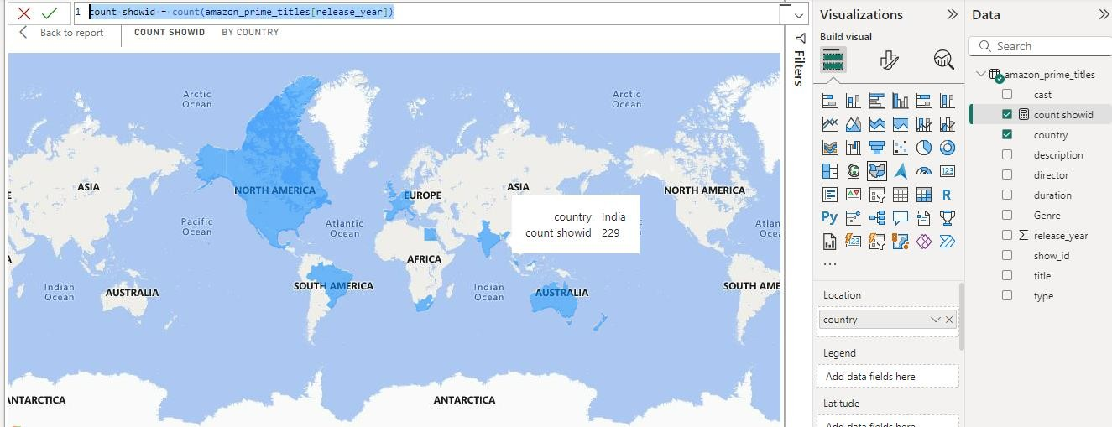

**v) Create a text sheet to show the description of any movie/movies.**

* Ensure your dataset has a **Description** column for each movie/TV show.
* Choose Table from the visuals and check the title and description columns.
* You can add slicer to search by title to get the description.

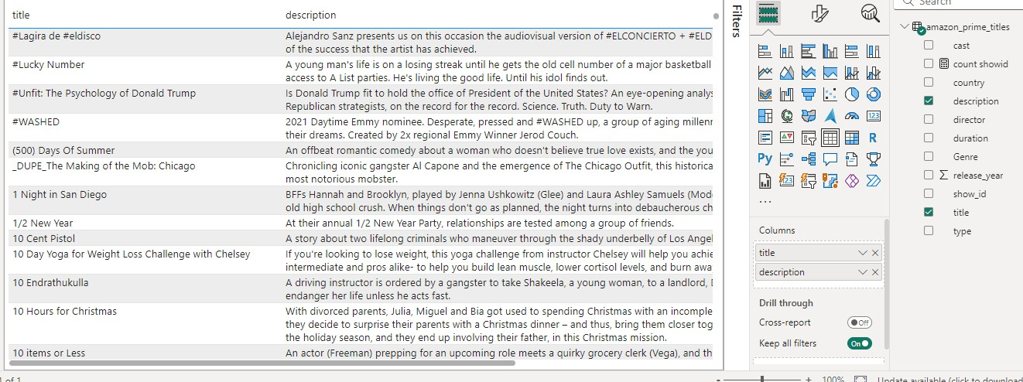

**vi) Build an interactive Dashboard:**

